St. Peter’s Episcopal Church

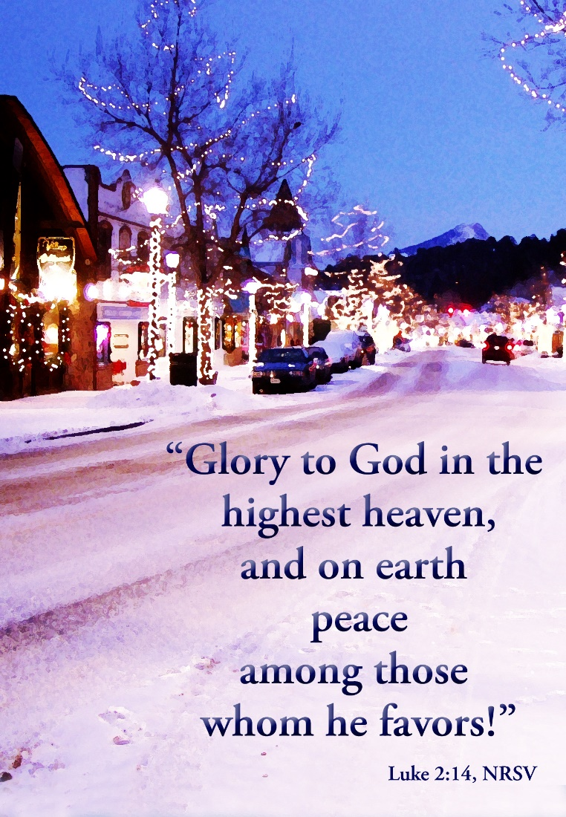

The Vigil of Nativity of Our Lord:

Christmas Day

Friday, December 24th, 2021
137-28 244th street,
Rosedale NY 11422
www.stpetersrosedale.org

The Very Rev. Steve Foster – Rector
Carols for The Vigil of the Nativity
While shepherds watched their flocks by night The Hymnal 1940 #13
1 | While shepherds watched their flocks by night,
 | all seated on the ground,
 | the angel of the Lord came down,
 | and glory shone around.
2 | “Fear not,” said he, for mighty dread
 | had seized their troubled mind;
 | “Glad tidings of great joy I bring
 | to you and all mankind.
3 | “To you, in David’s town, this day
 | is born of David’s line
 | the Savior, who is Christ the Lord;
 | and this shall be the sign:
4 | “The heavenly Babe you there shall find
 | to human view displayed,
 | all meanly wrapped in swathing bands,
 | and in a manger laid.”
5 | Thus spake the seraph, and forthwith
 | appeared a shining throng
 | of angels praising God, who thus
 | addressed their joyful song:
6 | “All glory be to God on high
 | and on the earth be peace;
 | good will henceforth from heaven to men
 | begin and never cease.”

It came upon the midnight clear The Hymnal 1940 #19
1 | It came upon the midnight clear,
 | that glorious song of old,
 | from angels bending near the earth
 | to touch their harps of gold:
 | “Peace on the earth, good will to men,
 | from heaven’s all-gracious King.”
 | The world in solemn stillness lay
 | to hear the angels sing.
2 | Still through the cloven skies they come
 | with peaceful wings unfurled,
 | and still their heavenly music floats
 | o’er all the weary world;
 | above its sad and lowly plains
 | they bend on hovering wing,
 | and ever o’er its Babel-sounds
 | the blessed angels sing.
3 | Yet with the woes of sin and strife
 | the world has suffered long;
 | beneath the heavenly hymn have rolled
 | two thousand years of wrong;
 | and warring humankind hears not
 | the tidings which they bring;
 | O hush the noise and cease your strife
 | and hear the angels sing!
4 | For lo! the days are hastening on,
 | by prophets seen of old,
 | when with the ever-circling years
 | shall come the time foretold,
 | when peace shall over all the earth
 | its ancient splendors fling,
 | and all the world give back the song
 | which now the angels sing.
O little town of Bethlehem The Hymnal 1940 #21
1 | O little town of Bethlehem,
 | how still we see thee lie!
 | Above thy deep and dreamless sleep
 | the silent stars go by;
 | yet in thy dark streets shineth
 | the everlasting Light;
 | the hopes and fears of all the years
 | are met in thee tonight.
2 | For Christ is born of Mary;
 | and gathered all above,
 | while mortals sleep, the angels keep
 | their watch of wondering love.
 | O morning stars, together
 | proclaim the holy birth!
 | and praises sing to God the King,
 | and peace to men on earth.
3 | How silently, how silently,
 | the wondrous gift is given!
 | So God imparts to human hearts
 | the blessings of his heaven.
 | No ear may hear his coming,
 | but in this world of sin,
 | where meek souls will receive him, still
 | the dear Christ enters in.
4 | Where children pure and happy
 | pray to the blessèd Child,
 | where misery cries out to thee,
 | Son of the mother mild;
 | where charity stands watching
 | and faith holds wide the door,
 | the dark night wakes, the glory breaks,
 | and Christmas comes once more.
5 | O holy Child of Bethlehem,
 | descend to us, we pray;
 | cast out our sin and enter in,
 | be born in us today.
 | We hear the Christmas angels
 | the great glad tidings tell;
 | O come to us, abide with us,
our Lord Emmanuel!

The first Nowell the angel did say The Hymnal 1940 #30
1 | The first Nowell the angel did say
 | was to certain poor shepherds in fields as they lay;
 | in fields as they lay, keeping their sheep,
 | on a cold winter’s night that was so deep.
 | Nowell, Nowell, Nowell, Nowell,
 | born is the King of Israel.
2 | They looked up and saw a star
 | shining in the east beyond them far,
 | and to the earth it gave great light,
 | and so it continued both day and night.
 | Refrain
3 | And by the light of that same star
 | three wise men came from country far;
 | to seek for a king was their intent,
 | and to follow the star wherever it went.
 | Refrain
4 | This star drew nigh to the northwest,
 | o’er Bethlehem it took its rest,
 | and there it did both stop and stay
 | right over the place where Jesus lay.
 | Refrain
5 | Then entered in those wise men three
 | full reverently upon their knee,
 | and offered there in his presence
 | their gold, and myrrh, and frankincense.
 | Refrain
6 | Then let us all with one accord
 | sing praises to our heavenly Lord;
 | that hath made heaven and earth of nought,
 | and with his blood our life hath bought.
 | Refrain

Before the first liturgy of Christmas or at some other convenient time a priest or bishop may bless the representation of the Lord’s birth in the form of a crèche. At their entry into the church for the celebration of the Holy Eucharist, the Presider (and other ministers) may make a station at the crèche. The figure of the Christ Child may be carried in the procession and placed in the crèche.
The Altar Party enters in silence to dimly lit church
The following anthem or some other hymn may be said by all:
O great mystery, and wonderful sacrament, that animals should see the new-born Lord, lying in a manger! Blessed is the Virgin whose womb was worthy to bear Christ the Lord. Alleluia!
V. The Word was made flesh
R. And dwelt among us.

Celebrant: Let us pray.
Almighty God, who in the Incarnation of your Son has revealed to us the holiness of creation, be pleased to bless and hallow this image of his sacred birth, so that those who gaze upon it may behold this mystery, whereby humanity shares in your very nature; through Christ our Lord. Amen.

The crèche may then be censed and blessed
Introit Hymn O come, all ye faithful The Hymnal 1940 #12
1 | O come, all ye faithful,
 | joyful and triumphant,
 | O come ye, O come ye to Bethlehem;
 | come, and behold him,
 | born the King of angels;
 | O come, let us adore him,
 | Christ the Lord.
2 | God from God,
 | Light from Light eternal,
 | lo! he abhors not the Virgin’s womb;
 | only-begotten
 | Son of God the Father;
 | Refrain
3 | Sing, choirs of angels,
 | sing in exultation,
 | sing, all ye citizens of heaven above;
 | glory to God,
 | glory in the highest;
 | Refrain
4 | See how the shepherds,
 | summoned to his cradle,
 | leaving their flocks, draw nigh to gaze;
 | we too will thither
 | bend our joyful footsteps;
 | Refrain
5 | Child, for us sinners
 | poor and in the manger,
 | we would embrace thee, with love and awe;
 | who would not love thee,
 | loving us so dearly?
 | Refrain
6 | Yea, Lord, we greet thee,
 | born this happy morning;
 | Jesus, to thee be glory given;
 | Word of the Father,
 | now in flesh appearing;

The Celebrant says
Blessed Be God, Father, Son and Holy Spirit.
People And Blessed be his kingdom, now and for ever. Amen

Almighty God, to you all hearts are open, all desires known, and from you no secrets are hid: Cleanse the thoughts of our hearts by the inspiration of your Holy Spirit, that we may perfectly love you, and worthily magnify your holy Name; through Christ our Lord. Amen
The following is said
Gloria in Excelsis
Glory to God in the highest, and peace to his people on earth. Lord God, heavenly King, almighty God and Father, we worship you, we give you thanks, we praise you for your glory. Lord Jesus Christ, only Son of the Father, Lord God, Lamb of God, you take away the sin of the world: have mercy on us; you are seated at the right hand of the Father: receive our prayer. For you alone are the Holy One, you alone are the Lord, you alone are the Most High, Jesus Christ, with the Holy Spirit, in the glory of God the Father. Amen.

Collect of the Day
Celebrant The Lord be with you.
People And also with you.
Celebrant Let us pray.

O God, you make us glad by the yearly festival of the birth of your only Son Jesus Christ: Grant that we, who joyfully receive him as our Redeemer, may with sure confidence behold him when he comes to be our Judge; who lives and reigns with you and the Holy Spirit, one God, now and for ever. Amen.

The Readings
First Reading Isaiah [9:2-7]

A Reading from the Book of the Prophet Isaiah
The people who walked in darkness have seen a great light; those who lived in a land of deep darkness – on them light has shined. You have multiplied the nation, you have increased its joy; they rejoice before you as with joy at the harvest, as people exult when dividing plunder. For the yoke of their burden, and the bar across their shoulders, the rod of their oppressor, you have broken as on the day of Midian. For all the boots of the tramping warriors and all the garments rolled in blood shall be burned as fuel for the fire. For a child has been born for us, a son given to us; authority rests upon his shoulders; and he is named Wonderful Counselor, Mighty God, Everlasting Father, Prince of Peace. His authority shall grow continually, and there shall be endless peace for the throne of David and his kingdom. He will establish and uphold it with justice and with righteousness from this time onward and forevermore. The zeal of the Lord of hosts will do this.
- The Word of the Lord.
- Thanks be to God.

Silence

THE GRADUAL: Psalm [96]

Antiphon: Today is born our Savior, Christ the Lord.

Sing to the Lord a new song; sing to the Lord, all the whole earth. Sing to the Lord and bless his Name; proclaim the good news of his salvation from day to day. Declare his glory among the nations and his wonders among all peoples. For great is the Lord and greatly to be praised; he is more to be feared than all gods.

Antiphon: Today is born our Savior, Christ the Lord.

As for all the gods of the nations, they are but idols; But it is the Lord who made the heavens. Oh, the majesty and magnificence of his presence! Oh, the power and the splendor of his sanctuary! Ascribe to the Lord the honor due his Name; Bring offerings and come into his courts. Worship the Lord in the beauty of holiness; Let the whole earth tremble before him.

Antiphon: Today is born our Savior, Christ the Lord.

Tell it out among the nations: “The Lord is King! He has made the world so firm that it cannot be moved; He will judge the peoples with equity.” Let the heavens rejoice, and let the earth be glad; let the sea thunder and all that is in it; let the field be joyful and all that is therein. Then shall all the trees of the wood shout for joy before the Lord when he comes, when he comes to judge the earth. He will judge the world with righteousness and the peoples with his truth.
Antiphon: Today is born our Savior, Christ the Lord.

Silence

THE EPISTLE: A Reading from the Letter of the Blessed Apostle Paul to Titus [2:11-14]

For the grace of God has appeared, bringing salvation to all, training us to renounce impiety and worldly passions, and in the present age to live lives that are self-controlled, upright, and godly, while we wait for the blessed hope and the manifestation of the glory of our great God and savior, Jesus Christ. He it is who gave himself for us that he might redeem us from all iniquity and purify for himself a people of his own who are zealous for good deeds.

- The Word of the Lord.
- Thanks be to God.

Silence

ALLELUIA:
Cantor: Alleluia
People: Alleluia
Cantor: Behold I bring you good news of a great joy. To you is born this day, a Savior, who is Christ the Lord.
People: Alleluia

THE HOLY GOSPEL: Luke [2:1-20]
V. The Holy Gospel of Our Lord Jesus Christ According Saint Luke
R. Glory to you, Lord Christ.
(+) In those days a decree went out from Emperor Augustus that all the world should be registered. This was the first registration and was taken while Quirinius was governor of Syria. All went to their own towns to be registered. Joseph also went from the town of Nazareth in Galilee to Judea, to the city of David called Bethlehem, because he was descended from the house and family of David. He went to be registered with Mary, to whom he was engaged and who was expecting a child. While they were there, the time came for her to deliver her child. And she gave birth to her firstborn son and wrapped him in bands of cloth, and laid him in a manger, because there was no place for them in the inn. In that region there were shepherds living in the fields, keeping watch over their flock by night. Then an angel of the Lord stood before them, and the glory of the Lord shone around them, and they were terrified. But the angel said to them, “Do not be afraid; for see – I am bringing you good news of great joy for all the people: to you is born this day in the city of David a Savior, who is the Messiah, the Lord. This will be a sign for you: you will find a child wrapped in bands of cloth and lying in a manger.” And suddenly there was with the angel a multitude of the heavenly host, praising God and saying, “Glory to God in the highest heaven, and on earth peace among those whom he favors!” When the angels had left them and gone into heaven, the shepherds said to one another, “Let us go now to Bethlehem and see this thing that has taken place, which the Lord has made known to us.” So they went with haste and found Mary and Joseph, and the child lying in the manger. When they saw this, they made known what had been told them about this child; and all who heard it were amazed at what the shepherds told them. But Mary treasured all these words and pondered them in her heart. The shepherds returned, glorifying and praising God for all they had heard and seen, as it had been told them.

V. The Gospel of the Lord.
R. Praise to you, Lord Christ.

Sermon Fr. Steve Foster

Silent reflection and allow God to speaking to you and through you.

Nicene Creed
All stand.
We believe in one God, the Father, the Almighty, maker of heaven and earth,
of all that is, seen and unseen. We believe in one Lord, Jesus Christ, the only Son
of God, eternally begotten of the Father, God from God, Light from Light, true
God from true God, begotten, not made, of one Being with the Father. Through him
all things were made. For us and for our salvation he came down from heaven: by
the power of the Holy Spirit he became incarnate from the Virgin Mary, and was
made man. For our sake he was crucified under Pontius Pilate; he suffered death
and was buried. On the third day he rose again in accordance with the Scriptures;
he ascended into heaven and is seated at the right hand of the Father. He will come
again in glory to judge the living and the dead, and his kingdom will have no end.
We believe in the Holy Spirit, the Lord, the giver of life, who proceeds from the
Father and the Son. With the Father and the Son he is worshiped and glorified. He
has spoken through the Prophets. We believe in one holy catholic and apostolic
Church. We acknowledge one baptism for the forgiveness of sins. We look for the
resurrection of the dead, and the life of the world to come. Amen.

Prayers of the People
Celebrant: Blessing and honor and glory and power be to our God, for his love revealed in the Word made flesh. Blessing and honor and glory and power be to our God, coming among us and sharing our humanity. Blessing and honor and glory and power be to our God, filling Mary with the life of the Divine. Blessing and honor and glory and power be to our God, for our salvation, for bringing joy and peace into our world; through Jesus Christ our Lord. Amen

Leader: Teach us to see your presence in each other: to be aware that what we do to each other we do to you. We give thanks for the word spoken by the prophets, but above all for the Word made flesh dwelling among us. May your whole church proclaim this Good News with joy.
Lord Jesus, born of the Virgin Mary, be born in us today.

Glory to God in the highest and on earth peace. We pray for lasting peace in the Middle East and for Bethlehem today. Lord, give peace in the hearts of all, peace in our land, peace among the nations: peace in our homes and peace in all our dealings; peace through him who is the Prince of Peace.
Lord Jesus, born of the Virgin Mary, be born in us today.

Lord Jesus, born of Mary, you are part of the human family: you share our joys and our sorrows, our hopes and our fears. Bless our homes with your presence; be known to be with us, our families and our friends.
Lord Jesus, born of the Virgin Mary, be born in us today.

Lord Jesus Christ, you came down to lift us up. You descended that we might ascend. You became human that we could share in the divine. We pray for all who are down at this time: we remember the outcast and the refugee; the homeless people and the street-dwellers. We pray for the lonely and those who are unloved, for all who will find this a sad day or a hard day. (Please mention your loved ones at this time, those as you carry in the silence of your hearts, we ask your prayers especially for the sick, shut in, and those in need of strength and guidance)
Lord Jesus, born of the Virgin Mary, be born in us today.

We give thanks that you have opened the kingdom to all believers. We pray for the loved ones departed from us, (Please mention your departed loved ones at this time or as you carry them in the silence of your hearts) that they may be one with you in your kingdom.
Lord Jesus, born of the Virgin Mary, be born in us today.

Celebrant: Praise be to God in his great love for us. He has entered our darkness with his great light. He comes as our God and yet as a child. Lord, help us and your whole church to walk as children of the light. AMEN

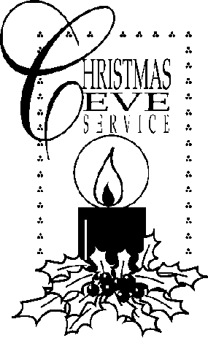

Confession of Sin
The Celebrant says
Jesus said, “The first commandment is this: Hear, O Israel: The Lord our God is the only Lord. Love the Lord your God with all your heart, with all your soul, with all your mind, and with all your strength. The second is this: Love your neighbor as yourself. There is no other commandment greater than these.” Mark 12:29-31
The Celebrant then says
Let us confess our sins to God.
Silence.
Minister and People
Most merciful God, we confess that we have sinned against you in thought, word, and deed, by what we have done, and by what we have left undone. We have not loved you with our whole heart; we have not loved our neighbors as ourselves. We are truly sorry and we humbly repent. For the sake of your Son Jesus Christ, have mercy on us and forgive us; that we may delight in your will, and walk in your ways, to the glory of your Name. Amen.
The Priest stands and says
Almighty God have mercy on you, forgive you all your sins through the grace of Jesus Christ, strengthen you in all goodness, and by the power of the Holy Spirit keep you in eternal life. Amen.
THE PEACE
Celebrant This day heaven comes down, we are one with our God;
People the Word is made flesh and dwells among us.
Celebrant The peace of the Lord be always with you.
People And also with you.

Offertory Sentence
Let us with gladness present the offerings and oblations of our life and labor to the Lord
. 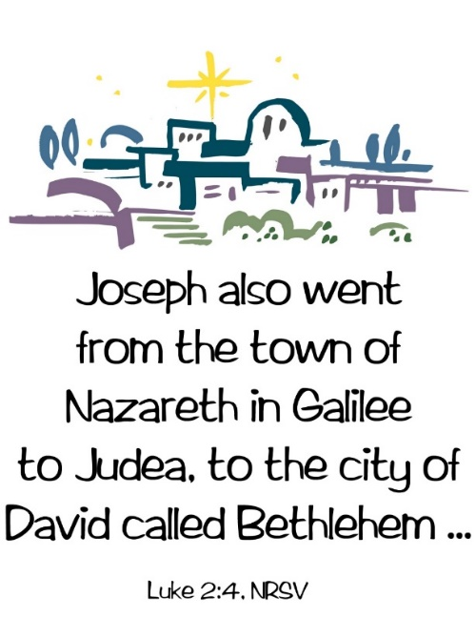
Offertory Hymn Once in royal David’s city The Hymnal 1940 #236
1 | Once in royal David’s city
 | stood a lowly cattle shed,
 | where a mother laid her baby
 | in a manger for his bed:
 | Mary was that mother mild,
 | Jesus Christ her little child.
2 | He came down to earth from heaven,
 | who is God and Lord of all,
 | and his shelter was a stable,
 | and his cradle was a stall;
 | with the poor, the scorned, the lowly,
 | lived on earth our Savior holy.
3 | We, like Mary, rest confounded
 | that a stable should display
 | heaven’s Word, the world’s creator,
 | cradled there on Christmas Day,
 | yet this child, our Lord and brother,
 | brought us love for one another.
4 | For he is our lifelong pattern;
 | daily, when on earth he grew,
 | he was tempted, scorned, rejected,
 | tears and smiles like us he knew.
 | Thus he feels for all our sadness,
 | and he shares in all our gladness.
5 | And our eyes at last shall see him,
 | through his own redeeming love;
 | for that child who seemed so helpless
 | is our Lord in heaven above;
 | and he leads his children on
 | to the place where he is gone.
6 | Not in that poor lowly stable,
 | with the oxen standing round,
 | we shall see him; but in heaven,
 | where his saints his throne surround:
 | Christ, revealed to faithful eye,
 | set at God’s right hand on high.

Great Thanksgiving
The people remain standing. The Celebrant, whether bishop or priest, faces them and sings or says
 | The Lord be with you.
People | And also with you.
Celebrant | Lift up your hearts.
People | We lift them to the Lord.
Celebrant | Let us give thanks to the Lord our God.
People | It is right to give him thanks and praise.
Then, facing the Holy Table, the Celebrant proceeds
It is right, and a good and joyful thing, always and everywhere to give thanks to you, Father Almighty, Creator of heaven and earth. Because you gave Jesus Christ, your only Son, to be born for us; who, by the mighty power of the Holy Spirit, was made perfect Man of the flesh of the Virgin Mary his mother; so that we might be delivered from the bondage of sin, and received power to become your children. Therefore, we praise you, joining our voices with Angels and Archangels and with all the company of heaven, who for ever sing this hymn to proclaim the glory of your Name:
Celebrant and People
Holy, Holy, Holy Lord, God of power and might, heaven and earth are full of your glory. Hosanna in the highest. Blessed is he who comes in the name of the Lord. Hosanna in the highest.
The people stand or kneel.
Then the Celebrant continues
We give thanks to you, O God, for the goodness and love which you have made known to us in creation; in the calling of Israel to be your people; in your Word spoken through the prophets; and above all in the Word made flesh, Jesus, your Son. For in these last days you sent him to be incarnate from the Virgin Mary, to be the Savior and Redeemer of the world. In him, you have delivered us from evil, and made us worthy to stand before you. In him, you have brought us out of error into truth, out of sin into righteousness, out of death into life.
On the night before he died for us, our Lord Jesus Christ took bread; and when he had given thanks to you, he broke it, and gave it to his disciples, and said, "Take, eat: This is my Body, which is given for you. Do this for the remembrance of me."
After supper he took the cup of wine; and when he had given thanks, he gave it to them, and said, "Drink this, all of you: This is my Blood of the new Covenant, which is shed for you and for many for the forgiveness of sins. Whenever you drink it, do this for the remembrance of me."
Therefore, according to his command, O Father,
Celebrant and People
We remember his death,
We proclaim his resurrection,
We await his coming in glory;
The Celebrant continues
And we offer our sacrifice of praise and thanksgiving to you, O Lord of all, presenting to you, from your creation, this bread and this wine.
We pray you, gracious God, to send your Holy Spirit upon these gifts that they may be the Sacrament of the Body of Christ and his Blood of the new Covenant. Unite us to your Son in his sacrifice, that we may be acceptable through him, being sanctified by the Holy Spirit. In the fullness of time, put all things in subjection under your Christ, and bring us to that heavenly country where, with the ever Blessed Virgin Mary Most Holy, St. Peter, St. Paul, and all your saints, we may enter the everlasting heritage of your sons and daughters; through Jesus Christ our Lord, the firstborn of all creation, the head of the Church, and the author of our salvation.
By him, and with him, and in him, in the unity of the Holy Spirit all honor and glory is yours, Almighty Father, now and for ever. AMEN.
And now, as our Savior Christ has taught us, we are bold to say,
Our Father in heaven, hallowed be your Name, your kingdom come, your will be
done, on earth as in heaven. Give us today our daily bread. Forgive us our sins as we
forgive those who sin against us. Save us from the time of trial and deliver us from
evil. For the kingdom, the power, and the glory are yours, now and forever. Amen.

The Breaking of the Bread
A period of silence is kept.
God of promise, you have prepared a banquet for us.
Happy are those who are called to the Supper of the Lamb.
The Celebrant says
The Gifts of God for the People of God. Take them in remembrance that Christ died for you, and feed on him in your hearts by faith, with thanksgiving.
All baptized persons are welcome to receive Holy Communion.
Communion Hymn Go, Tell It on the Mountain LEVAS 21
 | Go, tell it on the mountain
 | over the hills and everywhere;
 | go, tell it on the mountain,
 | that Jesus Christ is born.
1 | While shepherds kept their watching
 | o’er silent flocks by night,
 | Behold throughout the heavens
 | there shown a holy light.
 | Refrain
2 | The shepherds feared and trembled,
 | when lo! above the earth,
 | Rang out the angel chorus
 | that hailed the Savior’s birth.
 | Refrain
3 | Down in a lowly manger
 | the humble Christ was born,
 | And God sent us salvation
 | that blessed Christmas morn.
 | Refrain

Celebrant and People
Almighty and everliving God, we thank you for feeding us with the spiritual food of the most precious Body and Blood of your Son our Savior Jesus Christ; and for assuring us in these holy mysteries that we are living members of the Body of your Son, and heirs of your eternal kingdom. And now, Father, send us out to do the work you have given us to do, to love and serve you as faithful witnesses of Christ our Lord. To him, to you, and to the Holy Spirit, be honor and glory, now and for ever. Amen.

After the congregants have received the Blessed Sacrament, please knee for the Adoration of the Holy Child of Bethlehem, just as the Shepherds came and offered homage to the Christ Child during the singing of Silent Night.

Silent night, holy night LEVAS 26
1 | Silent night, holy night,
 | All is calm, all is bright
 | Round yon virgin mother and child,
 | Holy infant so tender and mild;
 | Sleep in heavenly peace.
2 | Silent night, holy night,
 | Shepherds quake at the sight,
 | Glories stream from heaven afar,
 | Heav’nly host sing Alleluia;
 | Christ the Savior is born.
3 | Silent night, holy night,
 | Son of God, loves pure light
 | Radiant beams from thy Holy face,
 | With the dawn of redeeming grace;
 | Jesus, Lord, at thy birth.
4 | Silent night, holy night,
 | All is dark save the light
 | Yonder where thy sweet vigils keep.
 | O’er the Babe who in silence sleep;
 | Rest in heavenly peace.

Silence

Please stand for the Hallelujah Chorus by St. Peter’s Choir

The Blessing
When he came to us as man, the Son of God scattered the darkness of this world,
and filled this holy night with his glory. May the God of infinite goodness scatter the darkness of sin and brighten your hearts with holiness. Amen.

God sent his angels to shepherds to herald the great joy of our Savior’s birth. May he fill you with joy and make you heralds of his gospel. Amen.

When the Word became man, earth was joined to heaven. May he give you his peace and good will, and fellowship with all the heavenly host. Amen.

And the blessing of God Almighty, the Father, the Son, and the Holy Spirit, be upon you and remain with you for ever. Amen.
Recessional Hymn Joy to the world! The Hymnal 1940 #775
1 | Joy to the world! the Lord is come:
 | let earth receive her King;
 | let every heart prepare him room,
 | and heaven and nature sing.
2 | Joy to the world! the Savior reigns;
 | let us our songs employ,
 | while fields and floods, rocks, hills and plains,
 | repeat the sounding joy.
3 | No more let sins and sorrows grow,
 | nor thorns infest the ground;
 | he comes to make his blessings flow
 | far as the curse is found.
4 | He rules the world with truth and grace,
 | and makes the nations prove
 | the glories of his righteousness,
 | and wonders of his love.

Let us go forth in the name of Christ.
People Thanks be to God.

Thank you for your generous contributions toward Christmas Flowers and Decorations beautifying our Church. They are given to the Glory of God in celebration of the Birth of Our Lord and Savior Jesus Christ and in memory of our loved ones who are celebrating in the arms of the Lord.
On behalf of the Vestry and Congregation of St. Peter’s, I extend to you and your family, a Blessed and Merry Christmas. and a Joyous and Spirit-filled 2022

St. Peter’s Church Rosedale
Staff

Mr. Jose Cruz - Sexton
Mr. Eiichi Shimada - Organist, and Choir Director
Ms. Dianne A. Worley – Parish Administrator
The Very Rev. Steve Foster – Rector

Vestry
Mrs. Phyllis Harris Williams – Warden
Mrs. Yvonne Robinson – Warden
Mrs. Lamarcia Parkin Bascombe – Clerk of the Vestry
Mrs. Karen Mayne Lee – Assistant Treasurer
Mrs. Cynthia Craig – Member
Mrs. Sandra George – Member
Mrs. Monica Carrington - Member
Mrs. Gail Adams – Member
Mr. Michael Prescod – Member
Ms. Elaine Henry – Member
Ms. Shadiyah Evans – Member
Mr. Richard Connell – Treasurer

Church Tel: (718) 528-1356
Rectory: (718) 528-2417
Fax: (718) 341-8635
E-mail Address: office@stpetersrosedale.org

