St. Peter’s Episcopal Church
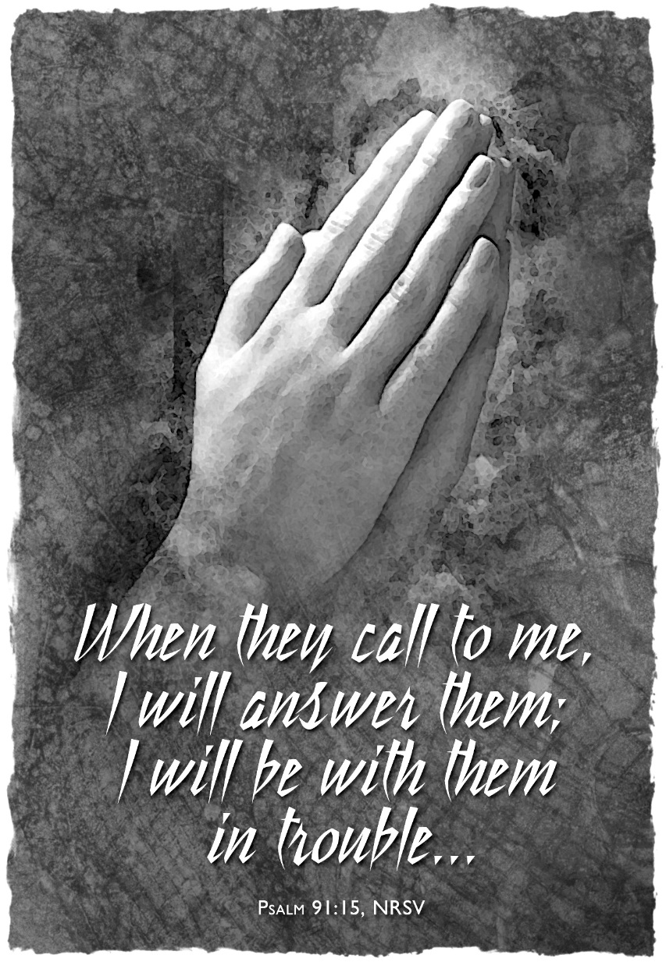
The first Sunday in Lent, Year C
Sunday, March 6th, 2022
137-28 244th street,
Rosedale NY 11422
www.stpetersrosedale.org

The Very Rev. Steve Foster- Rector

Liturgy of the Word
The Liturgy begins with the Great Litany on page 148 in the Book of Common Prayer. The Officiant says
O God the Father, Creator of heaven and earth,
Have mercy upon us.
O God the Son, Redeemer of the world,
Have mercy upon us.
O God the Holy Spirit, Sanctifier of the faithful,
Have mercy upon us.
O holy, blessed, and glorious Trinity, one God,
Have mercy upon us.
Remember not, Lord Christ, our offenses, nor the offenses of our forefathers; neither reward us according to our sins. Spare us, good Lord, spare thy people, whom thou hast
redeemed with thy most precious blood, and by thy mercy preserve us, for ever.
Spare us, good Lord.
From all evil and wickedness; from sin; from the crafts and assaults of the devil; and from everlasting damnation,
Good Lord, deliver us.
From all blindness of heart; from pride, vainglory, and hypocrisy; from envy, hatred, and malice; and from all want of charity,
Good Lord, deliver us.
From all inordinate and sinful affections; and from all the deceits of the world, the flesh, and the devil,
Good Lord, deliver us.
From all false doctrine, heresy, and schism; from hardness of heart, and contempt of thy Word and commandment,
Good Lord, deliver us.
From lightning and tempest; from earthquake, fire, and flood; from plague, pestilence, and famine,
Good Lord, deliver us.
From all oppression, conspiracy, and rebellion; from violence, battle, and murder; and from dying suddenly and unprepared,
Good Lord, deliver us.
By the mystery of thy holy Incarnation; by thy holy Nativity and submission to the Law; by thy Baptism, Fasting, and Temptation,
Good Lord, deliver us.
By thine Agony and Bloody Sweat; by thy Cross and Passion; by thy precious Death and Burial; by thy glorious Resurrection and Ascension; and by the Coming of the Holy Ghost,
Good Lord, deliver us.
In all time of our tribulation; in all time of our prosperity; in the hour of death, and in the day of judgment,
Good Lord, deliver us.
We sinners do beseech thee to hear us, O Lord God; and that it may please thee to rule and govern thy holy Church Universal in the right way,
We beseech thee to hear us, good Lord.
That it may please thee to illumine all bishops, priests, and deacons, with true knowledge and understanding of thy Word; and that both by their preaching and living, they may
set it forth, and show it accordingly,
We beseech thee to hear us, good Lord.
That it may please thee to bless and keep all thy people,
We beseech thee to hear us, good Lord.
That it may please thee to send forth laborers into thy harvest, and to draw all mankind into thy kingdom,
We beseech thee to hear us, good Lord.
That it may please thee to give to all people increase of grace to hear and receive thy Word, and to bring forth the fruits of the Spirit,
We beseech thee to hear us, good Lord.
That it may please thee to bring into the way of truth all such as have erred, and are deceived,
We beseech thee to hear us, good Lord.
That it may please thee to give us a heart to love and fear thee, and diligently to live after thy commandments,
We beseech thee to hear us, good Lord.
That it may please thee so to rule the hearts of thy servants, Joseph, the President of the United States, and all others in authority, that they may do justice, and love mercy,
and walk in the ways of truth,
We beseech thee to hear us, good Lord.
That it may please thee to make wars to cease in all the world; to give to all nations unity, peace, and concord; and to bestow freedom upon all peoples,
We beseech thee to hear us, good Lord.
That it may please thee to show thy pity upon all prisoners and captives, the homeless and the hungry, and all who are desolate and oppressed,
We beseech thee to hear us, good Lord.
That it may please thee to give and preserve to our use the bountiful fruits of the earth, so that in due time all may enjoy them,
We beseech thee to hear us, good Lord.
That it may please thee to inspire us, in our several callings, to do the work which thou givest us to do with singleness of heart as thy servants, and for the common good,
We beseech thee to hear us, good Lord.
That it may please thee to preserve all who are in danger by reason of their labor or their travel,
We beseech thee to hear us, good Lord.
That it may please thee to preserve, and provide for, all women in childbirth, young children and orphans, the widowed, and all whose homes are broken or torn by strife,
We beseech thee to hear us, good Lord.
That it may please thee to visit the lonely; to strengthen all who suffer in mind, body, and spirit; and to comfort with thy presence those who are failing and infirm,
We beseech thee to hear us, good Lord.
That it may please thee to support, help, and comfort all who are in danger, necessity, and tribulation,
We beseech thee to hear us, good Lord.
That it may please thee to have mercy upon all mankind,
We beseech thee to hear us, good Lord.
That it may please thee to give us true repentance; to forgive us all our sins, negligences, and ignorances; and to endue us with the grace of thy Holy Spirit to amend our lives
according to thy holy Word,
We beseech thee to hear us, good Lord.
That it may please thee to forgive our enemies, persecutors, and slanderers, and to turn their hearts,
We beseech thee to hear us, good Lord.
That it may please thee to strengthen such as do stand; to comfort and help the weak-hearted; to raise up those who fall; and finally to beat down Satan under our feet,
We beseech thee to hear us, good Lord.
That it may please thee to grant to all the faithful departed eternal life and peace,
We beseech thee to hear us, good Lord.
That it may please thee to grant that, in the fellowship of the Blessed Virgin Mary Most Holy, Blessed Saint Peter, Blessed Saint Paul and all the saints, we may attain to thy
heavenly kingdom,
We beseech thee to hear us, good Lord.
Son of God, we beseech thee to hear us.
Son of God, we beseech thee to hear us.
O Lamb of God, that takest away the sins of the world,
Have mercy upon us.
O Lamb of God, that takest away the sins of the world,
Have mercy upon us.
O Lamb of God, that takest away the sins of the world,
Grant us thy peace.
O Christ, hear us.
O Christ, hear us.
Lord, have mercy upon us.
Christ, have mercy upon us.
Lord, have mercy upon us.
Let us pray.
Almighty God, who hast promised to hear the petitions of those who ask in thy Son's Name: We beseech thee mercifully to incline thine ear to us who have now made our prayers and supplications unto thee; and grant that those things which we have asked faithfully according to thy will, may be obtained effectually, to the relief of our necessity, and to the setting forth of thy glory; through Jesus Christ our Lord. Amen.
Introit Hymn The glory of these forty days The Hymnal 1940 #61
1 | The glory of these forty days
 | we celebrate with songs of praise;
 | for Christ, through whom all things were made,
 | himself has fasted and has prayed.
2 | Alone and fasting Moses saw
 | the loving God who gave the law;
 | and to Elijah, fasting, came
 | the steeds and chariots of flame.
3 | So Daniel trained his mystic sight,
 | delivered from the lions’ might;
 | and John, the Bridegroom’s friend, became
 | the herald of Messiah’s name.
4 | Then grant us, Lord, like them to be
 | full oft in fast and prayer with thee;
 | our spirits strengthen with thy grace,
 | and give us joy to see thy face.
5 | O Father, Son, and Spirit blest,
 | to thee be every prayer addressed,
 | who art in threefold Name adored,
 | from age to age, the only Lord.

The Celebrant continues
Blessed the Lord who forgives all our sins.
People His mercy endures for ever.

Jesus said, "The first commandment is this: Hear, O Israel: The Lord our God is the only Lord. Love the Lord your God with all your heart, with all your soul, with all your mind, and with all your strength. The second is this: Love your neighbor as yourself. There is no other commandment greater than these." Mark 12:29-31
The Celebrant then says
Let us confess our sins to God.
Silence
Minister and People
Most merciful God, we confess that we have sinned against you in thought, word, and deed, by what we have done, and by what we have left undone. We have not loved you with our whole heart; we have not loved our neighbors as ourselves. We are truly sorry and we humbly repent. For the sake of your Son Jesus Christ, have mercy on us and forgive us; that we may delight in your will, and walk in your ways, to the glory of your Name. Amen.

The Celebrant says
Almighty God have mercy on you, forgive you all your sins through the grace of Jesus Christ, strengthen you in all goodness, and by the power of the Holy Spirit keep you in eternal life. Amen.

Collect of the Day
Celebrant The Lord be with you.
People And also with you.
Celebrant Let us pray.

Almighty God, whose blessed Son was led by the Spirit to be tempted by Satan: Come quickly to help us who are assaulted by many temptations; and, as you know the weaknesses of each of us, let each one find you mighty to save; through Jesus Christ your Son our Lord, who lives and reigns with you and the Holy Spirit, one God, now and for ever. Amen.

The Readings

First Reading: Deuteronomy 26:1-11

THE LESSON: A Reading from the Book of Deuteronomy
Moses said, “when you have come into the land that the Lord your God is giving you as an inheritance to possess, and you possess it, and settle in it, you shall take some of the first of all the fruit of the ground, which you harvest from the land that the Lord your God is giving you, and you shall put it in a basket and go to the place that the Lord your God will choose as a dwelling for his name. You shall go to the priest who is in office at that time, and say to him, “Today I declare to the Lord your God that I have come into the land that the Lord swore to our ancestors to give us.” When the priest takes the basket from your hand and sets it down before the altar of the Lord your God. Thus you shall say when you present the first-fruits to the Lord your God: “A wandering Aramean was my ancestor; he went down into Egypt and lived there as an alien, few in number, and there he became a great nation, mighty and populous. When the Egyptians treated us harshly and afflicted us, by imposing hard labor on us, we cried to the Lord, the God of our ancestors; the Lord heard our voice and saw our affliction, our toil, and our oppression. The Lord brought us out of Egypt with a mighty hand and an outstretched arm, with a terrifying display of power, and with signs and wonders; and he brought us into this place and gave us this land, a land flowing with milk and honey. So now I bring the first of the fruit of the ground that you, O Lord, have given me.” You shall set it down before the Lord your God and bow down before the Lord your God. Then you, together with the Levites and the aliens who reside among you, shall celebrate with all the bounty that the Lord your God has given to you and to your house.”

V. The Word of the Lord.
R. Thanks be to God.

Silence

THE GRADUAL: Psalm 91:1-2,9-16
Antiphon: God shall give the angels charge over you, to keep you in all your ways.

He who dwells in the shelter of the Most High, abides under the shadow of the Almighty. He shall say to the Lord, “You are my refuge and my stronghold, my God in whom I put my trust. Because you have made the Lord your refuge, and the Most High your habitation.
Antiphon: God shall give the angels charge over you, to keep you in all your ways.

There shall no evil happen to you, shall any plague come near your dwelling. For he shall give his angels charge over you, to keep you in all your ways. They shall bear you in their hands, lest you dash your foot against a stone.
Antiphon: God shall give the angels charge over you, to keep you in all your ways.

You shall tread upon the lion and adder; you shall trample the young lion and the serpent under your feet. Because he is bound to me in love, therefore will I deliver him; I will protect him, because he knows my Name.
Antiphon: God shall give the angels charge over you, to keep you in all your ways.

He shall call upon me, and I will answer him; I am with him in trouble. I will rescue him and bring him to honor. With long life will I satisfy him, and show him my salvation. I will rescue him and bring him to honor.
Antiphon: God shall give the angels charge over you, to keep you in all your ways.

Silence
Second Reading Romans 10:8b-13
THE EPISTLE: A Reading from the book of Romans
The word is near you, on your lips and in your heart” (that is, the word of faith that we proclaim); because if you confess with your lips that Jesus is Lord and believe in your heart that God raised him from the dead, you will be saved. For one believes with the heart and so is justified, and one confesses with the mouth and so is saved. The scripture says, “No one who believes in him will be put to shame.” For there is no distinction between Jew and Greek; the same Lord is Lord of all and is generous to all who call on him. For, “Everyone who calls on the name of the Lord shall be saved.”

V. The Word of the Lord.
R. Thanks be to God.

Silence
THE TRACT: [Psalm 91:1-4,9-11]

He who dwells in the shelter of the Most High,*
abides under the shadow of the Almighty.
He shall say to the Lord, “You are my refuge and my stronghold,*
my God in whom I put my trust.”

He shall deliver you from the snare of the hunter*
and from the deadly pestilence.
He shall cover you with his pinions, and you shall find refuge under his wings;*
his faithfulness shall be a shield and buckler.

Because you have made the Lord your refuge,*
and the Most High your habitation,
There shall no evil happen to you,*
neither shall any plague come near your dwelling.

For he shall give his angels charge over you,*
to keep you in all your ways.

Silence
THE HOLY GOSPEL: Luke 4:1-13
The Holy Gospel of Our Lord Jesus Christ According to Saint Luke.
R. Glory to you, Lord Christ.

After his baptism, Jesus, full of the Holy Spirit, returned from the Jordan and was led by the Spirit in the wilderness, where for forty days he was tempted by the devil. He ate nothing at all during those days, and when they were over, he was famished. The devil said to him, “If you are the Son of God, command this stone to become a loaf of bread.” Jesus answered him, “It is written, ‘One does not live by bread alone.’” Then the devil led him up and showed him in an instant all the kingdoms of the world. And the devil said to him, “To you I will give their glory and all this authority; for it has been given over to me, and I give it to anyone I please. If you, then, will worship me, it will all be yours.” Jesus answered him, “It is written, ‘Worship the Lord your God, and serve only him.’” Then the devil took him to Jerusalem, and placed him on the pinnacle of the temple, saying to him, “If you are the Son of God, throw yourself down from here, for it is written, ‘He will command his angels concerning you, to protect you,’ and ‘On their hands they will bear you up, so that you will not dash your foot against a stone.’” Jesus answered him, “It is said, ‘Do not put the Lord your God to the test.’” When the devil had finished every test, he departed from him until an opportune time.
Celebrant. The Gospel of the Lord.
People Praise to you, Lord Christ.

Sermon Fr. Foster

Be Silent and listen for God speaking to you.

Sermon Notes

Nicene Creed
We believe in one God, the Father, the Almighty, maker of heaven and earth, of all that is, seen and unseen. We believe in one Lord, Jesus Christ, the only Son of God, eternally begotten of the Father, God from God, Light from Light, true God from true God, begotten, not made, of one Being with the Father. Through him all things were made. For us and for our salvation he came down from heaven: by the power of the Holy Spirit he became incarnate from the Virgin Mary and was made man. For our sake he was crucified under Pontius Pilate; he suffered death and was buried. On the third day he rose again in accordance with the Scriptures; he ascended into heaven and is seated at the right hand of the Father. He will come again in glory to judge the living and the dead, and his kingdom will have no end. We believe in the Holy Spirit, the Lord, the giver of life, who proceeds from the Father and the Son. With the Father and the Son, he is worshiped and glorified. He has spoken through the Prophets. We believe in one holy catholic and apostolic Church. We acknowledge one baptism for the forgiveness of sins. We look for the resurrection of the dead, and the life of the world to come. Amen

Prayers of the People
Loving God, throughout all ages you have rescued and restored your people; we come to you for refreshment and renewal. Lord, protect us from all the terrors of the night and the dangers of the day. We pray for all who are seeking to know their vocation, all who are trying to sort out their priorities. We pray for all who are called to minister to others, for
spiritual counselors and advisers. We pray for Justin, the Archbishop of Canterbury and leader of the Anglican Communion, Michael our Presiding Bishop and Primate, Lawrence our Bishop Diocesan, Geralyn, Daniel and William our bishops, our Clergy, Gary, Dennison, Cecily, Keith, Kassinda, Ryan, Karen, Joshua, Bernice, Ephraim, Bernard, Mastine, Daryl, Charles and Steve, the congregation of St. Peter’s and the Jamaica Deanery.
Silence
Lord, in you we trust. You are our refuge and strength.

We pray for all in positions of authority, that they do not misuse their powers; for leaders of peoples, and for all who make decisions about our future. We remember all who are suffering from hunger or poverty, all who are experiencing a time of dryness or aridity in their lives. We pray also for all who are living below par, all who have lost their way. We
pray for those in government, and leaders of industries namely Joseph, the President,
Kathy, the Governor of New York, Eric, the Mayor of New York City, Donovan, the
Queens Borough President, our local representatives, elected officials, our local
Community Board, and the Rosedale Civic Association.

Silence
Lord, in you we trust. You are our refuge and strength.

We give thanks for all who have provided for us and protected us, for those who inspired us or directed us. We pray that we may be sensitive to your call and ready to do your will.
We ask you to bless and protect our loved ones and friends. We pray in a special way for Ukraine, for peace, healing, and wholeness. We pray for the end of this senseless war and assault.

Silence
Lord, in you we trust. You are our refuge and strength.

We seek your peace and healing in this moment of the COVID 19 pandemic. We pray for all who are infected, affected or displaced. We remember all who are ill and those who recovered. We pray also for their loved ones in this time of anxiety. We pray and give thanks for the essential workers, as they continue to risk themselves to serve fellow humanity. We pray for all who are engaged in research and scientific discovery for a vaccine and cure for the coronavirus.

Silence
Lord, in you we trust. You are our refuge and strength.

We pray for all who are caught up in crime and addiction, for all who are wasting their lives or giving their allegiance to wrong things. We pray for all who regret what they have done and are full of remorse; may they find new hope and courage in you, O Lord.
We remember all who are ill and longing to live full lives, for all who are restricted in any way. We pray especially for friends who are ill or in need, we remember those who are sick or shut-in and those who asked us to place them in our prayers.
Silence
Lord, in you we trust. You are our refuge and strength.

We give thanks for all who have escaped the temptations of the world, the flesh, and the devil and are now at peace in your eternal kingdom. We pray for all who have once been part of this church and community, for the saints, and all who have enriched our world. May they, with our dear ones departed, rejoice in doing your will in your kingdom.

Silence
Lord, in you we trust. You are our refuge and strength.

Almighty God, give us strength to stand against all that is evil: keep us firm in the times of trial and temptation; make us resolute in obeying your will and in seeking your kingdom; give us the power to stay true to you and proclaim your salvation; through Jesus Christ our Lord, who is alive and reigns with you and the Holy Spirit, one God, now and for ever. Amen.

The Peace
Celebrant Everyone who calls upon the name and the power of the Lord Jesus,
People will come to his peace and will be saved.
Celebrant The peace of the Lord be always with you.
People And also with you.
Offertory Sentence – Let us with gladness present the offerings and oblations of our life and labor to the Lord.
Offertory Hymn Forty days and forty nights The Hymnal 1982 # 150
1 | Forty days and forty nights
 | thou wast fasting in the wild;
 | forty days and forty nights
 | tempted, and yet undefiled.
2 | Should not we thy sorrow share
 | and from worldly joys abstain,
 | fasting with unceasing prayer,
 | strong with thee to suffer pain?
3 | Then if Satan on us press,
 | Jesus, Savior, hear our call!
 | Victor in the wilderness,
 | grant we may not faint nor fall!
4 | So shall we have peace divine:
 | holier gladness ours shall be;
 | round us, too, shall angels shine,
 | such as ministered to thee.
5 | Keep, O keep us, Savior dear,
 | ever constant by thy side;
 | that with thee we may appear
 | at the eternal Eastertide.

The HOLY EUCHARIST - Prayer A

The Lord be with you.
People | And also with you.
Celebrant | Lift up your hearts.
People | We lift them to the Lord.
Celebrant | Let us give thanks to the Lord our God.
People | It is right to give him thanks and praise.
It is right, and a good and joyful thing, always and everywhere to give thanks to you, Father Almighty, Creator of heaven and earth. Through Jesus Christ our Lord, who was tempted in every way as we are, yet did not sin. By his grace we are able to triumph over every evil, and to live no longer for ourselves alone, but for him who died for us and rose again. Therefore, we praise you, joining our voices with Angels and Archangels and with all the company of heaven, who for ever sing this hymn to proclaim the glory of your Name:
Celebrant and People
Holy, Holy, Holy Lord, God of power and might, heaven and earth are full of your glory. Hosanna in the highest. Blessed is he who comes in the name of the Lord. Hosanna in the highest.
The people stand or kneel.
Holy and gracious Father: In your infinite love you made us for yourself; and, when we had fallen into sin and become subject to evil and death, you, in your mercy, sent Jesus Christ, your only and eternal Son, to share our human nature, to live and die as one of us, to reconcile us to you, the God and Father of all. He stretched out his arms upon the cross, and offered himself in obedience to your will, a perfect sacrifice for the whole world.
At the following words concerning the bread, the Celebrant is to hold it or lay a hand upon it; and at the words concerning the cup, to hold or place a hand upon the cup and any other vessel containing wine to be consecrated.
On the night he was handed over to suffering and death, our Lord Jesus Christ took bread; and when he had given thanks to you, he broke it, and gave it to his disciples, and said, “Take, eat: This is my Body, which is given for you. Do this for the remembrance of me.”
After supper he took the cup of wine; and when he had given thanks, he gave it to them, and said, “Drink this, all of you: This is my Blood of the new Covenant, which is shed for you and for many for the forgiveness of sins. Whenever you drink it, do this for the remembrance of me.”
Therefore we proclaim the mystery of faith:
Celebrant and People
Christ has died. Christ is risen. Christ will come again.
We celebrate the memorial of our redemption, O Father, in this sacrifice of praise and thanksgiving. Recalling his death, resurrection, and ascension, we offer you these gifts. Sanctify them by your Holy Spirit to be for your people the Body and Blood of your Son, the holy food and drink of new and unending life in him. Sanctify us also that we may faithfully receive this holy Sacrament, and serve you in unity, constancy, and peace; and at the last day bring us with all your saints into the joy of your eternal kingdom. All this we ask through your Son Jesus Christ. By him, and with him, and in him, in the unity of the Holy Spirit all honor and glory is yours, Almighty Father, now and for ever. AMEN
The Celebrant then continues.
As our Savior Christ has taught us, we now pray,
Our Father in heaven, hallowed be your Name, your kingdom come, your will be
done, on earth as in heaven. Give us today our daily bread. Forgive us our sins as we
forgive those who sin against us. Save us from the time of trial and deliver us from
evil. For the kingdom, the power, and the glory are yours, now and forever. Amen.

The Breaking of the Bread
The Celebrant breaks the consecrated Bread.
A period of silence is kept.
Then said:
We break this bread to share in the Body of Christ.
We who are many are one body, for we all share in the one bread
Facing the people, the Celebrant says the following Invitation.
The Gifts of God for the People of God. Take them in remembrance that Christ died for you, and feed on him in your hearts by faith, with thanksgiving.
All baptized persons are welcome to receive Holy Communion.
Communion Hymn I Must Tell Jesus LEVAS 66
1 | I must tell Jesus all of my trials;
 | I cannot bear these burdens alone,
 | In my distress He kindly will help me,
 | He ever loves and cares for His own.
 | I must tell Jesus! I must tell Jesus!
 | I cannot bear my burdens alone;
 | I must tell Jesus! I must tell Jesus!
 | Jesus can help me, Jesus alone.
2 | I must tell Jesus all of my troubles,
 | He is a kind, compassionate friend;
 | If I but ask Him, He will deliver,
 | Make of my troubles quickly an end.
 | Refrain
3 | Tempted and tried I need a great Savior,
 | One who can help my burdens to bear
 | I must tell Jesus, I must tell Jesus;
 | He all my cares and sorrows will share.
 | Refrain
4 | O how the world to evil allures me!
 | O how my heart is tempted to sin!
 | I must tell Jesus, and He will help me,
 | Over the world the vict’ry win.
 | Refrain

Post-Communion Prayer
Let us pray.

Celebrant and People

Eternal God, heavenly Father, you have graciously accepted us as living members of your Son our Savior Jesus Christ, and you have fed us with spiritual food in the Sacrament of his Body and Blood. Send us now into the world in peace, and grant us strength and courage to love and serve you with gladness and singleness of heart; through Christ our Lord. Amen.
The Solemn Prayer

The Celebrant says Bow down before the Lord.
The people kneel and the Celebrant says the following prayers:
Lent 1
Grant, Almighty God, that your people may recognize their weakness and put their whole trust in your strength, so that they may rejoice for ever in the protection of your loving providence; through Christ our Lord. Amen.
Recessional Hymn Go forward, Christian soldier The Hymnal 1982 #563
1 | Go forward, Christian soldier,
 | beneath his banner true:
 | the Lord himself, thy Leader,
 | shall all thy foes subdue.
 | His love foretells thy trials;
 | he knows thine hourly need;
 | he can with bread of heaven
 | thy fainting spirit feed.
2 | Go forward, Christian soldier,
 | fear not the secret foe;
 | far more o’er thee are watching
 | than human eyes can know:
 | trust only Christ, thy Captain;
 | cease not to watch and pray;
 | heed not the treacherous voices
 | that lure thy soul astray.
3 | Go forward, Christian soldier,
 | nor dream of peaceful rest,
 | till Satan’s host is vanquished
 | and heaven is all possessed;
 | till Christ himself shall call thee
 | to lay thine armor by,
 | and wear in endless glory
 | the crown of victory.
4 | Go forward, Christian soldier,
 | fear not the gathering night:
 | the Lord has been thy shelter;
 | the Lord will be thy light.
 | When morn his face revealeth
 | thy dangers all are past:
 | O pray that faith and virtue
 | may keep thee to the last!

Let us go forth in the name of Christ.
People Thanks be to God.

ANNOUNCEMENTS for Week of 03/06/22
Sick and Shut-In
Please remember in our prayers members of our Parish as well as family and friends especially: Alisha, Carol Alexander, Gairy Allison, Paul Alloko, Kaiyden Bail, Olive Beckford, Jennifer Bennett, Cynthia Blake, Ida Bowen, Ermine Browne, Jennifer Brown, Lurline Brown, Jada Campbell, Rufus Carriman, Jose Cruz, Natasha Cunningham, Xiomara Fernandez, Hartley Foster, Linda Foster, Anne Foster, Marilyn Fremantle, Diana Galloway, O'Neal Gill, Cleonie Gordon, Frank Grausso, Dahlia Henriques, Pearl, Beatrice Jerome, Floyd Johnson, Kristen Jones, Winston Khan, Shauna Kerr, Norma King, Felicia Lamothe, Antoinette Lashley, Lena Lyn, Celeste Lora, Jessica Lora, Asima Malik, Nigel McLean, Sydney Miller, Arthur Mills, Ariayah Morgan-Mullet, Kerwayne Probherbs, Kwame Probherbs, Victor Rhodd, Jasmine Robinson, Clive Rodriguez, Luke Rojas, Adassa Samms, Basil Samms, Jean Scott, Coleen Shepherd, Rawl Shepherd, Suzette Smith, George Thompson, Louise Todd, Francine Trotman, April Tucker, Eugena Tucker, Pauline Watson, Lorna Wilson, and Ian Yankwitt,

STEWARDSHIP CORNER
To date we received 81 pledge cards for 2022 totaling $197, 000. The Vestry has
pledged $50, 209 toward the work of St. Peter’s Rosedale.

Definition of Stewardship Christian stewardship is really nothing less than all we do with all that we have. The amount Jesus is talking about is a pretty big amount: it’s 100 percent. Stewardship is not just about how much of what I own will I give to God. It’s about how much of me have I given to God…. Stewardship is not about paying dues. Sometimes I wish it were because that would be easier: just tell me how much I owe, and I can pay the Lord just as I pay the bills. It’s not paying dues. It’s about deliberately making deposits of my time and my energy and what I own into God’s business…. Fundamentally, stewardship begins with giving 100 percent of who I am to God. —Heidi Husted, “The Sermon on the Amount,” Preaching Today, Tape #122.

Schedule for the week of March 6th, through March 12th

Sunday, March 6th, The First Sunday in Lent
8:00 am Holy Eucharist
10:00 am Holy Eucharist
10:00 am Women’s History Presentation – Daughters of St. Peter
10:00 am Sunday School

Monday, March 7th, Office Closed
Compline 9 PM

Tuesday, March 8th, Evening Prayer & Reflection – 7 PM

Wednesday, March 9th, 10:00 am Morning Prayer and Bible study
7:30 PM Jamaica Deanery Service – Grace Church

Friday, March 11th, 8:00 PM Stations of The Cross Virtual/In-person

Saturday, March 12^{th,} Food Pantry 10:00 AM – 1:00 PM

Sunday, March 13th, The Second Sunday in Lent
8:00 am Holy Eucharist
10:00 am Holy Eucharist
10:00 am Pastoral Care presentation

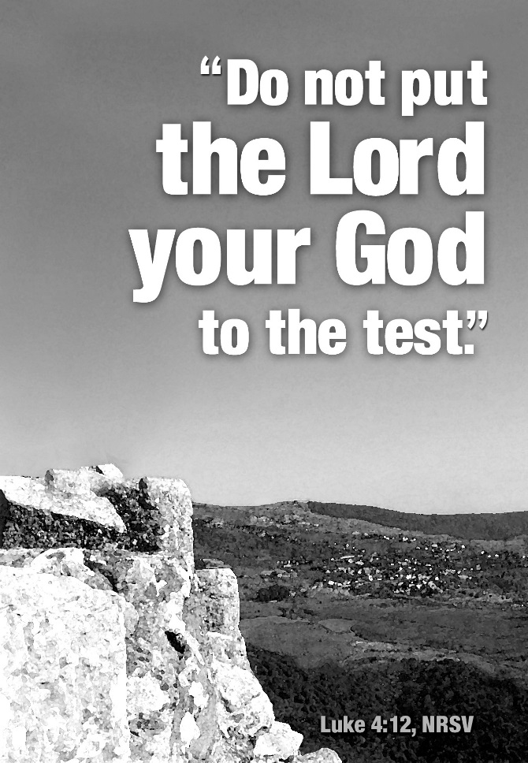

St. Peter’s Church Rosedale
Staff

Mr. Jose Cruz - Sexton
Mr. Eiichi Shimada - Organist, and Choir Director
Ms. Dianne A. Worley – Parish Administrator
The Very Rev. Steve Foster – Rector

Vestry
Mrs. Phyllis Harris Williams – Warden
Mrs. Yvonne Robinson – Warden
Mrs. Lamarcia Parkin Bascombe – Clerk of the Vestry
Mrs. Karen Mayne Lee – Assistant Treasurer
Mrs. Cynthia Craig – Member
Mrs. Sandra George – Member
Mrs. Monica Carrington - Member
Mrs. Gail Adams – Member
Mr. Michael Prescod – Member
Ms. Elaine Henry – Member
Ms. Shadiyah Evans – Member
Mr. Richard Connell – Treasurer

Church Tel: (718) 528-1356
Rectory: (718) 528-2417
Fax: (718) 341-8635
E-mail Address:
office@stpetersrosedale.org

