St. Peter’s Episcopal Church

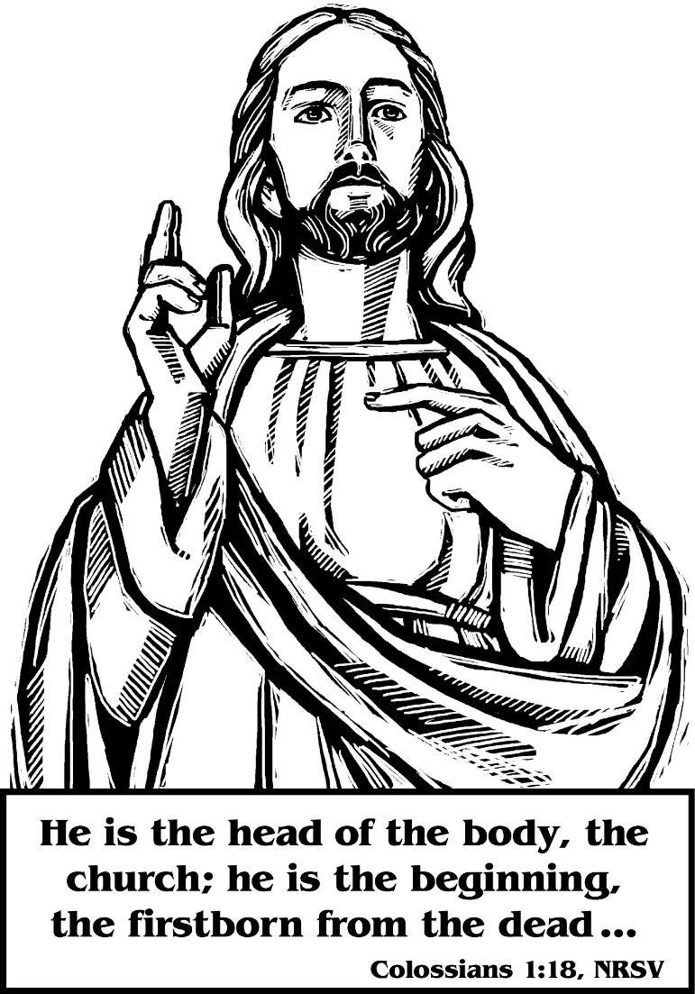

The Sixth Sunday After Pentecost

Proper 11

Sunday, July 17th, ,2022 – 9:00 AM
137-28 244th street,
Rosedale NY 11422

The Rev. Dr. Allen Robinson – Celebrant & Preacher

Liturgy of the Word

Introit Blessèd Jesus, at thy word The Hymnal 1982 #440
1 | Blessèd Jesus, at thy word
 | we are gathered all to hear thee;
 | let our hearts and souls be stirred
 | now to seek and love and fear thee;
 | by thy teachings pure and holy,
 | drawn from earth to love thee solely.
2 | All our knowledge, sense, and sight
 | lie in deepest darkness shrouded,
 | till thy Spirit breaks our night
 | with the beams of truth unclouded;
 | thou alone to God canst win us;
 | thou must work all good within us.
3 | Gracious Lord, thyself impart!
 | Light of Light, from God proceeding,
 | open thou our ears and heart,
 | help us by thy Spirit’s pleading.
 | Hear the cry thy Church upraises;
 | hear, and bless our prayers and praises.

The Celebrant says
Blessed Be God, Father, Son and Holy Spirit.
People And Blessed be his kingdom, now and for ever. Amen

Almighty God, to you all hearts are open, all desires known, and from you no secrets are hid: Cleanse the thoughts of our hearts by the inspiration of your Holy Spirit, that we may perfectly love you, and worthily magnify your holy Name; through Christ our Lord. Amen
The following is said
Gloria in Excelsis
Glory to God in the highest, and peace to his people on earth. Lord God, heavenly King, almighty God and Father, we worship you, we give you thanks, we praise you for your glory. Lord Jesus Christ, only Son of the Father, Lord God, Lamb of God, you take away the sin of the world: have mercy on us; you are seated at the right hand of the Father: receive our prayer. For you alone are the Holy One, you alone are the Lord, you alone are the Most High, Jesus Christ, with the Holy Spirit, in the glory of God the Father. Amen.

Collect of the Day
Celebrant The Lord be with you.
People And also with you.
Celebrant Let us pray.

Almighty God, the fountain of all wisdom, you know our necessities before we ask and our ignorance in asking: Have compassion on our weakness, and mercifully give us those things which for our unworthiness we dare not, and for our blindness we cannot ask; through the worthiness of your Son Jesus Christ our Lord, who lives and reigns with you and the Holy Spirit, one God, now and for ever. Amen.

The Readings
First Reading Amos 8:1-12 A reading from the book of the Prophet Amos
This is what the Sovereign LORD showed me: a basket of ripe fruit. “What do you see, Amos?” he asked. “A basket of ripe fruit,” I answered. Then the LORD said to me, “The time is ripe for my people Israel; I will spare them no longer. “In that day,” declares the Sovereign LORD, “the songs in the temple will turn to wailing. Many, many bodies—flung everywhere! Silence!” Hear this, you who trample the needy and do away with the poor of the land, saying, “When will the New Moon be over that we may sell grain, and the Sabbath be ended that we may market wheat?”— skimping on the measure, boosting the price and cheating with dishonest scales, buying the poor with silver and the needy for a pair of sandals, selling even the sweepings with the wheat. The LORD has sworn by himself, the Pride of Jacob: “I will never forget anything they have done. “Will not the land tremble for this, and all who live in it mourn? The whole land will rise like the Nile; it will be stirred up and then sink like the river of Egypt. “In that day,” declares the Sovereign LORD, “I will make the sun go down at noon and darken the earth in broad daylight. I will turn your religious festivals into mourning and all your singing into weeping. I will make all of you wear sackcloth and shave your heads. I will make that time like mourning for an only son and the end of it like a bitter day. “The days are coming,” declares the Sovereign LORD, “when I will send a famine through the land— not a famine of food or a thirst for water, but a famine of hearing the words of the LORD. People will stagger from sea to sea and wander from north to east, searching for the word of the LORD, but they will not find it.

- The Word of the Lord.
- Thanks be to God.

Silence

THE GRADUAL: Psalm [52]
Antiphon: We trust in God’s great mercy
You tyrant, why do you boast of wickedness against the godly all day long You plot ruin; your tongue is like a sharpened razor, o worker of deception. You love evil more than good and lying more than speaking the truth.
Antiphon: We trust in God’s great mercy

You love all words that hurt, O you deceitful tongue. Oh, that God would demolish you utterly, topple you, and snatch you from your dwelling, and
Root you out of the land of the living. The righteous shall see and tremble, and they shall laugh at him saying.
Antiphon: We trust in God’s great mercy

This is the one who did not take God for a refuge, but trusted in great wealth and relied upon wickedness. But I am like a green olive tree in the house of God for ever and ever. I will give you thanks for what you have done and declare the goodness of your name in the presence of the godly.
Antiphon: We trust in God’s mercy

Second Reading Colossians 1:15-28

THE EPISTLE:
A Reading from Paul’s letter to the Colossians
Jesus is the image of the invisible God, the firstborn of all creations for in him all things in heaven and on earth were created, things visible and invisible, whether thrones or dominions or rulers or powers – all things have been created through him and for him. He himself is before all things, and in him all things hold together. He is the head of the body, the church; he is the beginning, the firstborn from the dead, so that he might come to have first place in everything. For in him all the fullness of God was pleased to dwell, and through him God was pleased to reconcile to himself all things, whether on earth or in heaven, by making peace through the blood of his cross. And you who were once estranged and hostile in mind, doing evil deeds, he has now reconciled in his fleshly body through death, so as to present you holy and blameless and irreproachable before him – provided that you continue securely established and steadfast in the faith, without shifting from the hope promised by the gospel that you heard, which has been proclaimed to every creature under heaven. I, Paul, became a servant of this gospel. I am now rejoicing in my sufferings for your sake, and in my flesh I am completing what is lacking in Christ’s afflictions for the sake of his body, that is, the church. I became its servant according to God’s commission that was given to me for you, to make the word of God fully known, the mystery that has been hidden throughout the ages and generations but has now been revealed to his saints. To them God chose to make known how great among the Gentiles are the riches of the glory of this mystery, which is Christ in you, the hope of glory. It is he whom we proclaim, warning everyone and teaching everyone in all wisdom, so that we may present everyone mature in Christ.

- The Word of the Lord.
R. Thanks be to God.

Silence
ALLELUIA:
Cantor: Alleluia
People: Alleluia
Cantor: Jesus said, “Mary has chosen the good portion, Which shall not be taken away from her.”
People: Alleluia
THE HOLY GOSPEL: Luke 10:38-42

V. The Holy Gospel of Our Lord Jesus Christ According to Saint Luke
R. Glory to you, Lord Christ

As Jesus and his disciples went on their way, Jesus entered a village where a woman named Martha welcomed him into her home. She had a sister named Mary, who sat at the Lord’s feet and listened to what he was saying. But Martha was distracted by her many tasks; so she came to him and asked, “Lord, do you not care that my sister has left me to do all the work by myself? Tell her then to help me.” But the Lord answered her, “Martha, Martha, you are worried and distracted by many things; there is need of only one thing. Mary has chosen the better part, which will not be taken away from her.”

V. The Gospel of the Lord.
R. Praise to you, Lord Christ.

Sermon Fr. Robinson

Silence and listen for God speaking to you.
Sermon Notes

Nicene Creed
We believe in one God, the Father, the Almighty, maker of heaven and earth, of all that is, seen and unseen. We believe in one Lord, Jesus Christ, the only Son of God, eternally begotten of the Father, God from God, Light from Light, true God from true God, begotten, not made, of one Being with the Father. Through him all things were made. For us and for our salvation he came down from heaven: by the power of the Holy Spirit he became incarnate from the Virgin Mary and was made man. For our sake he was crucified under Pontius Pilate; he suffered death and was buried. On the third day he rose again in accordance with the Scriptures; he ascended into heaven and is seated at the right hand of the Father. He will come again in glory to judge the living and the dead, and his kingdom will have no end. We believe in the Holy Spirit, the Lord, the giver of life, who proceeds from the Father and the Son. With the Father and the Son, he is worshiped and glorified. He has spoken through the Prophets. We believe in one holy catholic and apostolic Church. We acknowledge one baptism for the forgiveness of sins. We look for the resurrection of the dead, and the life of the world to come. Amen.

Prayers of the People
Celebrant: Knowing God’s love and concern for us, let us settle ourselves in his presence and pray to him now.

Lord of hosts and hospitality, teach us to be welcoming, open, and friendly. May your church be attentive to the needs of strangers and visitors; may each church be welcoming and friendly and so reflect your love. We pray for churches that are struggling because of opposition, for churches that strive to serve in areas where there is apathy and animosity. We pray for Justin, the Archbishop of Canterbury and leader of the Anglican Communion, Michael our Presiding Bishop and Primate, Lawrence our Bishop Diocesan, Geralyn, Daniel, and William our bishops, our Clergy, Gary, Dennison, Karen, Frederick, Keith, Ryan, Kassinda, Joshua, Bernice, Ephraim, Bernard, Mastine, Lloyd, Daryl, Charles, Allen and Steve, the Jamaica Deanery and our St. Peter’s parish community.
We remember all who are persecuted for their faith. God of grace and goodness, keep us in your peace.

We ask you to bless all who are overworked, stressed, and over-anxious; we remember especially those who have no time for their homes or for leisure. We pray for the work-weary, the exhausted, and the worn out. We remember children who rarely see their parents and who lack affection. We pray for all who are restless and cannot enjoy where they are. God of grace and goodness, keep us in your peace.

We give thanks for our homes, for places of peace and quiet, for places of leisure and recreation. We pray for all who help us to relax, for musicians, artists, broadcasters and sportsmen, and sportswomen. We pray for our friends and loved ones. God of grace and goodness, keep us in your peace.

We ask for peace upon all agitated and distressed peoples and communities. We remember before you all who feel neglected or ignored, all lonely and troubled people.
We pray for all who have been misused or abused by others, all who have suffered from traumatic events, all who have witnessed horror. We ask that our friends and loved ones who are ill may know your love and protection. God of grace and goodness, keep us in your peace.

We pray in this moment of the COVID 19 pandemic for peace and healing. We pray for all who are infected, affected, or displaced. We remember all who are ill or those who recovered. We pray also for their loved ones in this time of anxiety. We pray and give thanks for the essential workers, as they continue to risk themselves to serve fellow humanity. We pray for all who are engaged in research and scientific discovery for a vaccine and cure for the coronavirus. God of grace and goodness, keep us in your peace.

We give thanks for those who are at rest in you, who have found new peace and new life. We give thanks for the saints and pray that our loved ones departed may share with them in that glory which is everlasting. God of grace and goodness, keep us in your peace.

Celebrant:
Lord, among the busyness and bustle of the world, Make us to be still attentive to your presence; Keep our ears open to your call, Keep our hearts open to your love, Make our minds sensitive to your coming, That we may ever rejoice that we dwell in you and you are in us; Through Jesus Christ, our Lord, Who lives and reigns with you and the Holy Spirit, One God, now and for ever. Amen.

Confession of Sin
The Celebrant says
Jesus said, “The first commandment is this: Hear, O Israel: The Lord our God is the only Lord. Love the Lord your God with all your heart, with all your soul, with all your mind, and with all your strength. The second is this: Love your neighbor as yourself. There is no other commandment greater than these.” Mark 12:29-31
The Celebrant then says
Let us confess our sins against God and our neighbor.
Silence.
Celebrant and People
Most merciful God, we confess that we have sinned against you in thought, word, and deed, by what we have done, and by what we have left undone. We have not loved you with our whole heart; we have not loved our neighbors as ourselves. We are truly sorry and we humbly repent. For the sake of your Son Jesus Christ, have mercy on us and forgive us; that we may delight in your will, and walk in your ways, to the glory of your Name. Amen.

The Celebrant says
Almighty God have mercy on you, forgive you all your sins through our Lord Jesus Christ, strengthen you in all goodness, and by the power of the Holy Spirit keep you in eternal life. Amen.

Peace
Celebrant: Be still and accept the peace that God’s presence brings:
People peace in our hearts, peace in our minds, peace in all our dealings We have
Celebrant: The peace of the Lord be always with you.
People And also with you.

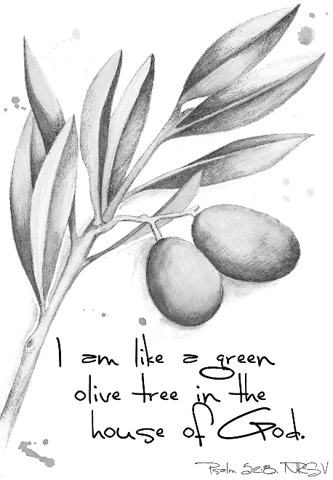

Offertory Sentences – Walk in love as Christ loved us and gave himself for us, a fragrant offering and sacrifice to God.
Offertory Hymn Immortal, invisible, God only wise The Hymnal 1982 #423
1 | Immortal, invisible, God only wise,
 | in light inaccessible hid from our eyes,
 | most blessed, most glorious, the Ancient of Days,
 | almighty, victorious, thy great Name we praise.
2 | Unresting, unhasting, and silent as light,
 | nor wanting, nor wasting, thou rulest in might;
 | thy justice like mountains high soaring above
 | thy clouds, which are fountains of goodness and love.
3 | To all life thou givest, to both great and small;
 | in all life thou livest, the true life of all;
 | we blossom and flourish, like leaves on the tree,
 | then wither and perish; but nought changeth thee.
4 | Thou reignest in glory, thou rulest in light,
 | thine angels adore thee, all veiling their sight;
 | all laud we would render: O help us to see
 | ’tis only the splendor of light hideth thee.
Great Thanksgiving – Eucharistic Prayer A
The people remain standing.
Celebrant The Lord be with you.
People And also with you.
Celebrant Lift up your hearts.
People We lift them to the Lord.
Celebrant Let us give thanks to the Lord our God.
People It is right to give him thanks and praise.
The Celebrant continues
It is right, and a good and joyful thing, always and everywhere to give thanks to you, Father Almighty, Creator of heaven and earth. Through Jesus Christ our Lord; who on the first day of the week overcame death and the grave, and by his glorious resurrection opened to us the way of everlasting life. Therefore, we praise you, joining our voices with Angels and Archangels and with all the company of heaven, who for ever sing this hymn to proclaim the glory of your Name:
Celebrant and People
Holy, Holy, Holy Lord, God of power and might, heaven and earth are full of your glory. Hosanna in the highest. Blessed is he who comes in the name of the Lord. Hosanna in the highest.
The people stand or kneel.
The Celebrant continues
Holy and gracious Father: In your infinite love you made us for yourself; and, when we had fallen into sin and become subject to evil and death, you, in your mercy, sent Jesus Christ, your only and eternal Son, to share our human nature, to live and die as one of us, to reconcile us to you, the God and Father of all. He stretched out his arms upon the cross, and offered himself in obedience to your will, a perfect sacrifice for the whole world.
At the following words concerning the bread, the Celebrant is to hold it or lay a hand upon it; and at the words concerning the cup, to hold or place a hand upon the cup and any other vessel containing wine to be consecrated.
On the night he was handed over to suffering and death, our Lord Jesus Christ took bread; and when he had given thanks to you, he broke it, and gave it to his disciples, and said, “Take, eat: This is my Body, which is given for you. Do this for the remembrance of me.”
After supper he took the cup of wine; and when he had given thanks, he gave it to them, and said, “Drink this, all of you: This is my Blood of the new Covenant, which is shed for you and for many for the forgiveness of sins. Whenever you drink it, do this for the remembrance of me.”
Therefore, we proclaim the mystery of faith:
Celebrant and People
Christ has died. Christ is risen. Christ will come again.
The Celebrant continues
We celebrate the memorial of our redemption, O Father, in this sacrifice of praise and thanksgiving. Recalling his death, resurrection, and ascension, we offer you these gifts. Sanctify them by your Holy Spirit to be for your people the Body and Blood of your Son, the holy food and drink of new and unending life in him. Sanctify us also that we may faithfully receive this holy Sacrament, and serve you in unity, constancy, and peace; and at the last day bring us with all your saints into the joy of your eternal kingdom. All this we ask through your Son Jesus Christ. By him, and with him, and in him, in the unity of the Holy Spirit all honor and glory is yours, Almighty Father, now and for ever. AMEN
And now, as our Savior Christ has taught us, we are bold to say,
Our Father in heaven, hallowed be your Name, your kingdom come, your will be
done, on earth as in heaven. Give us today our daily bread. Forgive us our sins as we
forgive those who sin against us. Save us from the time of trial and deliver us from
evil. For the kingdom, the power, and the glory are yours, now and forever. Amen.
The Breaking of the Bread
The Celebrant breaks the consecrated Bread.
A period of silence is kept.
Then said:
Alleluia. Christ our Passover is sacrificed for us;
Therefore let us keep the feast. Alleluia.
Facing the people, the Celebrant says the following Invitation.
The Gifts of God for the People of God.
Communion Hymn Were You There? LEVAS 37
1 | Were you there when they crucified my Lord?
 | O! Sometimes it causes me to tremble, tremble, tremble.
 | Were you there when they crucified my Lord?
2 | Were you there when they nailed Him to the tree?
 | O! Sometimes it causes me to tremble, tremble, tremble.
 | Were you there when they nailed Him to the tree?
3 | Were you there when they laid Him in the tomb?
 | O! Sometimes it causes me to tremble, tremble, tremble.
 | Were you there when they laid Him in the tomb?
4 | Were you there when He rose up from the grave?
 | O! Sometimes it causes me to tremble, tremble, tremble.
 | Were you there when He rose up from the grave?

Celebrant: Let us Pray

Prayer of Thanksgiving
Eternal God, heavenly Father, you have graciously accepted us as living members of your Son our Savior Jesus Christ, and you have fed us with spiritual food in the Sacrament of his Body and Blood. Send us now into the world in peace, and grant us strength and courage to love and serve you with gladness and singleness of heart; through Christ our Lord. Amen.

The Blessing
May the peace of the Lord Christ go with you, wherever he may send you. Amen
May He guide you through the wilderness, protect you through the storm. Amen
May He bring you home rejoicing at the wonders He has shown you. Amen
May He bring you home rejoicing once again into our doors. Amen
The blessing of God Almighty, + the Father, the Son, and the Holy Spirit, be upon you and remain with you for ever. Amen.
Let us go forth in the name of Christ.
People Thanks be to God.

Recessional Hymn The God of Abraham praise The Hymnal 1982 #401
1 | The God of Abraham praise,
 | who reigns enthroned above;
 | Ancient of everlasting days,
 | and God of love;
 | the Lord, the great I AM,
 | by earth and heaven confessed:
 | we bow and bless the sacred Name
 | for ever blest.
2 | He by himself hath sworn:
 | we on his oath depend;
 | we shall, on eagle-wings upborne,
 | to heaven ascend:
 | we shall behold his face,
 | we shall his power adore,
 | and sing the wonders of his grace
 | for evermore.
3 | There dwells the Lord, our King,
 | the Lord, our Righteousness,
 | triumphant o’er the world and sin,
 | the Prince of Peace;
 | on Zion’s sacred height
 | his kingdom he maintains,
 | and, glorious with his saints in light,
 | for ever reigns.
4 | The God who reigns on high
 | the great archangels sing,
 | and “Holy, holy, holy,” cry,
 | “Almighty King!
 | Who was, and is, the same,
 | and evermore shall be:
 | eternal Father, great I AM,
 | we worship thee.”
5 | The whole triumphant host
 | give thanks to God on high;
 | “Hail, Father, Son, and Holy Ghost!”
 | they ever cry;
 | hail, Abraham’s Lord divine!
 | With heaven our songs we raise;
 | all might and majesty are thine,
 | and endless praise.
ANNOUNCEMENTS for Week of 7/17/2022

We extend a warm welcome to the Rev. Dr. Allen Robinson Rector of Grace Church, Brooklyn Heights, New York City. It is a joy and delight to have you as our Celebrant and Preacher.

The Pentecostal Talent Seed is available for those who were unable to receive it last Sunday. Please speak with the Wardens, Mrs. Yvonne Robinson, or Mrs. Phyllis Harris-Williams to sign up. Let us utilize our talents to the glory of God.

The Yvonne Gittens Pantry
The Pantry will be closed from July 9th – July 23rd. Re-opening on July 30th.

STEWARDSHIP CORNER
To date we received 88 pledge cards for 2022 totaling $211, 195. The Vestry has
pledged $50, 209 toward the work of St. Peter’s Rosedale.

Warren Bailey, eighty-eight, died in July 2000. He had no family. And to the best of anybody’s recollection in St. Mary’s, Georgia, Bailey hadn’t been to church in at least twenty years. He did, however, make annual donations of about $100,000 to St. Mary’s United Methodist Church, a 350-member congregation with an annual budget of less than $300,000. Members of St. Mary’s probably weren’t surprised when Bailey bequeathed money to the church. But there was stunned silence among the assembled parishioners when Rev. Derek -McAleer broke the news that the man who owned 49 percent of the region’s Camden Telephone Company had left the church $60 million. “This is a number that doesn’t have any reality,” the pastor said. Bailey’s will included no instructions on how the money was to be used, so the church has set up an advisory board to decide how to handle the money. McAleer has been besieged by calls from people asking for money. And he admits worrying that greed could consume his congregation. “How do we remain a Christian church with all this money?” he laments. — Associated Press (October 30, 2000)

Schedule for the week of July 17th through July 23th

Sunday. July 17^{th,} The Sixth Sunday after Pentecost
9:00 am Holy Eucharist –

Monday, July 18th, Office Closed

St. Peter’s Summer Calendar

JULY
3 Summer schedule Mass on the Grass – USA Anniversary of Independence Celebration
4 Independence Day
5 West Africa Trip Departure – Return - 25th July, - Safe Travels
15 Friday’s on the Lawn
30 Annual Summer Festival
31 Summer BBQ after service

AUGUST
6 THE FEAST OF THE TRANSFIGURATION – Mass 10:00 AM
7 Jamaica’s Anniversary of Independence Celebration
7 Ivory Coast’s Anniversary of Independence Celebration
13 College Students send-off – Social Mixer
14 Mass Recognizing College Students
19 Friday’s on the Lawn
15 ST. MARY THE VIRGIN, Mass 10:00 AM
21 Parish BBQ
24 ST. BARTHOLOMEW, APOSTLE – Mass 10:00 AM
29 Trinidad and Tobago’s Anniversary of Independence Celebration

SEPTEMBER
2 Back to School Night
5 Labor Day
10 Pastoral Care Day
11 Sunday school registration –
9/11 21st Anniversary PRAYER SERVICE @ 4:00 PM
14 HOLY CROSS DAY – Mass 10:00AM
18 Homecoming Sunday – Sunday school starts –
18 Christmas orders for wreaths & pecans sale
21 ST. MATTHEW, EVANGELIST- Mass 10:00AM
24 Senior Appreciation Celebration
25 YOUTH SUNDAY
Canned Food Contributions
29 ST MICHAEL AND ALL ANGELS – Mass 10:00AM

OCTOBER
1 Decorating Church for Harvest
2 HARVEST SUNDAY
2 Nigeria’s Anniversary of Independence Anniversary
8 Harvest Supper 4:00PM
9 Ministry Fair
10 Columbus Day
15 Young Adults Walk – Making Strides against Breast Cancer
16 Healing Mass @ 8:00 AM & 10:00 AM
16 Legal Eagles presentation
18 ST. LUKE, EVANGELIST - Mass 10:00AM
22 St. Peter’s Day @ the shelter
23 Winter Coats and Clothing Drive begins
24 ST. JAMES OF JERUSALEM – Mass 10:00AM (Trans.)
28 ST. SIMON AND ST, JUDE, APOSTLES – Mass 10:00AM
29 Spiritual Day - Daughters of St. Peters – Prayer Breakfast

St. Peter’s Church Rosedale
Staff

Mr. Eiichi Shimada - Organist, and Choir Director
Ms. Dianne A. Worley – Parish Administrator
The Very Rev. Steve Foster – Rector

Vestry
Mrs. Phyllis Harris Williams – Warden
Mrs. Yvonne Robinson – Warden
Mrs. Lamarcia Parkin Bascombe – Clerk of the Vestry
Mrs. Karen Mayne Lee – Assistant Treasurer
Mrs. Cynthia Craig – Member
Mrs. Sandra George – Member
Mrs. Monica Carrington - Member
Mrs. Gail Adams – Member
Mr. Michael Prescod – Member
Ms. Elaine Henry – Member
Ms. Shadiyah Evans – Member
Mr. Richard Connell – Treasurer

