St. Peter’s Episcopal Church

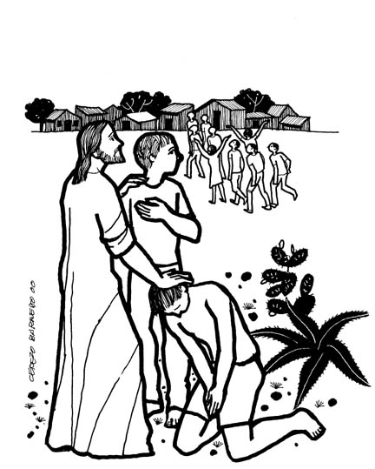

The Eighteenth Sunday after Pentecost

Sunday, October 9th, 2022
137-28 244th street,
Rosedale NY 11422
www.STPETERSROSEDALE.ORG
The Very Rev. Steve Foster – Rector

Saint Peter’s Church is a place of faith, hope, and love serving all of God’s people.
Saint Peter’s Episcopal Church
Mission Statement, Vision Statement, and Core Values
Mission Statement
Saint Peter’s Church is a place of faith, hope, and love serving all of God’s people.
Vision Statement
Saint Peter’s is a lighthouse of Faith, Hope, and God’s Love. Worship, prayer, Christian education, stewardship, fellowship, evangelism, and outreach.
Framing Passage: Ephesians 4:13-16
13 Until we all reach unity in the faith and the knowledge of the Son of God and become mature, attaining the whole measure of the fullness of Christ. 14 Then we will no longer be infants, tossed back and forth by the waves, and blown here and there by every wind of teaching and by the cunning and craftiness of people in their deceitful scheming. 15 Instead, speaking the truth in love, we will grow to become in every respect the mature body of him who is the head, that is, Christ. 16 From him, the whole body, joined and held together by every supporting ligament, grows and builds itself up in love, as each part does its work.

Core values
Called to grow and live by faith
Being committed to lifelong learning and study translates into putting what we believe into practice through our daily witness, sharing the good news of God in Christ.
Challenged to be hopeful
Being bearers of hope to each other and the surrounding communities urges us to advocate for justice and peace in the spirit of compassion and mercy.
Commissioned to love
Being agents of God’s redemptive and transforming love demands us to see the imprint of Christ on each other’s faces. Thus, respecting the dignity of every human being is paramount. You are welcome wherever you are, in life or on your faith journey. You are loved, affirmed, and respected as a beloved child of God.
Committed to Service
It is committed to serving together to build up the Body of Christ in God’s community.

Liturgy of the Word
Introit Praise, my soul, the King of heaven The Hymnal 1940 #282
1 | Praise, my soul, the King of heaven;
 | to his feet thy tribute bring;
 | ransomed, healed, restored, forgiven,
 | evermore his praises sing:
 | Alleluia, alleluia!
 | Praise the everlasting King.
2 | Praise him for his grace and favor
 | to his people in distress;
 | praise him still the same as ever,
 | slow to chide, and swift to bless:
 | Alleluia, alleluia!
 | Glorious in this faithfulness.
3 | Father-like he tends and spares us;
 | well our feeble frame he knows;
 | in his hand he gently bears us,
 | rescues us from all our foes.
 | Alleluia, alleluia!
 | Widely yet his mercy flows.
4 | Angels, help us to adore him;
 | ye behold him face to face;
 | sun and moon, bow down before him,
 | dwellers all in time and space.
 | Alleluia, alleluia!
 | Praise with us the God of grace.

The Celebrant says
Blessed Be God, Father, Son, and Holy Spirit.
People And Blessed be his kingdom, now and for ever. Amen

Almighty God, to you all hearts are open, all desires known, and from you no secrets are hid: Cleanse the thoughts of our hearts by the inspiration of your Holy Spirit, that we may perfectly love you, and worthily magnify your holy Name; through Christ our Lord. Amen
The following is sung
Gloria in Excelsis
Glory to God in the highest, and peace to his people on earth. Lord God, heavenly King, almighty God and Father, we worship you, we give you thanks, we praise you for your glory. Lord Jesus Christ, only Son of the Father, Lord God, Lamb of God, you take away the sin of the world: have mercy on us; you are seated at the right hand of the Father: receive our prayer. For you alone are the Holy One, you alone are the Lord, you alone are the Most High, Jesus Christ, with the Holy Spirit, in the glory of God the Father. Amen.

Collect of the Day
Celebrant The Lord be with you.
People And also with you.
Celebrant Let us pray.

Lord, we pray that your grace may always precede and follow us, that we may continually be given to good works; through Jesus Christ our Lord, who lives and reigns with you and the Holy Spirit, one God, now and for ever. Amen.

The Readings
First Reading Jeremiah 29:1, 4-7

A Reading from the Book of Jeremiah

These are the words of the letter that the prophet Jeremiah sent from Jerusalem to the remaining elders among the exiles, and to the priests, the prophets, and all the people, whom Nebuchadnezzar had taken into exile from Jerusalem to Babylon. Thus says the Lord of hosts, the God of Israel, to all the exiles whom I have sent into exile from Jerusalem to Babylon: ⁵Build houses and live in them; plant gardens and eat what they produce. Take wives and have sons and daughters; take wives for your sons, and give your daughters in marriage, that they may bear sons and daughters; multiply there, and do not decrease. But seek the welfare of the city where I have sent you into exile, and pray to the Lord on its behalf, for in its welfare you will find your welfare.

- The Word of the Lord.
- Thanks be to God.

Silence

THE GRADUAL Psalm 66:1-11

Antiphon: Be joyful in God all you lands
Be joyful in God, all you lands; sing the glory of his Name; sing the glory of his praise. Say to God, "How awesome are your deeds! because of your great strength your enemies cringe before you. All the earth bows down before you, sings to you, sings out your Name."
Antiphon: Be joyful in God all you lands
Come now and see the works of God, how wonderful he is in his doing toward all
people. He turned the sea into dry land, so that they went through the water on foot,
and there we rejoiced in him. In his might he rules for ever; his eyes keep watch over
the nations; let no rebel rise up against him.
Antiphon: Be joyful in God all you lands

Bless our God, you peoples; make the voice of his praise to be heard; Who holds our
souls in life, and will not allow our feet to slip. For you, O God, have proved us; you
have tried us just as silver is tried.
Antiphon: Be joyful in God all you lands
You brought us into the snare; you laid heavy burdens upon our backs. You let
enemies ride over our heads; we went through fire and water; but you brought us out
into a place of refreshment.
Antiphon: Be joyful in God all you lands
Silence

Second Reading 2 Timothy 2:8-15

THE EPISTLE: A Reading from the Second Letter of blessed Apostle Paul to Timothy
Remember Jesus Christ, raised from the dead, a descendant of David—that is my gospel, for which I suffer hardship, even to the point of being chained like a criminal. But the word of God is not chained. Therefore I endure everything for the sake of the elect, so that they may also obtain the salvation that is in Christ Jesus, with eternal glory. The saying is sure: If we have died with him, we will also live with him; if we endure, we will also reign with him; if we deny him, he will also deny us; if we are faithless, he remains faithful—for he cannot deny himself. Remind them of this, and warn them before God* that they are to avoid wrangling over words, which does no good but only ruins those who are listening. Do your best to present yourself to God as one approved by him, a worker who has no need to be ashamed, rightly explaining the word of truth.
V. The Word of the Lord.
R. Thanks be to God.

Silence

ALLELUIA:
Cantor: Alleluia
People: Alleluia
Cantor: If we have died with Christ, we shall also live with him
If we endure, we shall also reign with him.
People: Alleluia
THE HOLY GOSPEL: Luke 17:11-19
V. The Holy Gospel of Our Lord Jesus Christ According to Saint Luke
R. Glory to you, Lord Christ.

On the way to Jerusalem Jesus was going through the region between Samaria and Galilee. As he entered a village, ten lepers approached him. Keeping their distance, they called out, saying, “Jesus, Master, have mercy on us!” When he saw them, he said to them, “Go and show yourselves to the priests.” And as they went, they were made clean. Then one of them, when he saw that he was healed, turned back, praising God with a loud voice. He prostrated himself at Jesus’ feet and thanked him. And he was a Samaritan. Then Jesus asked, “Were not ten made clean? But the other nine, where are they? Was none of them found to return and give praise to God except this foreigner?” Then he said to him, “Get up and go on your way; your faith has made you well.”

V. The Gospel of the Lord.
R. Praise to you, Lord Christ.

Sermon Fr. Foster

Silence and listen for God speaking to you.

Sermon Notes

Nicene Creed
We believe in one God, the Father, the Almighty, maker of heaven and earth, of all that is, seen and unseen. We believe in one Lord, Jesus Christ, the only Son of God, eternally begotten of the Father, God from God, Light from Light, true God from true God, begotten, not made, of one Being with the Father. Through him all things were made. For us and for our salvation he came down from heaven: by the power of the Holy Spirit he became incarnate from the Virgin Mary and was made man. For our sake he was crucified under Pontius Pilate; he suffered death and was buried. On the third day he rose again in accordance with the Scriptures; he ascended into heaven and is seated at the right hand of the Father. He will come again in glory to judge the living and the dead, and his kingdom will have no end. We believe in the Holy Spirit, the Lord, the giver of life, who proceeds from the Father and the Son. With the Father and the Son, he is worshiped and glorified. He has spoken through the Prophets. We believe in one holy catholic and apostolic Church. We acknowledge one baptism for the forgiveness of sins. We look for the resurrection of the dead, and the life of the world to come. Amen.

Prayers of the People
Celebrant: Knowing God’s love and concern for us all, let us settle ourselves in his
presence and pray to him now.

Leader: Let us pray to God who loves us, knows our needs, and provides for us.

Holy and Mighty God, how wonderful is all your creation; we give you thanks and praise for all you have given to us. We pray for the work of the church among the scorned and rejected, among those who are not easily socially acceptable. We pray for the church’s work among those suffering from leprosy, among those with AIDS, and among all of whom society is afraid of or scornful. We pray for Christians who work in dangerous or lonely places; we remember those who suffer persecution for their faith. Lord, you are our hope. We put our trust in you.

We pray for downtown areas of cities, for areas of deprivation, and for places looked on as ghettos. We pray for all who are not allowed a fair chance in life because of where they come from or because of their looks. We remember all areas where there is prejudice and hostility, all places of ethnic fear and animosity. Lord, you are our hope. We put our trust in you.

We give thanks for those who have accepted us as we are, and we pray for our friends and our loved ones, that our communities may be places of peace and mutual love, and that all may learn respect for all peoples. We remember all those who feel rejected and unloved. Lord, you are our hope. We put our trust in you.

We pray for all who have been disfigured through accident or illness. We remember those who suffer through the cruelty and thoughtlessness of others. We pray for all who are working with people with contagious diseases. We remember friends and loved ones who are ill at this time. We pray especially for those on our sick and shut-in list, those whom you carry in the silence of your hearts, and those known and unknown to us. Lord, you are our hope. We put our trust in you.

We pray in this moment of the COVID-19 pandemic for peace and healing. We pray for all who are infected, affected or displaced. We remember all who are ill or those who recovered. We pray also for their loved ones in this time of anxiety. We pray and give thanks for the essential workers, as they continue to risk themselves to serve fellow humanity. We pray for all who are engaged in research and scientific discovery for a vaccine and cure for the coronavirus and its mutations. Lord, in these growing days, we are faced with monkeypox, polio, and other diseases, Lord, we seek your guidance and protection. Guide those in medicine and research to find cures for healing and wholeness. Lord, you are our hope. We put our trust in you.

We give thanks that you heal and renew your people. We pray for loved ones who have been changed into glory, remembering especially today Mathilda Galloway, Olivet Thomas, those who perished as a result of Hurricane Ian, flooding in Pakistan, or any other natural disaster or gun violence, or war. Lord, you are our hope. We put our trust in you.

Almighty God, whose power is revealed in our weakness, and whose grace meets our every need; we give you thanks for your healing and your love and pray you will guide us always to keep our hope and our trust in you through Jesus Christ our Lord, who is alive and reigns with you and the Holy Spirit, one God, world without end. Amen.

Confession of Sin
The Celebrant says
Jesus said, “The first commandment is this: Hear, O Israel: The Lord our God is the only Lord. Love the Lord your God with all your heart, with all your soul, with all your mind, and with all your strength. The second is this: Love your neighbor as yourself. There is no other commandment greater than these.” Mark 12:29-31
The Celebrant then says
Let us confess our sins against God and our neighbor.
Silence
Celebrant and People
Most merciful God, we confess that we have sinned against you in thought, word, and deed, by what we have done, and by what we have left undone. We have not loved you with our whole heart; we have not loved our neighbors as ourselves. We are truly sorry and we humbly repent. For the sake of your Son Jesus Christ, have mercy on us and forgive us; that we may delight in your will, and walk in your ways, to the glory of your Name. Amen.

The Celebrant says
Almighty God, have mercy on you, forgive you all your sins through our Lord Jesus Christ, strengthen you in all goodness, and by the power of the Holy Spirit, keep you in eternal life. Amen.

Peace
Celebrant The Lord is your strength and your salvation,
People in him alone is wholeness and peace.
Celebrant The peace of the Lord be always with you.
People And also with you.

Welcome & Announcements
Welcome to all who are worshipping at St. Peter’s for the first time. It is a delight and a joy to welcome you. If you are curious and have come to see, Welcome. If you are hurting and have come for solace. Welcome. If you are grateful and have come to share. Welcome. If you are weary and heavy burdened, Welcome. If you are tired and need respite, Welcome. If you are seeking and looking for answers, welcome. If you are listening and have come to pray, Welcome. If you want just to be; Welcome. Whatever reason has brought you to these doors, Welcome. God loves you and so does this parish community. Welcome.
Offertory Sentences – Walk in love as Christ loved us and gave himself for us, a fragrant offering and sacrifice to God.
Offertory Hymn Thine arm, O Lord, in days of old The Hymnal 1940 #517
1 | Thine arm, O Lord, in days of old
 | was strong to heal and save;
 | it triumphed o’er disease and death,
 | o’er darkness and the grave.
 | To thee they went, the blind, the deaf,
 | the palsied, and the lame,
 | the leper set apart and shunned,
 | the sick with fevered frame.
2 | And lo! thy touch brought life and health,
 | gave hearing, strength, and sight;
 | and youth renewed and frenzy calmed
 | owned thee, the Lord of light:
 | and now, O Lord, be near to bless,
 | almighty as of yore,
 | in crowded street, by restless couch,
 | as by Gennesaret’s shore.
3 | Be thou our great deliverer still,
 | thou Lord of life and death;
 | restore and quicken, soothe and bless,
 | with thine almighty breath:
 | to hands that work and eyes that see,
 | give wisdom’s heavenly lore,
 | that whole and sick, and weak and strong,
 | may praise thee evermore.

The HOLY EUCHARIST - Prayer A

The Lord be with you.
People | And also with you.
Celebrant | Lift up your hearts.
People | We lift them to the Lord.
Celebrant | Let us give thanks to the Lord our God.
People | It is right to give him thanks and praise.
It is right, and a good and joyful thing, always and everywhere, to give thanks to you, Father Almighty, Creator of heaven and earth. Through Jesus Christ our Lord; who on the first day of the week overcame death and the grave, and by his glorious resurrection opened to us the way of everlasting life. Therefore, we praise you, joining our voices with Angels and Archangels and with all the company of heaven, who for ever sing this hymn to proclaim the glory of your Name:
Celebrant and People
Holy, Holy, Holy Lord, God of power and might, heaven and earth are full of your glory. Hosanna in the highest. Blessed is he who comes in the name of the Lord. Hosanna in the highest.
The people stand or kneel.
The Celebrant continues
Holy and gracious Father: In your infinite love, you made us for yourself; and, when we had fallen into sin and become subject to evil and death, you, in your mercy, sent Jesus Christ, your only and eternal Son, to share our human nature, to live and die as one of us, to reconcile us to you, the God and Father of all. He stretched out his arms upon the cross, and offered himself in obedience to your will, a perfect sacrifice for the whole world.
At the following words concerning the bread, the Celebrant is to hold it or lay a hand upon it; and at the words concerning the cup, to hold or place a hand upon the cup and any other vessel containing wine to be consecrated.
On the night he was handed over to suffering and death, our Lord Jesus Christ took bread; and when he had given thanks to you, he broke it, and gave it to his disciples, and said, “Take, eat: This is my Body, which is given for you. Do this for the remembrance of me.”
After supper he took the cup of wine; and when he had given thanks, he gave it to them, and said, “Drink this, all of you: This is my Blood of the new Covenant, which is shed for you and for many for the forgiveness of sins. Whenever you drink it, do this for the remembrance of me.”
Therefore, we proclaim the mystery of faith:
Celebrant and People
Christ has died. Christ is risen. Christ will come again.
The Celebrant continues
We celebrate the memorial of our redemption, O Father, in this sacrifice of praise and thanksgiving. Recalling his death, resurrection, and ascension, we offer you these gifts. Sanctify them by your Holy Spirit to be for your people the Body and Blood of your Son, the holy food and drink of new and unending life in him. Sanctify us also that we may faithfully receive this holy Sacrament, and serve you in unity, constancy, and peace; and at the last day bring us with all your saints into the joy of your eternal kingdom. All this we ask through your Son Jesus Christ. By him, and with him, and in him, in the unity of the Holy Spirit all honor and glory is yours, Almighty Father, now and for ever. AMEN
The Celebrant then continues
The Celebrant then continues

The Lord’s Prayer
As our Savior Christ has taught us, we now pray,

People and Celebrant
Our Father in heaven, hallowed be your Name, your kingdom come, your will be done, on earth as in heaven. Give us today our daily bread. Forgive us our sins as we
forgive those who sin against us. Save us from the time of trial and deliver us from
evil. For the kingdom, the power, and the glory are yours, now and forever. Amen.
The Breaking of the Bread
The Celebrant breaks the consecrated Bread.
A period of silence is kept.
Celebrant says
Alleluia. Christ our Passover is sacrificed for us;
Therefore let us keep the feast. Alleluia.
Facing the people, the Celebrant says the following Invitation.
The Gifts of God for the People of God.
Communion Hymns
Wade in the water WLP 740
 | Wade in the water, wade in the water, children,
 | Wade in the water, God’s a-gonna trouble the water.
1 | See that host all dressed in white,
 | God’s a-gonna trouble the water.
 | The leader looks like the Israelite,
 | God’s a-gonna trouble the water.
 | Refrain
2 | See that band all dressed in red,
 | God’s a-gonna trouble the water.
 | Looks like the band that Moses led,
 | God’s a-gonna trouble the water.
 | Refrain
3 | Look over yonder, what do I see?
 | God’s a-gonna trouble the water.
 | The Holy Ghost a-coming on me,
 | God’s a-gonna trouble the water.
 | Refrain
4 | If you don’t believe I’ve been redeemed,
 | God’s a-gonna trouble the water.
 | Just follow me down to Jordan’s stream,
 | God’s a-gonna trouble the water.
 | Refrain

No saint on earth lives life to self alone WLP 776
1 | No saint on earth lives life to self alone
 | or dies alone, for we with Christ are one.
 | So if we live, for Christ alone we live,
 | and if we die, to Christ our dying give.
 | In living and in dying this confess:
 | we are the Lord’s, safe in God’s faithfulness.
2 | For to this end our Lord by death was slain,
 | that to new life he might arise again.
 | Through sorrow on to triumph Christ has led,
 | and reigns o’er all: the living and the dead.
 | In living and in dying, him we bless.
 | We are the Lord’s, safe in God’s faithfulness.

Post-Communion Prayer
Eternal God, heavenly Father, you have graciously accepted us as living members of your Son our Savior Jesus Christ, and you have fed us with spiritual food in the Sacrament of his Body and Blood. Send us now into the world in peace, and grant us strength and courage to love and serve you with gladness and singleness of heart; through Christ our Lord. Amen.

The Blessing
We have laid our burdens down in the presence of the living God. Amen
We have been nourished for our journey in the presence of the living God. Amen
We have taken on the armor of Christ in the presence of the living God. Amen
Now lead us, guide us, defend us, as we go into your world in your name for your sake, O loving, living God. Amen.
The blessing of God Almighty, + the Father, the Son, and the Holy Spirit, be upon you and remain with you for ever. Amen.
Let us go forth in the name of Christ.
People Thanks be to God.

Recessional Now thank we all our God The Hymnal 1940 #276
1 | Now thank we all our God,
 | with heart, and hands, and voices,
 | who wondrous things hath done,
 | in whom his world rejoices;
 | who from our mother’s arms
 | hath blessed us on our way
 | with countless gifts of love,
 | and still is ours today.
2 | O may this bounteous God
 | through all our life be near us!
 | With ever-joyful hearts
 | and blessed peace to cheer us;
 | and keep us in his grace,
 | and guide us when perplexed,
 | and free us from all ills
 | in this world and the next.
3 | All praise and thanks to God
 | the Father now be given,
 | the Son, and him who reigns
 | with them in highest heaven,
 | eternal, Triune God,
 | whom earth and heaven adore;
 | for thus it was, is now,
 | and shall be, evermore.

ANNOUNCEMENTS for the Week of 10/09/2022
Schedule for the week of October 9th through October 15th

Sunday, October 9th The Eighteenth Sunday after Pentecost
Holy Eucharist - 8:00 & 10:00 AM
Ministry Fair

Monday, October 10th Columbus Day - Office closed

Saturday, October 15th Young Adults Walk – Making Strides Against Breast Cancer
Food Pantry 11:00 AM – 1:00 PM

Sunday, October 16th, The Nineteenth Sunday after Pentecost,
Holy Eucharist – 8:00 AM and 10:00 AM
Healing Mass @ 8:00 AM & 10:00 AM

Announcements
The St. Peter’s Library team will be conducting a survey on Sunday, October 16, 2022, after the 8:00 & 10:00 o’clock mass. This brief survey is open to all members. Everyone is encouraged to participate.

The Rector, Wardens, Vestry, and St. Peter’s Church family, extend heartfelt condolences to the following persons on the deaths of their beloved ones.
Ms. Pamela Michael and family on the passing of her dear friend and goddaughter’s mother Olivet Thomas. May she rest in peace.
The Galloway family on the passing of Mathilda Galloway, 102 years, eldest sister of the late Diana Galloway. May they rest in peace.

Confirmation class begins October 15th, 2022. Please submit names and see the Rector for application.

Winter coat drive. Please bring in your gently used coats and place them in the boxes provided in the parish hall. Donations will run until November 13th.

Please submit the names of your family and friends for the All-Souls commemoration.

STEWARDSHIP CORNER
To date we received 88 pledge cards for 2022 totaling $211, 195. The Vestry has
pledged $50, 209 toward the work of St. Peter’s Rosedale.

We have been blessed with more than enough – what are we tithing? What are we giving? How is our stewardship?
Corporate giving is no longer about signing fat checks, public preening, and charity balls, says Jeff Skoll, vice president of strategic planning and analysis for eBay Inc. “Young, ‘newly minted’ givers anticipate seeing the effects of their gifts within their lifetimes and want a more hands-on role,” he says. For example, Ken Blanchard, coauthor of How to Make Serious Money for Both You and Your Company, says, “We tithe 10 percent of our profit. . . . We divide it among all our employees to give away. The lowest-paid employee gets to give $1,000 away, and the highest gets to give $3,500. We gave to 160 charities last year.”
The results of this personalized giving are touching. “A guy in shipping came up to me with tears in his eyes,” Blanchard said. “He got the chance to give $1,000 to his parish to buy robes for the choir. He’s become a local hero.”
— Lorenzo Della Foresta, “Twenty-first Century Giving,” PreachingToday.com
St Peter’s Episcopal Church is now on AmazonSmile.

Would you like to support St Peter’s Episcopal Church when you shop online?

AmazonSmile is a simple way for you to support St Peter’s Episcopal Church every time you shop online, at no additional cost to you. When you shop at smile.amazon.com, you will find the same low prices, vast selection, and convenient shopping experience as Amazon.com, with the bonus that Amazon will donate a portion of the purchase price to St Peter’s Episcopal Church.

To shop at AmazonSmile, go to smile.amazon.com on the internet. If you already have an account at Amazon, you can use the same account. You do not have to set up a new account. Your shopping cart, wish list, and account settings are all the same.

The first time you visit AmazonSmile (smile.amazon.com), you will be prompted to select a charitable organization from among the eligible organizations. To browse or shop at AmazonSmile, you must first select a charitable organization. Please type “St Peter’s Episcopal Church” as your supporting charity.

There are millions of products for sale on AmazonSmile that are eligible for donations to St Peter’s Episcopal Church. Eligible products are marked “Eligible for AmazonSmile donation” on the product detail pages. For each eligible purchase you make at AmazonSmile, the AmazonSmile Foundation will donate 0.5% of the purchase price to your selected charitable organization, St Peter’s Episcopal Church.

Please note that recurring subscribe-and-save purchases and subscription renewals are not eligible for donation.
Thank you in advance for listing and remembering the St Peter’s Episcopal Church when shopping online.

Travel and Educational Experiences 2023- 2024
- Morocco 2023:
14-Day – Enchanting Tour May 22, 2023 – June 4, 2023
- Civil Rights Trail 2023- Atlanta, Alabama, and New Orleans
August 1, 2023, To August 9, 2023
- 2024 Western Mediterranean Cruise Destination
July 23 to August 2, 2024

St. Peter’s Summer Calendar

OCTOBER
2 HARVEST SUNDAY
2 Nigeria’s Anniversary of Independence Anniversary
8 Harvest Supper 4:00PM
9 Ministry Fair
10 Columbus Day
15 Young Adults Walk – Making Strides against Breast Cancer
16 Healing Mass @ 8:00 AM & 10:00 AM
16 Legal Eagles presentation
18 ST. LUKE, EVANGELIST - Mass 10:00AM
22 St. Peter’s Day @ the shelter
23 Winter Coats and Clothing Drive begins
24 ST. JAMES OF JERUSALEM – Mass 10:00AM (Trans.)
28 ST. SIMON AND ST, JUDE, APOSTLES – Mass 10:00AM
29 Spiritual Day - Daughters of St. Peters – Prayer Breakfast

NOVEMBER
1 All Saints Day – Mass @ 10:00 AM
2 All Souls Day – Mass @ 10:00 AM
5 Whine and Wings – 6:00PM
6 All Saints Sunday Mass @ 8:00 AM & 10:00 AM
6 Men’s corporate communion & brunch
6 All Souls – Commemoration of the faithful Departed @ 4:00 PM
11 Veterans Day
12 Community walk
13 Mass and Veterans Recognition – 10:00 AM
18 Annual Dinner Dance
19 Distribution of Thanksgiving Baskets
20 COMMITMENT SUNDAY
24 Thanksgiving Day Mass @ 9:00 AM & Brunch
27 FIRST SUNDAY OF ADVENT
27 Barbados Independence Celebration

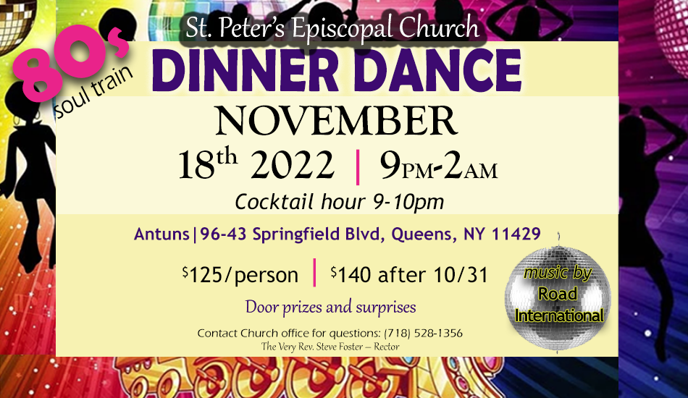

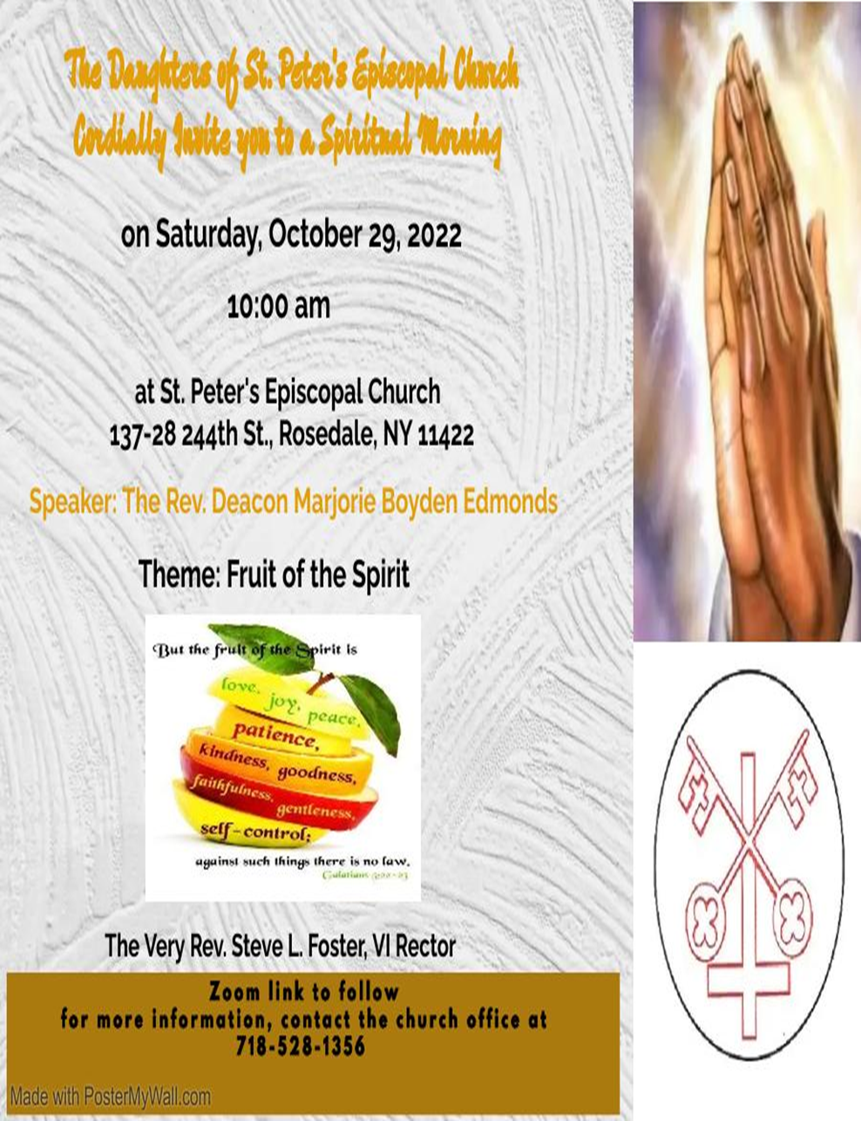

St. Peter’s Church Rosedale
Staff
Mr. Carl Hampden – Sexton
Mr. Eiichi Shimada - Organist, and Choir Director
Ms. Dianne A. Worley – Parish Administrator
The Very Rev. Steve Foster – Rector

Vestry
Mrs. Phyllis Harris Williams – Warden
Mrs. Yvonne Robinson – Warden
Mrs. Lamarcia Parkin Bascombe – Clerk of the Vestry
Mrs. Karen Mayne Lee – Assistant Treasurer
Mrs. Cynthia Craig – Member
Mrs. Sandra George – Member
Mrs. Monica Carrington - Member
Mrs. Gail Adams – Member
Mr. Michael Prescod – Member
Ms. Elaine Henry – Member
Ms. Shadiyah Evans – Member
Mr. Richard Connell – Treasurer

