St. Peter’s Episcopal Church

The Nineteenth Sunday after Pentecost

Proper 23

Sunday, October 16^{h}, 2022
137-28 244th street,
Rosedale NY 11422
www.STPETERSROSEDALE.ORG
The Very Rev. Steve Foster – Rector

Saint Peter’s Church is a place of faith, hope, and love serving all of God’s people.
Saint Peter’s Episcopal Church
Mission Statement, Vision Statement, and Core Values
Mission Statement
Saint Peter’s Church is a place of faith, hope, and love serving all of God’s people.
Vision Statement
Saint Peter’s is a lighthouse of Faith, Hope, and God’s Love. Worship, prayer, Christian education, stewardship, fellowship, evangelism, and outreach.
Framing Passage: Ephesians 4:13-16
13 Until we all reach unity in the faith and the knowledge of the Son of God and become mature, attaining the whole measure of the fullness of Christ. 14 Then we will no longer be infants, tossed back and forth by the waves, and blown here and there by every wind of teaching and by the cunning and craftiness of people in their deceitful scheming. 15 Instead, speaking the truth in love, we will grow to become in every respect the mature body of him who is the head, that is, Christ. 16 From him, the whole body, joined and held together by every supporting ligament, grows and builds itself up in love, as each part does its work.

Core values
Called to grow and live by faith
Being committed to lifelong learning and study translates into putting what we believe into practice through our daily witness, sharing the good news of God in Christ.
Challenged to be hopeful
Being bearers of hope to each other and the surrounding communities urges us to advocate for justice and peace in the spirit of compassion and mercy.
Commissioned to love
Being agents of God’s redemptive and transforming love demands us to see the imprint of Christ on each other’s faces. Thus, respecting the dignity of every human being is paramount. You are welcome wherever you are, in life or on your faith journey. You are loved, affirmed, and respected as a beloved child of God.
Committed to Service
It is committed to serving together to build up the Body of Christ in God’s community.

Liturgy of the Word
Introit Praise to the living God The Hymnal 1982 #372
1 | Praise to the living God!
 | All praisèd be his Name
 | who was, and is, and is to be
 | for ay the same.
 | The one eternal God
 | ere aught that now appears:
 | the first, the last, beyond all thought
 | his timeless years!
2 | Formless, all lovely forms
 | declare his loveliness;
 | holy, no holiness of earth
 | can his express.
 | Lo, he is Lord of all.
 | Creation speaks his praise,
 | and everywhere above, below,
 | his will obeys.
3 | His Spirit floweth free,
 | high surging where it will:
 | in prophet’s word he spoke of old;
 | he speaketh still.
 | Established is his law,
 | and changeless it shall stand,
 | deep writ upon the human heart,
 | on sea, on land.
4 | Eternal life hath he
 | implanted in the soul;
 | his love shall be our strength and stay
 | while ages roll.
 | Praise to the living God!
 | All praisèd be his Name
 | who was, and is, and is to be,
 | for ay the same.

The Celebrant says
Blessed Be God, Father, Son, and Holy Spirit.
People And Blessed be his kingdom, now and for ever. Amen

Almighty God, to you all hearts are open, all desires known, and from you no secrets are hid: Cleanse the thoughts of our hearts by the inspiration of your Holy Spirit, that we may perfectly love you, and worthily magnify your holy Name; through Christ our Lord. Amen
The following is sung
Gloria in Excelsis
Glory to God in the highest, and peace to his people on earth. Lord God, heavenly King, almighty God and Father, we worship you, we give you thanks, we praise you for your glory. Lord Jesus Christ, only Son of the Father, Lord God, Lamb of God, you take away the sin of the world: have mercy on us; you are seated at the right hand of the Father: receive our prayer. For you alone are the Holy One, you alone are the Lord, you alone are the Most High, Jesus Christ, with the Holy Spirit, in the glory of God the Father. Amen.

Collect of the Day
Celebrant The Lord be with you.
People And also with you.
Celebrant Let us pray.
Almighty and everlasting God, in Christ you have revealed your glory among the nations: Preserve the works of your mercy, that your Church throughout the world may persevere with steadfast faith in the confession of your Name; through Jesus Christ our Lord, who lives and reigns with you and the Holy Spirit, one God, for ever and ever. Amen.

The Readings
First Reading Jeremiah 31:27-34

A Reading from the Book of the Prophet Jeremiah
The days are surely coming, says the Lord, when I will sow the house of Israel and the house of Judah with the seed of humans and the seed of animals. And just as I have watched over them to pluck up and break down, to overthrow, destroy, and bring evil, so I will watch over them to build and to plant, says the Lord. In those days they shall no longer say: The parents have eaten sour grapes, and the children’s teeth are set on edge.
But all shall die for their own sins; the teeth of everyone who eats sour grapes shall be set on edge. The days are surely coming, says the Lord, when I will make a new covenant with the house of Israel and the house of Judah. It will not be like the covenant that I made with their ancestors when I took them by the hand to bring them out of the land of Egypt—a covenant that they broke, though I was their husband, says the Lord. But this is the covenant that I will make with the house of Israel after those days, says the Lord: I will put my law within them, and I will write it on their hearts; and I will be their God, and they shall be my people. No longer shall they teach one another, or say to each other, ‘Know the Lord’, for they shall all know me, from the least of them to the greatest, says the Lord; for I will forgive their iniquity, and remember their sin no more.

- The Word of the Lord.
- Thanks be to God.

Silence

THE GRADUAL Psalm 119:97-104

Antiphon: Your Word is ever with me, O God.

Oh, how I love your law! all the day long it is in my mind. Your commandment has made me wiser than my enemies, and it is always with me. I have more understanding than all my teachers, for your decrees are my study.
Antiphon: Your Word is ever with me, O God.

I am wiser than the elders, because I observe your commandments. I restrain my feet from every evil way, that I may keep your word. I do not shrink from your judgments, because you yourself have taught me.
Antiphon: Your Word is ever with me, O God.

How sweet are your words to my taste! they are sweeter than honey to my mouth.
Through your commandments I gain understanding; therefore I hate every lying way.
Antiphon: Your Word is ever with me, O God.

Silence

Second Reading 2 Timothy 3:14-4:5

THE EPISTLE: A Reading from the Second Letter of blessed Apostle Paul to Timothy
As for you, continue in what you have learned and firmly believed, knowing from whom you learned it, and how from childhood you have known the sacred writings that are able to instruct you for salvation through faith in Christ Jesus. All scripture is inspired by God and is useful for teaching, for reproof, for correction, and for training in righteousness, so that everyone who belongs to God may be proficient, equipped for every good work. In the presence of God and of Christ Jesus, who is to judge the living and the dead, and in view of his appearing and his kingdom, I solemnly urge you: proclaim the message; be persistent whether the time is favourable or unfavourable; convince, rebuke, and encourage, with the utmost patience in teaching. For the time is coming when people will not put up with sound doctrine, but having itching ears, they will accumulate for themselves teachers to suit their own desires, and will turn away from listening to the truth and wander away to myths. As for you, always be sober, endure suffering, do the work of an evangelist, carry out your ministry fully.
V. The Word of the Lord.
R. Thanks be to God.

Silence

ALLELUIA:
Cantor: Alleluia
People: Alleluia
Cantor: Continue in what you have learned and have firmly believed,
For salvation through faith in Christ Jesus.
People: Alleluia
THE HOLY GOSPEL: Luke 18:1-8
V. The Holy Gospel of Our Lord Jesus Christ According to Saint Luke
R. Glory to you, Lord Christ.
Then Jesus told them a parable about their need to pray always and not to lose heart. He said, ‘In a certain city there was a judge who neither feared God nor had respect for people. In that city there was a widow who kept coming to him and saying, “Grant me justice against my opponent.” For a while he refused; but later he said to himself, “Though I have no fear of God and no respect for anyone, yet because this widow keeps bothering me, I will grant her justice, so that she may not wear me out by continually coming.” And the Lord said, ‘Listen to what the unjust judge says. ⁷And will not God grant justice to his chosen ones who cry to him day and night? Will he delay long in helping them? I tell you, he will quickly grant justice to them. And yet, when the Son of Man comes, will he find faith on earth?’

V. The Gospel of the Lord.
R. Praise to you, Lord Christ.

Sermon Fr. Foster

Silence and listen for God speaking to you.

Sermon Notes

Nicene Creed
We believe in one God, the Father, the Almighty, maker of heaven and earth, of all that is, seen and unseen. We believe in one Lord, Jesus Christ, the only Son of God, eternally begotten of the Father, God from God, Light from Light, true God from true God, begotten, not made, of one Being with the Father. Through him all things were made. For us and for our salvation he came down from heaven: by the power of the Holy Spirit he became incarnate from the Virgin Mary and was made man. For our sake he was crucified under Pontius Pilate; he suffered death and was buried. On the third day he rose again in accordance with the Scriptures; he ascended into heaven and is seated at the right hand of the Father. He will come again in glory to judge the living and the dead, and his kingdom will have no end. We believe in the Holy Spirit, the Lord, the giver of life, who proceeds from the Father and the Son. With the Father and the Son, he is worshiped and glorified. He has spoken through the Prophets. We believe in one holy catholic and apostolic Church. We acknowledge one baptism for the forgiveness of sins. We look for the resurrection of the dead, and the life of the world to come. Amen.

Prayers of the People
Celebrant: Knowing God’s love and concern for us all, let us settle ourselves in his
presence and pray to him now.

Leader: Let us pray, with thanksgiving to God for all the blessings of this life.

Empower the church to be a refuge for all people, a beacon to all nations. Keep her ministers always ready to receive and comfort those who come to them for any kind of help. We pray for Justin, the Archbishop of Canterbury and leader of the Anglican Communion, Michael, our Presiding Bishop and Primate; Lawrence, our Bishop Diocesan; Geralyn, Daniel, and William, our bishops. Our Clergy; Gary, Dennison, Karen, Frederick, Keith, Ryan, Kassinda, Joshua, Bernice, Ephraim, Bernard, Mastine, Lloyd, Daryl, Charles, and Steve, the Jamaica Deanery and our St. Peter’s parish community. Lord, in your mercy, hear our prayer.

Bring reconciliation wherever there is a conflict between faiths and races; we pray in a special way for Ukraine and Russia conflict, in Jerusalem, Sudan, and Burkina Faso…. grant the spirit of peace, that none may be despised for their status or condition but all new drawn into a single harmony of life. Lord, in your mercy, hear our prayer.

We pray for our families, friends, and neighbors, for shared sympathy and mutual help…. make us duly thankful for all the benefits we have received, (you may offer to Almighty God thanks for your benefits,) bless and strengthen all who work for the abandoned and homeless in our community. Lord, in your mercy, hear our prayer.

We pray in this moment of the COVID-19 pandemic for peace and healing. We pray for all who are infected, affected or displaced. We remember all who are ill or those who recovered. We pray also for their loved ones in this time of anxiety. We pray and give thanks for the essential workers, as they continue to risk themselves to serve fellow humanity. We pray for all who are engaged in research and scientific discovery for a vaccine and cure for the coronavirus and its mutations. Lord, in these growing days, we are faced with monkeypox, polio, and other diseases, Lord, we seek your guidance and protection. Guide those in medicine and research to find cures for healing and wholeness. Lord in your mercy, hear our prayer.

Grant healing to the sick and skilled to those who work for them; we pray especially for those on our sick and shut-in list, those whom you carry in the silence of your hearts, and those known and unknown to us; repair particularly for those suffering from chronic illness and for those who are shunned because of their affliction. Lord, in your mercy, hear our prayer.

We pray for those who have come through tribulation and suffering in this world, to be made whole in heaven, in a special way, remember Julian Holder. Give to them an old departed the eternal life of the faithful. Lord, in your mercy, hear our prayer.

May our prayers be accepted in the name of Christ, the merciful Healer.

Confession of Sin
The Celebrant says
Jesus said, “The first commandment is this: Hear, O Israel: The Lord our God is the only Lord. Love the Lord your God with all your heart, with all your soul, with all your mind, and with all your strength. The second is this: Love your neighbor as yourself. There is no other commandment greater than these.” Mark 12:29-31
The Celebrant then says
Let us confess our sins against God and our neighbor.
Silence
Celebrant and People
Most merciful God, we confess that we have sinned against you in thought, word, and deed, by what we have done, and by what we have left undone. We have not loved you with our whole heart; we have not loved our neighbors as ourselves. We are truly sorry and we humbly repent. For the sake of your Son Jesus Christ, have mercy on us and forgive us; that we may delight in your will, and walk in your ways, to the glory of your Name. Amen.

The Celebrant says
Almighty God, have mercy on you, forgive you all your sins through our Lord Jesus Christ, strengthen you in all goodness, and by the power of the Holy Spirit, keep you in eternal life. Amen.

Peace
Celebrant The Lord is your strength and your salvation,
People in him alone is wholeness and peace.
Celebrant The peace of the Lord be always with you.
People And also with you.

Welcome & Announcements
Welcome to all who are worshipping at St. Peter’s for the first time. It is a delight and a joy to welcome you. If you are curious and have come to see, Welcome. If you are hurting and have come for solace. Welcome. If you are grateful and have come to share. Welcome. If you are weary and heavy burdened, Welcome. If you are tired and need respite, Welcome. If you are seeking and looking for answers, welcome. If you are listening and have come to pray, Welcome. If you want just to be; Welcome. Whatever reason has brought you to these doors, Welcome. God loves you and so does this parish community. Welcome.
Offertory Sentences – Walk in love as Christ loved us and gave himself for us, a fragrant offering and sacrifice to God.
Offertory Hymn O God of Bethel, by whose hand The Hymnal 1940 #497
1 | O God of Bethel, by whose hand
 | thy people still are fed;
 | who through this earthly pilgrimage
 | hast all thine Israel led:
2 | Our vows, our prayers, we now present
 | before thy throne of grace:
 | O God of Israel, be the God
 | of this succeeding race.
3 | Through each perplexing path of life
 | our wandering footsteps guide;
 | give us each day our daily bread,
 | and raiment fit provide.
4 | O spread thy sheltering wings around,
 | till all our wanderings cease,
 | and at our Father’s loved abode
 | our souls arrive in peace!
5 | Such blessings from thy gracious hand
 | our humble prayers implore;
 | and thou shalt be our covenant God
 | and portion evermore.
The HOLY EUCHARIST - Prayer A

The Lord be with you.
People |  | And also with you.
Celebrant |  | Lift up your hearts.
People |  | We lift them to the Lord.
Celebrant |  | Let us give thanks to the Lord our God.
People |  | It is right to give him thanks and praise.
It is right, and a good and joyful thing, always and everywhere, to give thanks to you, Father Almighty, Creator of heaven and earth. Through Jesus Christ our Lord; who on the first day of the week overcame death and the grave, and by his glorious resurrection opened to us the way of everlasting life. Therefore, we praise you, joining our voices with Angels and Archangels and with all the company of heaven, who for ever sing this hymn to proclaim the glory of your Name:
Celebrant and People
Holy, Holy, Holy Lord, God of power and might, heaven and earth are full of your glory. Hosanna in the highest. Blessed is he who comes in the name of the Lord. Hosanna in the highest.
The people stand or kneel.
The Celebrant continues
Holy and gracious Father: In your infinite love, you made us for yourself; and, when we had fallen into sin and become subject to evil and death, you, in your mercy, sent Jesus Christ, your only and eternal Son, to share our human nature, to live and die as one of us, to reconcile us to you, the God and Father of all. He stretched out his arms upon the cross, and offered himself in obedience to your will, a perfect sacrifice for the whole world.
At the following words concerning the bread, the Celebrant is to hold it or lay a hand upon it; and at the words concerning the cup, to hold or place a hand upon the cup and any other vessel containing wine to be consecrated.
On the night he was handed over to suffering and death, our Lord Jesus Christ took bread; and when he had given thanks to you, he broke it, and gave it to his disciples, and said, “Take, eat: This is my Body, which is given for you. Do this for the remembrance of me.”
After supper he took the cup of wine; and when he had given thanks, he gave it to them, and said, “Drink this, all of you: This is my Blood of the new Covenant, which is shed for you and for many for the forgiveness of sins. Whenever you drink it, do this for the remembrance of me.”
Therefore, we proclaim the mystery of faith:
Celebrant and People
Christ has died. Christ is risen. Christ will come again.
The Celebrant continues
We celebrate the memorial of our redemption, O Father, in this sacrifice of praise and thanksgiving. Recalling his death, resurrection, and ascension, we offer you these gifts. Sanctify them by your Holy Spirit to be for your people the Body and Blood of your Son, the holy food and drink of new and unending life in him. Sanctify us also that we may faithfully receive this holy Sacrament, and serve you in unity, constancy, and peace; and at the last day bring us with all your saints into the joy of your eternal kingdom. All this we ask through your Son Jesus Christ. By him, and with him, and in him, in the unity of the Holy Spirit all honor and glory is yours, Almighty Father, now and for ever. AMEN
The Celebrant then continues
The Celebrant then continues

The Lord’s Prayer
As our Savior Christ has taught us, we now pray,

People and Celebrant
Our Father in heaven, hallowed be your Name, your kingdom come, your will be done, on earth as in heaven. Give us today our daily bread. Forgive us our sins as we
forgive those who sin against us. Save us from the time of trial and deliver us from
evil. For the kingdom, the power, and the glory are yours, now and forever. Amen.
The Breaking of the Bread
The Celebrant breaks the consecrated Bread.
A period of silence is kept.
Celebrant says
Alleluia. Christ our Passover is sacrificed for us;
Therefore let us keep the feast. Alleluia.
Facing the people, the Celebrant says the following Invitation.
The Gifts of God for the People of God.
Communion Hymns
Standin’ in the Need of Prayer LEVAS 177
 | It’s me, it’s me, O Lord,
 | Standin’ in the need of prayer;
 | It’s me, it’s me, O Lord,
 | Standin’ in the need of prayer.
1 | Not my brother, not my sister, but it’s me, O Lord,
 | Standin’ in the need of prayer,
 | Refrain
2 | Not the preacher, not the deacon, but it’s me, O Lord,
 | Standin’ in the need of prayer,
 | Refrain
3 | Not my father, not my mother, but it’s me, O Lord,
 | Standin’ in the need of prayer,
 | Refrain
4 | Not the stranger, not my neighbor, but it’s me, O Lord,
 | Standin’ in the need of prayer,
 | Refrain

Sweet Hour of Prayer LEVAS 178
1 | Sweet hour of prayer, sweet hour of prayer,
 | That calls me from a world of care,
 | And bids me at my Father’s throne
 | Make all my wants and wishes known.
 | In seasons of distress and grief
 | My soul has often found relief.
 | And oft escaped the tempter’s snare
 | By thy return, sweet hour of prayer.
2 | Sweet hour of prayer, sweet hour of prayer,
 | Thy wings shall my petition bear
 | To Him whose truth and faithfulness
 | Engage the waiting soul to bless;
 | And since He bids me seek His face,
 | Believe His word and trust His grace.
 | I’ll cast on Him my ev’ry care,
 | And wait for thee, sweet hour of prayer.
3 | Sweet hour of prayer, sweet hour of prayer,
 | May I thy consolation share,
 | Till from Mount Pisgah’s lofty height
 | I view my home and take my flight:
 | This robe of flesh I’ll drop, and rise
 | To seize the everlasting prize.
 | And shout, while passing through the air,
 | “Farewell, farewell, sweet hour of prayer!”

Post-Communion Prayer
Eternal God, heavenly Father, you have graciously accepted us as living members of your Son our Savior Jesus Christ, and you have fed us with spiritual food in the Sacrament of his Body and Blood. Send us now into the world in peace, and grant us strength and courage to love and serve you with gladness and singleness of heart; through Christ our Lord. Amen.

The Blessing
We have laid our burdens down in the presence of the living God. Amen
We have been nourished for our journey in the presence of the living God. Amen
We have taken on the armor of Christ in the presence of the living God. Amen
Now lead us, guide us, defend us, as we go into your world in your name for your sake, O loving, living God. Amen.
The blessing of God Almighty, + the Father, the Son, and the Holy Spirit, be upon you and remain with you for ever. Amen.
Let us go forth in the name of Christ.
People Thanks be to God.

Recessional Spread, O spread, thou mighty word The Hymnal 1940 #253
1 | Spread, O spread, thou mighty word,
 | spread the kingdom of the Lord,
 | that to earth’s remotest bound
 | all may heed the joyful sound;
2 | word of how the Father’s will
 | made the world, and keeps it, still;
 | how his only Son he gave,
 | earth from sin and death to save;
3 | word of how the Savior’s love
 | earth’s sore burden doth remove;
 | how forever, in its need,
 | through his death the world is freed;
4 | word of how the Spirit came
 | bringing peace in Jesus’ name;
 | how his never-failing love
 | guides us on to heaven above.
5 | Word of life, most pure and strong,
 | word for which the nations long,
 | spread abroad, until from night
 | all the world awakes to light.

ANNOUNCEMENTS for the Week of 10/16/2022
Schedule for the week of October 16th through October 22nd

Sunday, October 16th The Nineteenth Sunday after Pentecost
Holy Eucharist - 8:00 & 10:00 AM
Legal Eagles Presentation

Monday, October 17th Office closed
Compline 9:00 PM

Tuesday, October 18th, ST. LUKE, EVANGELST – Mas 10:00 AM
Book Club @7: 30 PM Reading -The Promised Land
By Barack Obama

Saturday, October 22nd, St. Peter’s Day @ the Shelter
Food Pantry 11:00 AM – 1:00 PM

Sunday, October 23rd, The Twentieth Sunday after Pentecost,
Holy Eucharist – 8:00 AM and 10:00 AM
Laying on of Hands for Healing 8:00 & 10:00 AM

Announcements
The Rector, Wardens, Vestry, and the entire St. Peter’s church family, extend sincere condolences to Jacqueline Jones, on the passing of her brother
Julian Holder, in Guyana. May his soul and the souls of the faithful departed rest in peace and rise in glory.

The confirmation class began on October 15th, 2022. Please submit names and see the Rector for application.

Winter coats and clothing drive begins today. Please bring in your gently used coats and place them in the boxes provided in the parish hall. Donations will run until November 13th.

Please submit the names of your family and friends for the All-Souls
commemoration.

STEWARDSHIP CORNER
To date we received 88 pledge cards for 2022 totaling $211, 195. The Vestry has
pledged $50, 209 toward the work of St. Peter’s Rosedale.

We have been blessed with more than enough – what are we tithing? What are we giving? How is our stewardship?
Corporate giving is no longer about signing fat checks, public preening, and charity balls, says Jeff Skoll, vice president of strategic planning and analysis for eBay Inc. “Young, ‘newly minted’ givers anticipate seeing the effects of their gifts within their lifetimes and want a more hands-on role,” he says. For example, Ken Blanchard, coauthor of How to Make Serious Money for Both You and Your Company, says, “We tithe 10 percent of our profit. . . . We divide it among all our employees to give away. The lowest-paid employee gets to give $1,000 away, and the highest gets to give $3,500. We gave to 160 charities last year.”
The results of this personalized giving are touching. “A guy in shipping came up to me with tears in his eyes,” Blanchard said. “He got the chance to give $1,000 to his parish to buy robes for the choir. He’s become a local hero.”
— Lorenzo Della Foresta, “Twenty-first Century Giving,” PreachingToday.com
St Peter’s Episcopal Church is now on AmazonSmile.

Would you like to support St Peter’s Episcopal Church when you shop online?

AmazonSmile is a simple way for you to support St Peter’s Episcopal Church every time you shop online, at no additional cost to you. When you shop at smile.amazon.com, you will find the same low prices, vast selection, and convenient shopping experience as Amazon.com, with the bonus that Amazon will donate a portion of the purchase price to St Peter’s Episcopal Church.

To shop at AmazonSmile, go to smile.amazon.com on the internet. If you already have an account at Amazon, you can use the same account. You do not have to set up a new account. Your shopping cart, wish list, and account settings are all the same.

The first time you visit AmazonSmile (smile.amazon.com), you will be prompted to select a charitable organization from among the eligible organizations. To browse or shop at AmazonSmile, you must first select a charitable organization. Please type “St Peter’s Episcopal Church” as your supporting charity.

There are millions of products for sale on AmazonSmile that are eligible for donations to St Peter’s Episcopal Church. Eligible products are marked “Eligible for AmazonSmile donation” on the product detail pages. For each eligible purchase you make at AmazonSmile, the AmazonSmile Foundation will donate 0.5% of the purchase price to your selected charitable organization, St Peter’s Episcopal Church.

Please note that recurring subscribe-and-save purchases and subscription renewals are not eligible for donation.
Thank you in advance for listing and remembering the St Peter’s Episcopal Church when shopping online.

Travel and Educational Experiences 2023- 2024
- Morocco 2023:
14-Day – Enchanting Tour May 22, 2023 – June 4, 2023
- Civil Rights Trail 2023- Atlanta, Alabama, and New Orleans
August 1, 2023, To August 9, 2023
- 2024 Western Mediterranean Cruise Destination
July 23 to August 2, 2024

St. Peter’s Summer Calendar

OCTOBER
15 Young Adults Walk – Making Strides Against Breast Cancer
16 Healing Mass @ 8:00 AM & 10:00 AM
16 Legal Eagles presentation
18 ST. LUKE, EVANGELIST - Mass 10:00AM
22 St. Peter’s Day @ the shelter
23 Winter Coats and Clothing Drive begins
24 ST. JAMES OF JERUSALEM – Mass 10:00 AM (Trans.)
28 ST. SIMON AND ST, JUDE, APOSTLES – Mass 10:00 AM
29 Spiritual Day - Daughters of St. Peters – Prayer Breakfast

NOVEMBER
1 All Saints Day – Mass @ 10:00 AM
2 All Souls Day – Mass @ 10:00 AM
5 Whine and Wings – 6:00 PM
6 All Saints Sunday Mass @ 8:00 AM & 10:00 AM
6 Men’s corporate communion & brunch
6 All Souls – Commemoration of the Faithful Departed @ 4:00 PM
11 Veterans Day
12 Community walk
13 Mass and Veterans Recognition – 10:00 AM
18 Annual Dinner Dance
19 Distribution of Thanksgiving Baskets
20 COMMITMENT SUNDAY
24 Thanksgiving Day Mass @ 9:00 AM & Brunch
27 FIRST SUNDAY OF ADVENT
27 Barbados Independence Celebration

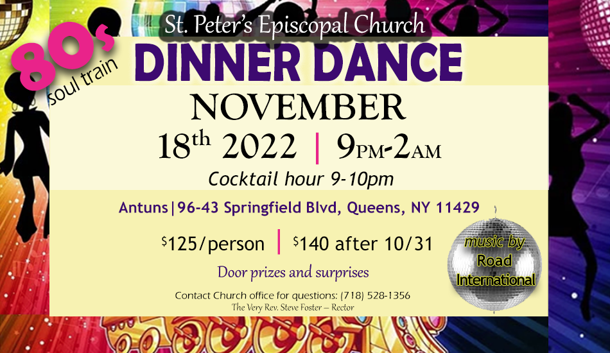

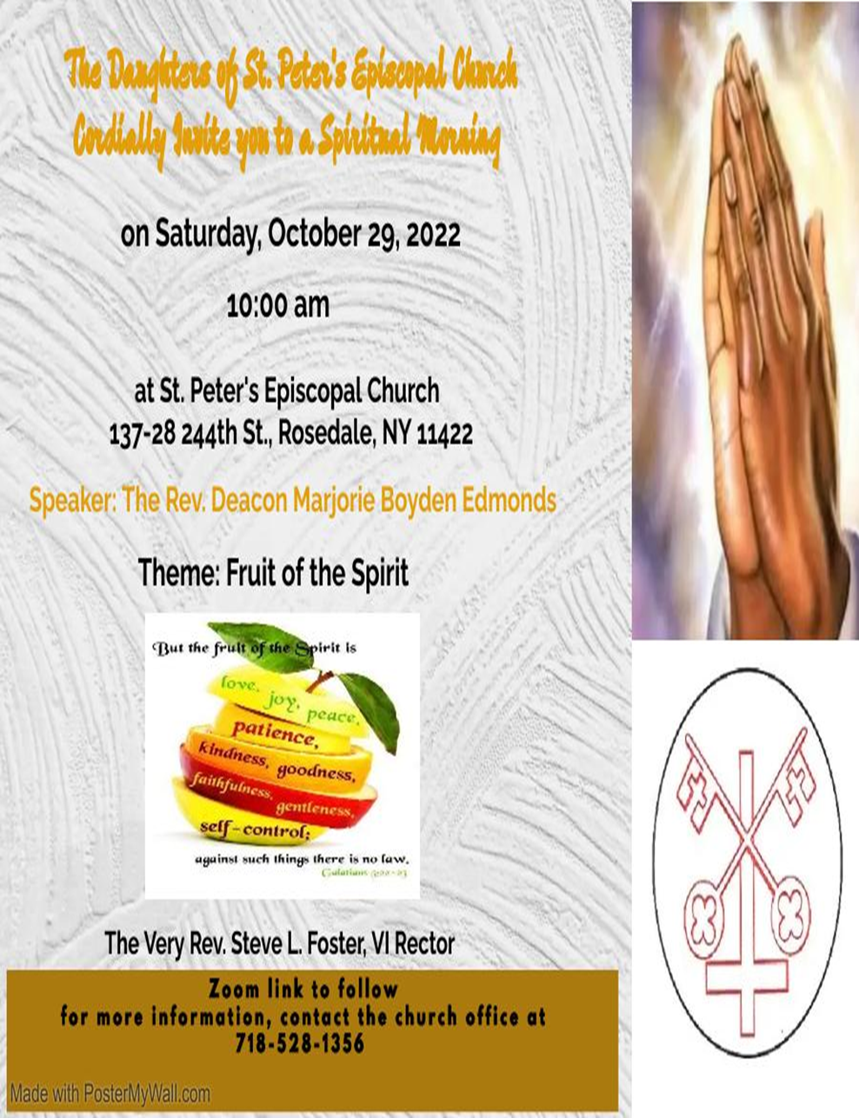

St. Peter’s Church Rosedale
Staff
Mr. Carl Hampden – Sexton
Mr. Eiichi Shimada - Organist, and Choir Director
Ms. Dianne A. Worley – Parish Administrator
The Very Rev. Steve Foster – Rector

Vestry
Mrs. Phyllis Harris Williams – Warden
Mrs. Yvonne Robinson – Warden
Mrs. Lamarcia Parkin Bascombe – Clerk of the Vestry
Mrs. Karen Mayne Lee – Assistant Treasurer
Mrs. Cynthia Craig – Member
Mrs. Sandra George – Member
Mrs. Monica Carrington - Member
Mrs. Gail Adams – Member
Mr. Michael Prescod – Member
Ms. Elaine Henry – Member
Ms. Shadiyah Evans – Member
Mr. Richard Connell – Treasurer

