St. Peter’s Episcopal Church



The Twentieth Sunday after Pentecost

Proper 25

Sunday, October 23rd, 2022
137-28 244th street,
Rosedale NY 11422
www.STPETERSROSEDALE.ORG
The Very Rev. Steve Foster – Rector

Saint Peter’s Church is a place of faith, hope, and love serving all of God’s people.
Saint Peter’s Episcopal Church
Mission Statement, Vision Statement, and Core Values
Mission Statement
Saint Peter’s Church is a place of faith, hope, and love serving all of God’s people.
Vision Statement
Saint Peter’s is a lighthouse of Faith, Hope, and God’s Love. Worship, prayer, Christian education, stewardship, fellowship, evangelism, and outreach.
Framing Passage: Ephesians 4:13-16
Until we all reach unity in the faith and the knowledge of the Son of God and become mature, attaining the whole measure of the fullness of Christ. Then we will no longer be infants, tossed back and forth by the waves, and blown here and there by every wind of teaching and by the cunning and craftiness of people in their deceitful scheming. Instead, speaking the truth in love, we will grow to become in every respect the mature body of him who is the head, that is, Christ. From him, the whole body, joined and held together by every supporting ligament, grows and builds itself up in love, as each part does its work.

Core values
Called to grow and live by faith
Being committed to lifelong learning and study translates into putting what we believe into practice through our daily witness, sharing the good news of God in Christ.
Challenged to be hopeful
Being bearers of hope to each other and the surrounding communities urges us to advocate for justice and peace in the spirit of compassion and mercy.
Commissioned to love
Being agents of God’s redemptive and transforming love demands us to see the imprint of Christ on each other’s faces. Thus, respecting the dignity of every human being is paramount. You are welcome wherever you are, in life or on your faith journey. You are loved, affirmed, and respected as a beloved child of God.
Committed to Service
It is committed to serving together to build up the Body of Christ in God’s community.

Liturgy of the Word
Introit How lovely is thy dwelling-place The Hymnal 1982 #517
1 | How lovely is thy dwelling-place,
 | O Lord of hosts, to me!
 | My thirsty soul desires and longs
 | within thy courts to be;
 | my very heart and flesh cry out,
 | O living God, for thee.
2 | Beside thine altars, gracious Lord,
 | the swallows find a nest;
 | how happy they who dwell with thee
 | and praise thee without rest,
 | and happy they whose hearts are set
 | upon the pilgrim’s quest.
3 | They who go through the desert vale
 | will find it filled with springs,
 | and they shall climb from height to height
 | till Zion’s temple rings
 | with praise to thee, in glory throned,
 | Lord God, great King of kings.
4 | One day within thy courts excels
 | a thousand spent away;
 | how happy they who keep thy laws
 | nor from thy precepts stray,
 | for thou shalt surely bless all those
 | who live they words they pray.

The Celebrant says
Blessed Be God, Father, Son, and Holy Spirit.
People And Blessed be his kingdom, now and for ever. Amen

Almighty God, to you all hearts are open, all desires known, and from you no secrets are hid: Cleanse the thoughts of our hearts by the inspiration of your Holy Spirit, that we may perfectly love you, and worthily magnify your holy Name; through Christ our Lord. Amen
The following is sung
Gloria in Excelsis
Glory to God in the highest, and peace to his people on earth. Lord God, heavenly King, almighty God and Father, we worship you, we give you thanks, we praise you for your glory. Lord Jesus Christ, only Son of the Father, Lord God, Lamb of God, you take away the sin of the world: have mercy on us; you are seated at the right hand of the Father: receive our prayer. For you alone are the Holy One, you alone are the Lord, you alone are the Most High, Jesus Christ, with the Holy Spirit, in the glory of God the Father. Amen.

Collect of the Day
Celebrant The Lord be with you.
People And also with you.
Celebrant Let us pray.
Almighty and everlasting God, increase in us the gifts of faith, hope, and charity; and, that we may obtain what you promise, make us love what you command; through Jesus Christ our Lord, who lives and reigns with you and the Holy Spirit, one God, for ever and ever. Amen.

The Readings
First Reading Joel 2:23-32

A Reading from the Book of Joel
O children of Zion, be glad and rejoice in the Lord your God; for he has given the early rain for your vindication, he has poured down for you abundant rain, the early and the later rain, as before. The threshing floors shall be full of grain the vats shall overflow with wine and oil. I will repay you for the years that the swarming locust has eaten,
the hopper, the destroyer, and the cutter, my great army, which I sent against you. You shall eat in plenty and be satisfied, and praise the name of the Lord your God, who has dealt wondrously with you. And my people shall never again be to shame. You shall know that I am in the midst of Israel, and that I, the Lord, am your God, and there is no other. And my people shall never again be put to shame. Then afterwards I will pour out my spirit on all flesh; your sons and your daughters shall prophesy, your old men shall dream dreams, and your young men shall see visions. Even on the male and female slaves, in those days, I will pour out my spirit. I will show portents in the heavens and on the earth, blood and fire and columns of smoke. The sun shall be turned to darkness, and the moon to blood, before the great and terrible day of the Lord comes. ³²Then everyone who calls on the name of the Lord shall be saved; for in Mount Zion and in Jerusalem there shall be those who escape, as the Lord has said, and among the survivors shall be those whom the Lord calls.
- The Word of the Lord.
- Thanks be to God.

Silence

THE GRADUAL Psalm 65

Antiphon: You crown the year with your goodness, O Lord

You are to be praised, O God, in Zion; to you shall vows be performed in Jerusalem. To you, that hear prayer shall all flesh come, because of their transgressions. Our sins are stronger than we are, but you will blot them out.
Antiphon: You crown the year with your goodness, O Lord.

Happy are they whom you choose and draw to your courts to dwell there! they will be satisfied by the beauty of your house, by the holiness of your temple. Awesome things will you show us in your righteousness, O God of our salvation, O Hope of all the ends of the seas that are far away. You make fast the mountains by your power; they are girded about with might.
Antiphon: You crown the year with your goodness, O Lord.

You still the roaring of the seas, the roaring of their waves, and the clamor of the peoples. Those who dwell at the ends of the earth will tremble at your marvelous signs; you make the dawn and the dusk to sing for joy. You visit the earth and water it abundantly; you make it very plenteous; the river of God is full of water.
Antiphon: You crown the year with your goodness, O Lord.
You prepare the grain, for so you provide for the earth. You drench the furrows and smooth out the ridges; with heavy rain, you soften the ground and bless its increase. You crown the year with your goodness, and your paths overflow with plenty.
Antiphon: You crown the year with your goodness, O Lord.
May the fields of the wilderness be rich for grazing, and the hills be clothed with joy.
May the meadows cover themselves with flocks, and the valleys cloak themselves
with grain; let them shout for joy and sing.
Antiphon: You crown the year with your goodness, O Lord.

Silence

Second Reading 2 Timothy 4:6-8, 16-18

THE EPISTLE: A Reading from the Second Letter of blessed Apostle Paul to Timothy
As for me, I am already being poured out as a libation, and the time of my departure has come. I have fought the good fight, I have finished the race, I have kept the faith. From now on there is reserved for me the crown of righteousness, which the Lord, the righteous judge, will give me on that day, and not only to me but also to all who have longed for his appearing. At my first defense no one came to my support, but all deserted me. May it not be counted against them! But the Lord stood by me and gave me strength, so that through me the message might be fully proclaimed and all the Gentiles might hear it. So I was rescued from the lion’s mouth. The Lord will rescue me from every evil attack and save me for his heavenly kingdom. To him be the glory forever and ever. Amen.

V. The Word of the Lord.
R. Thanks be to God.

Silence

ALLELUIA:
Cantor: Alleluia
People: Alleluia
Cantor: Everyone who exalts himself will be humbled
but he who humbles himself will be exalted.
People: Alleluia
THE HOLY GOSPEL: Luke 18:9-14
V. The Holy Gospel of Our Lord Jesus Christ According to Saint Luke
R. Glory to you, Lord Christ.

Jesus told his parable to some who trusted in themselves that they were righteous and regarded others with contempt: “Two men went up to the temple to pray, one a Pharisee and the other a tax collector. The Pharisee, standing by himself, was praying thus, ‘God, I thank you that I am not like other people: thieves, rogues, adulterers, or even like this tax collector. I fast twice a week; I give a tenth of all my income.’ But the tax collector, standing far off, would not even look up to heaven, but was beating his breast and saying, ‘God, be merciful to me a sinner!’ I tell you, this man went down to his home justified rather than the other; for all who exalt themselves will be humbled, but all who humble themselves will be exalted.”

V. The Gospel of the Lord.
R. Praise to you, Lord Christ.

Sermon Fr. Foster

Silence and listen for God speaking to you.

Sermon Notes

Pray for the World and the Church, particularly for God’s healing grace

A Litany for Healing

The Celebrant introduces the Litany with these or similar words

Let us name before God those for whom we offer our prayers.

The people offer names either silently or aloud.

The leader continues with these words:
Let us offer our prayers for God’s healing, saying, “Answer our prayer”

Holy God, source of health and salvation,

Here and after each petition, the people respond

Answer our prayer

Holy and Mighty, wellspring of abundant life, Answer our prayer

Holy Immortal One, protector of the faithful, Answer our prayer

Holy Trinity, the source of all wholeness, Answer our prayer

Comfort, relieve, and heal all sick children; we pray to you, O God, Answer our prayer
Give courage to all who await surgery; we pray to you, O God, Answer our prayer

Support and encourage those who live with chronic illness; we pray to you, O God, Answer our prayer

Strengthen those who endure continual pain, and give them hope; we pray to you, O God, Answer our prayer

Grant the refreshment of peaceful sleep to all who suffer; we pray to you, O God, Answer our prayer

Befriend all who are anxious, lonely, despondent, or afraid; we pray to you, O God, Answer our prayer

Restore those with mental illness to clarity of mind and hopefulness of heart; we pray to you, O God, Answer our prayer

Give rest to the weary, and hold the dying in your loving arms; we pray to you, O God, Answer our prayer

Help us to prepare for death with confident expectation and hope of Easter joy; we pray to you, O God, Answer our prayer

Give your wisdom and compassion to healthcare workers, so that they may minister to the sick and dying with knowledge, skill, and kindness; we pray to you, O God, Answer our prayer

Uphold those who keep watch with the sick; we pray to you, O God, Answer our prayer

Guide those who search for the causes and cures of sickness and disease; we pray to you, O God, Answer our prayer

Jesus, Lamb of God, Answer our prayer

Jesus, bearer of our sins, Answer our prayer

Jesus, redeemer of the world, Answer our prayer

The Celebrant concludes with the following Collect:

Compassionate God: You so loved the world that you sent us Jesus to bear our infirmities and afflictions. Through acts of healing, he revealed you as the true source of health and salvation. For the sake of your Christ who suffered and died for us, conquered death, and now reigns with you in glory, hear the cry of your people. Have mercy on us, make us whole, and bring us at last into the fullness of your eternal life. Amen.

Let us confess our need for God’s healing grace.

Silence

Minister and People

Compassionate God, we confess our weaknesses and our need for your strengthening touch. We confess that some illnesses stem from our own fault,
while others are beyond our control. We turn to you, source of life, and ask in the name of our Savior, Jesus Christ, for the gifts of true healing and life in you. Amen.

Minister

May the God of love visit you in your times of trial and weakness, and raise you to newness of life, through Jesus Christ, in the power of the Holy Spirit. Amen.

Laying on of Hands and Anointing

The minister may introduce the laying on of hands and anointing with these words

Holy Scripture teaches us that Jesus healed many who were sick as a sign of the reign of God coming near and sent the disciples to continue this work of healing through prayer in his name, that the afflicted might be raised up and their sins are forgiven, bringing them to eternal salvation. By laying hands upon the sick and anointing them, the disciples witness the marvelous power and presence of God. Pray that as we follow their example, we may experience Christ’s, unfailing love.

The minister may invite each person to be anointed to give her or his name and any particular request for prayer. The minister then lays hands upon the sick person and anoints the person, prays silently, then prays aloud using one of the following forms or similar words

N., I lay my hands upon you and anoint you with oil in the Name of the Father, and of the Son, and of the Holy Spirit, beseeching our Lord Jesus Christ to sustain you with his presence, to drive away all sickness of body and spirit, and to give you that victory of life and peace which will enable you to serve him both now and evermore. Amen.

During the Laying on of Hands and Anointing, the following is sung –
Heal me, hands of Jesus WLP 773
1 | Heal me, hands of Jesus,
 | and search out all my pain:
 | restore my hope, remove my fear
 | and bring me peace again.
2 | Cleanse me, blood of Jesus,
 | take bitterness away;
 | let me forgive as one forgiven
 | and bring me peace today.
3 | Know me, mind of Jesus,
 | and show me all my sin;
 | dispel the memories of guilt,
 | and bring me peace within.
4 | Fill me, joy of Jesus:
 | anxiety shall cease
 | and heaven’s serenity be mine,
 | or Jesus brings me peace!

The Laying on of Hands and Anointing concludes with the following Collect

Generous God, we give you thanks for your beloved Jesus Christ, in whom you have shared the beauty and pain of human life. Look with compassion upon all for whom we pray, and strengthen us to be your instruments of healing in the world, by the power of the Holy Spirit. Amen.

Peace
Celebrant The kingdom of God is justice, peace and joy inspired by the Holy Spirit,
People They who serve Christ are acceptable to God and approved by others
Celebrant The peace of the Lord be always with you.
People And also with you.

Welcome & Announcements
Welcome to all who are worshipping at St. Peter’s for the first time. It is a delight and a joy to welcome you. If you are curious and have come to see, Welcome. If you are hurting and have come for solace. Welcome. If you are grateful and have come to share. Welcome. If you are weary and heavy burdened, Welcome. If you are tired and need respite, Welcome. If you are seeking and looking for answers, welcome. If you are listening and have come to pray, Welcome. If you want just to be; Welcome. Whatever reason has brought you to these doors, Welcome. God loves you and so does this parish community. Welcome.
Offertory Sentences – Walk in love as Christ loved us and gave himself for us, a fragrant offering and sacrifice to God.
Offertory Hymn Blest are the pure in heart The Hymnal 1982 #656
1 | Blest are the pure in heart,
 | for they shall see our God;
 | the secret of the Lord is theirs,
 | their soul is Christ’s abode.
2 | The Lord, who left the heavens
 | our life and peace to bring,
 | to dwell in lowliness with us,
 | our pattern and our King;
3 | he to the lowly soul
 | will still himself impart
 | and for his dwelling and his throne
 | will choose the pure in heart.
4 | Lord, we thy presence seek;
 | may ours this blessing be;
 | give us a pure and lowly heart,
 | a temple fit for thee.

The Holy Eucharist - Eucharistic Prayer EOW 1

Celebrant The Lord be with you.
People And also with you.
Celebrant Lift up your hearts.
People We lift them to the Lord.
Celebrant Let us give thanks to the Lord our God.
People It is right to give God thanks and praise.
Celebrant It is truly right, and good and joyful, to give you thanks, all-holy
God, source of life and fountain of mercy.

Through Jesus Christ our Lord; who on the first day of the week overcame death and the grave, and by his glorious resurrection opened to us the way of everlasting life. Therefore, joining with Angels and Archangels and with the faithful of every generation, we lift our voices with all creation as we say:
Celebrant and People

Holy, holy, holy Lord, God of power and might, heaven and earth are full of your glory. Hosanna in the highest. Blessed is he who comes in the name of the Lord. Hosanna in the highest.

The Celebrant continues

Blessed are you, gracious God, creator of the universe and giver of life. You formed us in your own image and called us to dwell in your infinite love. You gave the world into our care that we might be your faithful stewards and show forth your bountiful grace.

But we failed to honor your image in one another and in ourselves; we would not see your goodness in the world around us; and so we violated your creation, abused one another, and rejected your love. Yet you never ceased to care for us, and prepared the way of salvation for all people.

Through Abraham and Sarah, you called us into covenant with you. You delivered us from slavery, sustained us in the wilderness, and raised up prophets to renew your promise of salvation. Then, in the fullness of time, you sent your eternal Word, made mortal flesh in Jesus. Born into the human family, and dwelling among us, he revealed your glory. Giving himself freely to death on the cross, he triumphed over evil, opening the way of freedom and life.

At the following words concerning the bread, the Celebrant is to hold it, or lay a hand upon it; and at the words concerning the cup, to hold or place a hand upon the cup and any other vessel containing wine to be consecrated.

On the night before he died for us, Our Savior Jesus Christ took bread, and when he had given thanks to you, he broke it, and gave it to his friends, and said: “Take, eat: This is my Body which is given for you. Do this for the remembrance of me.”

As supper was ending, Jesus took the cup of wine, and when he had given thanks, he gave it to them, and said: “Drink this, all of you: This is my Blood of the new Covenant,
which is poured out for you and for all for the forgiveness of sins.Whenever you drink it,
do this for the remembrance of me.”

Therefore we proclaim the mystery of faith:

Celebrant and People

Christ has died.
Christ is risen.
Christ will come again.

The Celebrant continues

Remembering his death and resurrection, we now present to you from your creation this bread and this wine. By your Holy Spirit, may they be for us the Body and Blood of our Savior Jesus Christ. Grant that we who share these gifts may be filled with the Holy Spirit and live as Christ’s Body in the world.

Bring us into the everlasting heritage of your daughters and sons, that with the Blessed Virgin Mary Most Holy, Blessed Peter, Blessed Paul, and Blessed Luke and all your saints, past, present, and yet to come, we may praise your Name for ever. Through Christ and with Christ and in Christ, in the unity of the Holy Spirit, to you be honor, glory, and praise, for ever and ever. AMEN.

The Lord’s Prayer
As our Savior Christ has taught us, we now pray,

People and Celebrant
Our Father in heaven, hallowed be your Name, your kingdom come, your will be done, on earth as in heaven. Give us today our daily bread. Forgive us our sins as we
forgive those who sin against us. Save us from the time of trial and deliver us from
evil. For the kingdom, the power, and the glory are yours, now and forever. Amen.
The Breaking of the Bread
The Celebrant breaks the consecrated Bread.
A period of silence is kept.
Celebrant says
Alleluia. Christ our Passover is sacrificed for us;
Therefore let us keep the feast. Alleluia.
Facing the people, the Celebrant says the following Invitation.
The Gifts of God for the People of God.
Communion Hymns
Go Preach My Gospel LEVAS 161
1 | “Go preach my gospel,” saith the Lord,
 | “Bid the whole earth my grace receive,
 | Explain to them my sacred word,
 | Bid them believe, obey, and live.”
2 | “I’ll make my great commission known,
 | And ye shall prove my gospel true
 | By all the works that I have done,
 | And all the wonders ye shall do.”
3 | “Go heal the sick, go raise the dead,
 | Go cast out devils in my name.
 | Nor let my prophets be afraid,
 | Though man reproach, and will blaspheme.”
4 | “While thus ye follow my commands,
 | I’m with you till the world shall end.
 | All pow’r in trusted in my hands;
 | I can destroy, and can defend.”
5 | He spake and light shone round His head,
 | On a bright cloud to heav’n He rode.
 | They to the farthest nation spread
 | The grace of their ascended God.
I Couldn’t Hear Nobody Pray LEVAS 171
 | O, I couldn’t hear nobody pray,
 | couldn’t hear nobody pray.
 | O, way down yonder by myself,
 | And I couldn’t hear nobody pray.
1 | In de valley,
 | Couldn’t hear nobody pray,
 | On ma knees,
 | Couldn’t hear nobody pray,
 | Wid ma burden,
 | Couldn’t hear nobody pray,
 | An’ ma Savior.
 | Couldn’t hear nobody pray,
 | O ma Lord,
 | Refrain
2 | Chilly waters,
 | Couldn’t hear nobody pray,
 | In de Jerden,
 | Couldn’t hear nobody pray,
 | Crossin’ over,
 | Couldn’t hear nobody pray,
 | Into Canaan.
 | Couldn’t hear nobody pray,
 | Refrain
3 | Hallelujah!
 | Couldn’t hear nobody pray,
 | Troubles over
 | Couldn’t hear nobody pray,
 | In de kingdom,
 | Couldn’t hear nobody pray,
 | Wid my Jesus.
 | Couldn’t hear nobody pray,
 | Refrain

Post-Communion Prayer
The Celebrant says

The Lord be with you.
People And also with you.
Celebrant Let us pray.

Celebrant and People

Loving God, we give you thanks for restoring us in your image and nourishing us with spiritual food in the Sacrament of Christ’s Body and Blood. Now send us forth
a people, forgiven, healed, renewed; that we may proclaim your love to the world
and continue in the risen life of Christ our Savior. Amen.
.
The Blessing
We have laid our burdens down in the presence of the living God. Amen
We have been nourished for our journey in the presence of the living God. Amen
We have taken on the armor of Christ in the presence of the living God. Amen
Now lead us, guide us, defend us, as we go into your world in your name for your sake, O loving, living God. Amen.
The blessing of God Almighty, + the Father, the Son, and the Holy Spirit, be upon you and remain with you for ever. Amen.
Recessional All my hope on God is founded The Hymnal 1982 #665
1 | All my hope on God is founded;
 | he doth still my trust renew,
 | me through change and chance he guideth,
 | only good and only true.
 | God unknown,
 | he alone
 | calls my heart to be his own.
2 | Mortal pride and earthly glory,
 | sword and crown betray our trust;
 | though with care and toil we build them,
 | tower and temple fall to dust.
 | But God’s power,
 | hour by hour,
 | is my temple and my tower.
3 | God’s great goodness e’er endureth,
 | deep his wisdom passing thought:
 | splendor, light, and life attend him,
 | beauty springeth out of nought.
 | Evermore
 | from his store
 | newborn worlds rise and adore.
4 | Daily doth the almighty Giver
 | bounteous gifts on us bestow;
 | his desire our soul delighteth,
 | pleasure leads us where we go.
 | Love doth stand
 | at his hand;
 | joy doth wait on his command.
5 | Still from earth to God eternal
 | sacrifice of praise be done,
 | high above all praises praising
 | for the gift of Christ, his Son.
 | Christ doth call
 | one and all:
 | ye who follow shall not fall.

Let us go forth in the name of Christ.
People Thanks be to God.

ANNOUNCEMENTS for the Week of 10/23/2022
Schedule for the week of October 23rd through October 29th

Sunday, October 23rd, The Twentieth Sunday after Pentecost
Holy Eucharist - 8:00 & 10:00 AM with Healing Liturgy

Monday, October 24^{th,} Office closed
Compline 9:00 PM

Tuesday, October 25th, Book Club @7: 30 PM Reading -The Promised Land
By Barack Obama

Friday, October 28th, ST SIMON & ST. JUDGE, APOSTLES – MASS 10:00 AM

Saturday, October 29th, Spiritual Day – Daughters of St. Peters – Prayer Breakfast
Food Pantry 11:00 AM – 1:00 PM

Sunday, October 30th, The Twenty-First Sunday after Pentecost,
Holy Eucharist – 8:00 AM and 10:00 AM

Announcements
The Confirmation class started on October 15th, 2022. Please submit names and see the Rector for application.

The Winter coats and clothing drive begins today. Please bring in your gently used coats and place them in the boxes provided in the parish hall. Donations will run until November 13th.

Please submit the names of your family and friends for the All-Souls
commemoration.

STEWARDSHIP CORNER
To date we received 88 pledge cards for 2022 totaling $211, 195. The Vestry has
pledged $50, 209 toward the work of St. Peter’s Rosedale.

We have been blessed with more than enough – what are we tithing? What are we giving? How is our stewardship?
Corporate giving is no longer about signing fat checks, public preening, and charity balls, says Jeff Skoll, vice president of strategic planning and analysis for eBay Inc. “Young, ‘newly minted’ givers anticipate seeing the effects of their gifts within their lifetimes and want a more hands-on role,” he says. For example, Ken Blanchard, coauthor of How to Make Serious Money for Both You and Your Company, says, “We tithe 10 percent of our profit. . . . We divide it among all our employees to give away. The lowest-paid employee gets to give $1,000 away, and the highest gets to give $3,500. We gave to 160 charities last year.”
The results of this personalized giving are touching. “A guy in shipping came up to me with tears in his eyes,” Blanchard said. “He got the chance to give $1,000 to his parish to buy robes for the choir. He’s become a local hero.”
— Lorenzo Della Foresta, “Twenty-first Century Giving,” PreachingToday.com
St Peter’s Episcopal Church is now on AmazonSmile.

Would you like to support St Peter’s Episcopal Church when you shop online?

AmazonSmile is a simple way for you to support St Peter’s Episcopal Church every time you shop online, at no additional cost to you. When you shop at smile.amazon.com, you will find the same low prices, vast selection, and convenient shopping experience as Amazon.com, with the bonus that Amazon will donate a portion of the purchase price to St Peter’s Episcopal Church.

To shop at AmazonSmile, go to smile.amazon.com on the internet. If you already have an account at Amazon, you can use the same account. You do not have to set up a new account. Your shopping cart, wish list, and account settings are all the same.

The first time you visit AmazonSmile (smile.amazon.com), you will be prompted to select a charitable organization from among the eligible organizations. To browse or shop at AmazonSmile, you must first select a charitable organization. Please type “St Peter’s Episcopal Church” as your supporting charity.

There are millions of products for sale on AmazonSmile that are eligible for donations to St Peter’s Episcopal Church. Eligible products are marked “Eligible for AmazonSmile donation” on the product detail pages. For each eligible purchase you make at AmazonSmile, the AmazonSmile Foundation will donate 0.5% of the purchase price to your selected charitable organization, St Peter’s Episcopal Church.

Please note that recurring subscribe-and-save purchases and subscription renewals are not eligible for donation.
Thank you in advance for listing and remembering the St Peter’s Episcopal Church when shopping online.
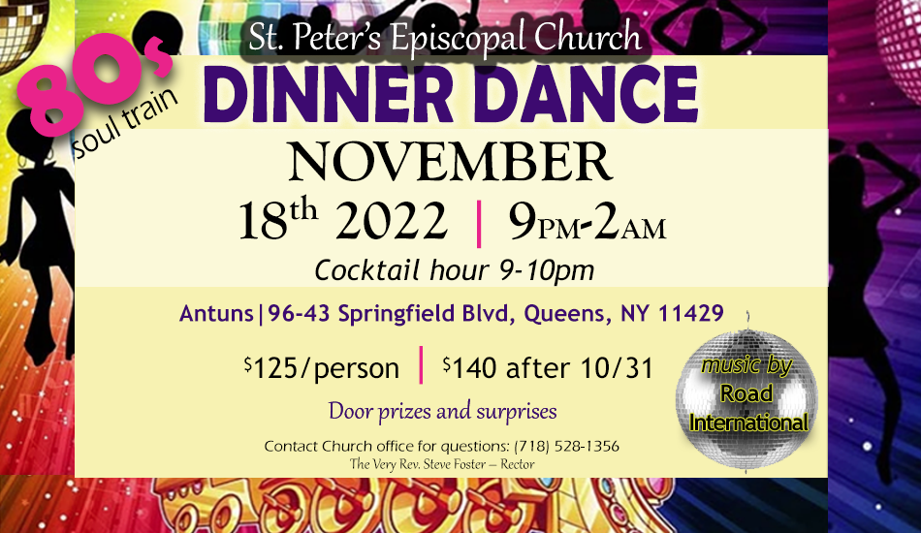
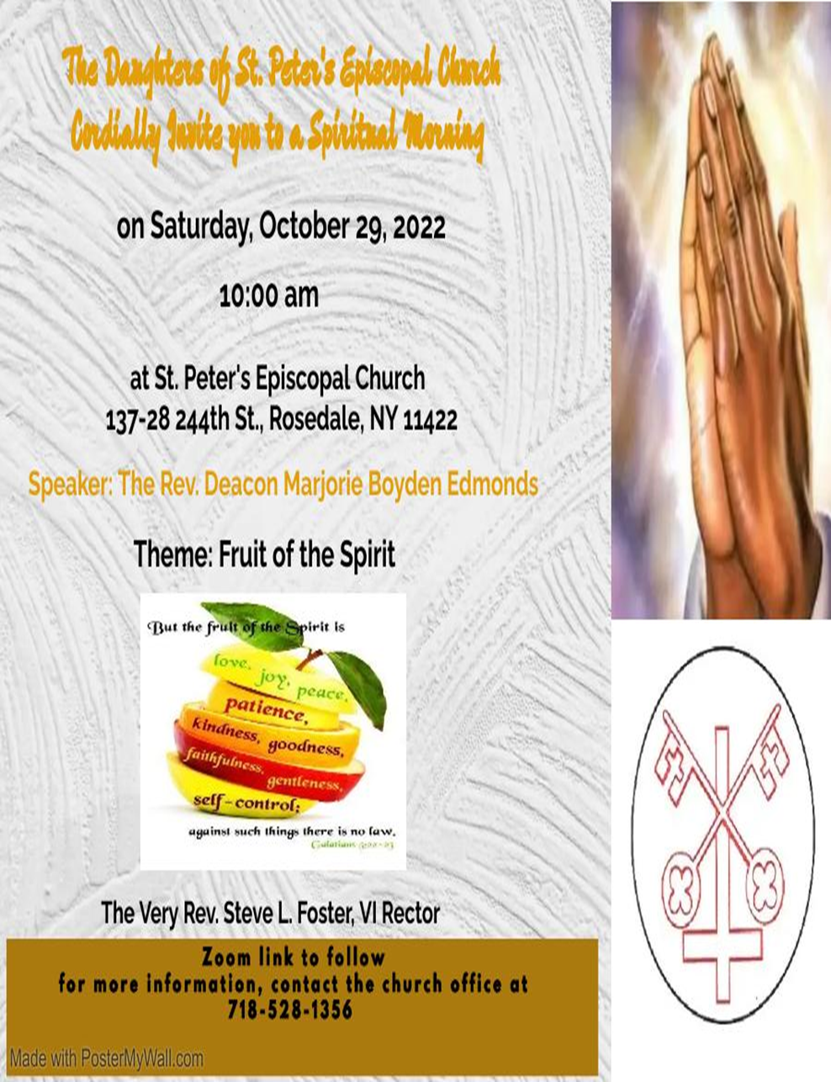

St. Peter’s Church Rosedale
Staff
Mr. Carl Hampden – Sexton
Mr. Eiichi Shimada - Organist, and Choir Director
Ms. Dianne A. Worley – Parish Administrator
The Very Rev. Steve Foster – Rector

Vestry
Mrs. Phyllis Harris Williams – Warden
Mrs. Yvonne Robinson – Warden
Mrs. Lamarcia Parkin Bascombe – Clerk of the Vestry
Mrs. Karen Mayne Lee – Assistant Treasurer
Mrs. Cynthia Craig – Member
Mrs. Sandra George – Member
Mrs. Monica Carrington - Member
Mrs. Gail Adams – Member
Mr. Michael Prescod – Member
Ms. Elaine Henry – Member
Ms. Shadiyah Evans – Member
Mr. Richard Connell – Treasurer

