St. Peter’s Episcopal Church

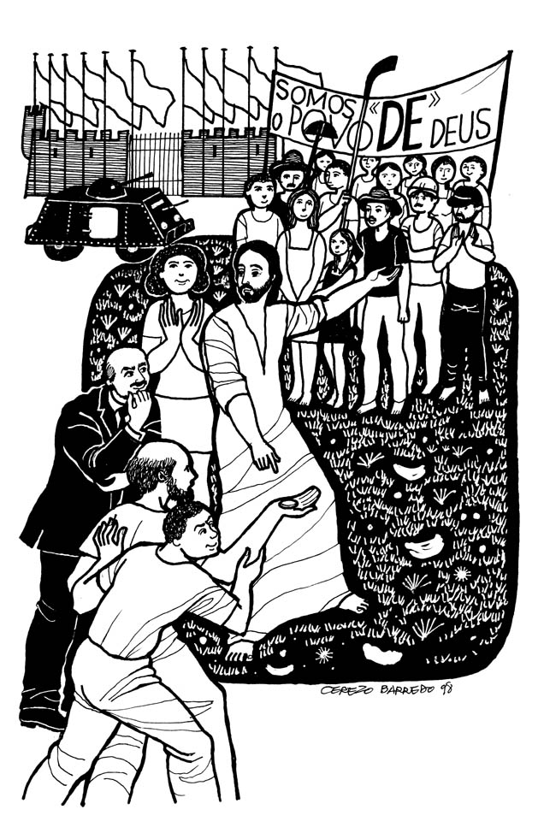

The Twenty-first Sunday after Pentecost, Proper 24, Year A

Holy Eucharist

Sunday, October 22nd, 2023

137-28 244th Street, Rosedale, NY 11422
www.stpetersrosedale.org
Saint Peter’s Church is a place of faith, hope, and love serving all of God’s people.
The Very Rev. Steve Foster- Rector
Saint Peter’s Episcopal Church
Mission Statement, Vision Statement, and Core Values
Mission Statement
Saint Peter’s Church is a place of faith, hope, and love serving all of God’s people.
Vision Statement
Saint Peter’s is a lighthouse of Faith, Hope, and God’s Love. Worship, prayer, Christian education, stewardship, fellowship, evangelism, and outreach.
Framing Passage: Ephesians 4:13-16
Until we all reach unity in the faith and the knowledge of the Son of God and become mature, attaining the whole measure of the fullness of Christ. Then we will no longer be infants, tossed back and forth by the waves, and blown here and there by every wind of teaching and by the cunning and craftiness of people in their deceitful scheming. Instead, speaking the truth in love, we will grow to become in every respect the mature body of him who is the head, that is, Christ. From him, the whole body, joined and held together by every supporting ligament, grows and builds itself up in love, as each part does its work.

Core values
Called to grow and live by faith
Being committed to lifelong learning and study translates into putting what we believe into practice through our daily witness, sharing the good news of God in Christ.
Challenged to be hopeful
Being bearers of hope to each other and the surrounding communities urges us to advocate for justice and peace in the spirit of compassion and mercy.
Commissioned to love
Being agents of God’s redemptive and transforming love demands us to see the imprint of Christ on each other’s faces. Thus, respecting the dignity of every human being is paramount. You are welcome wherever you are, in life or on your faith journey. You are loved, affirmed, and respected as a beloved child of God.
Committed to Service
It is committed to serving together to build up the Body of Christ in God’s community.
Introit All people that on earth do dwell The Hymnal 1982 #377
Celebrant Blessed be God, Father, Son, and Holy Spirit.
People And Blessed be his kingdom, now and forever. Amen

Almighty God, to you all hearts are open, all desires known, and from you no secrets are hid: Cleanse the thoughts of our hearts by the inspiration of your Holy Spirit, that we may perfectly love you, and worthily magnify your holy Name; through Christ our Lord. Amen.
The following is said
Gloria in Excelsis
Glory to God in the highest, and peace to his people on earth. Lord God, heavenly King, almighty God and Father, we worship you, we give you thanks, we praise you for your glory. Lord Jesus Christ, only Son of the Father, Lord God, Lamb of God, you take away the sin of the world: have mercy on us; you are seated at the right hand of the Father: receive our prayer. For you alone are the Holy One, you alone are the Lord, you alone are the Most High, Jesus Christ, with the Holy Spirit, in the glory of God the Father. Amen.

Collect of the Day
Celebrant The Lord be with you.
People And also with you.
Celebrant Let us pray.

Almighty and everlasting God, in Christ you have revealed your glory among the nations: Preserve the works of your mercy, that your Church throughout the world may persevere with steadfast faith in the confession of your Name; through Jesus Christ our Lord, who lives and reigns with you and the Holy Spirit, one God, for ever and ever. Amen.

The Readings
First Reading Exodus 33:12-23

A Reading from the Second Book of Moses Called Exodus
Moses said to the LORD, "See, you have said to me, "Bring up this people'; but you have not let me know whom you will send with me. Yet you have said, "I know you by name, and you have also found favor in my sight.' Now if I have found favor in your sight, show me your ways, so that I may know you and find favor in your sight. Consider too that this nation is your people." He said, "My presence will go with you, and I will give you rest." And he said to him, "If your presence will not go, do not carry us up from here. For how shall it be known that I have found favor in your sight, I and your people, unless you go with us? In this way, we shall be distinct, I and your people, from every people on the face of the earth." The LORD said to Moses, "I will do the very thing that you have asked; for you have found favor in my sight, and I know you by name." Moses said, "Show me your glory, I pray." And he said, "I will make all my goodness pass before you, and will proclaim before you the name, "The LORD'; and I will be gracious to whom I will be gracious, and will show mercy on whom I will show mercy. But," he said, "you cannot see my face; for no one shall see me and live." And the LORD continued, "See, there is a place by me where you shall stand on the rock; and while my glory passes by I will put you in a cleft of the rock, and I will cover you with my hand until I have passed by; then I will take away my hand, and you shall see my back; but my face shall not be seen."

- The Word of the Lord.
- Thanks be to God.

Silence
THE GRADUAL: Psalm 99
Antiphon: Proclaim the greatness of the Lord our God, who is the Holy One.
The Lord is King; let the people tremble; he is enthroned upon the cherubim; let the earth shake. The Lord is great in Zion; he is high above all peoples. Let them confess his Name, which is great and awesome; he is the Holy One.
Antiphon: Proclaim the greatness of the Lord our God, who is the Holy One.

"O mighty King, lover of justice, you have established equity; you have executed
justice and righteousness in Jacob." Proclaim the greatness of the Lord our God
and fall down before his footstool; he is the Holy One. Moses and Aaron among his
priests, and Samuel among those who call upon his Name, they called upon the
Lord, and he answered them.
Antiphon: Proclaim the greatness of the Lord our God, who is the Holy One.

He spoke to them out of the pillar of cloud; they kept his testimonies and the decree
that he gave them. “O Lord our God, you answered them indeed; you were a God
who forgave them, yet punished them for their evil deeds.” Proclaim the greatness
of the Lord our God and worship him upon his holy hill; for the Lord our God is
the Holy One.
Antiphon: Proclaim the greatness of the Lord our God, who is the Holy One.

Second Reading Thessalonians 1:1-10
A Reading from the First Letter of the Blessed Apostle Paul to the Thessalonians
Paul, Silvanus, and Timothy, To the church of the Thessalonians in God the Father and the Lord Jesus Christ: Grace to you and peace. We always give thanks to God for all of you and mention you in our prayers, constantly remembering before our God and Father your work of faith and labor of love and steadfastness of hope in our Lord Jesus Christ. For we know, brothers and sisters beloved by God, that he has chosen you, because our message of the gospel came to you not in word only, but also in power and in the Holy Spirit and with full conviction; just as you know what kind of persons we proved to be among you for your sake. And you became imitators of us and of the Lord, for in spite of persecution you received the word with joy inspired by the Holy Spirit, so that you became an example to all the believers in Macedonia and in Achaia. For the word of the Lord has sounded forth from you not only in Macedonia and Achaia, but in every place your faith in God has become known, so that we have no need to speak about it. For the people of those regions report about us what kind of welcome we had among you, and how you turned to God from idols, to serve a living and true God, and to wait for his Son from heaven, whom he raised from the dead – Jesus, who rescues us from the wrath that is coming.

- The Word of the Lord.
R. Thanks be to God.

Silence
ALLELUIA:
Cantor: Alleluia
People: Alleluia
Cantor: Jesus said to them, “Give therefore to the emperor the things that are the emperor’s, and to God the things that are God’s.”
People: Alleluia
THE HOLY GOSPEL: Matthew 22:15-22
V. The Holy Gospel of Our Lord Jesus Christ According to Matthew
R. Glory to you, Lord Christ.
(+)The Pharisees went and plotted to entrap him in what he said. So they sent their disciples to him, along with the Herodians, saying, “Teacher, we know that you are sincere, and teach the way of God in accordance with truth, and show deference to no one; for you do not regard people with partiality. Tell us, then, what you think. Is it lawful to pay taxes to the emperor, or not?” But Jesus, aware of their malice, said, “Why are you putting me to the test, you hypocrites? Show me the coin used for the tax.” And they brought him a denarius. Then he said to them, “Whose head is this, and whose title?” They answered, “The emperor’s.” Then he said to them, “Give therefore to the emperor the things that are the emperor’s, and to God the things that are God’s.” When they heard this, they were amazed; and they left him and went away.
V. The Gospel of the Lord.
R. Praise to you, Lord Christ.

Sermon 8:00 a.m.- The Very Rev. Steve Foster
10:00 a.m. Ms. Tracey Connell
Silence and listen for God speaking to you.

Nicene Creed
We believe in one God, the Father, the Almighty, maker of heaven and earth, of all that is, seen and unseen. We believe in one Lord, Jesus Christ, the only Son of God, eternally begotten of the Father, God from God, Light from Light, true God from true God, begotten, not made, of one Being with the Father. Through him all things were made. For us and for our salvation he came down from heaven: by the power of the Holy Spirit he became incarnate from the Virgin Mary and was made man. For our sake he was crucified under Pontius Pilate; he suffered death and was buried. On the third day he rose again in accordance with the Scriptures; he ascended into heaven and is seated at the right hand of the Father. He will come again in glory to judge the living and the dead, and his kingdom will have no end. We believe in the Holy Spirit, the Lord, the giver of life, who proceeds from the Father and the Son. With the Father and the Son, he is worshiped and glorified. He has spoken through the Prophets. We believe in one holy catholic and apostolic Church. We acknowledge one baptism for the forgiveness of sins. We look for the resurrection of the dead, and the life of the world to come. Amen.

Prayers of the People
Celebrant: Christians live in two dimensions, citizens of the city of God, and citizens of the world. Let us pray for the needs of this world, with our hearts set on the endless kingdom that is to come.
Leader: Let us focus our gaze on the great God of our making, as we pour out to him our prayers.
Lord of all, give your Church such maturity and wisdom that we may not be swayed from our purpose and calling by trivialities or worldly pressures, but know increasingly our dependence on you in all things and proclaim your Gospel with steadfastness and joy. We pray for Justin, the Archbishop of Canterbury and leader of the Anglican Communion; Michael, our Presiding Bishop and Primate; Lawrence, our Bishop Diocesan; Geralyn, Daniel, and William, our bishops. Our Clergy; Dennison, Keith, Ryan, Karen, Frederick, Rudolph, Joshua, Fred, Bernice, Ephraim, Bernard, Mastine, Lloyd and Darryl, Charles, and Steve, the Jamaica Deanery and the congregation of St. Peter’s.
Silence
You, O Lord; are the ground of our being.
Lord of all, give to all leaders and heads of state graciousness and integrity, that all in power and authority may undertake their duties in a spirit of humility; that the oppressed may find a voice, and the nations work together for the good of the world.
Silence
You, O Lord; are the ground of our being.
Lord of all, give to our homes and places of work and leisure your harmony and peace; give us grace to respect one another and ourselves in the way we talk and think, and in the way we behave.
Silence
You, O Lord; are the ground of our being.
Lord of all, speak your peace into the hearts of all who are agitated, anxious or confused. Lay your hands of healing on all who are ill and let them know your reassurance and ove.
Silence
You, O Lord; are the ground of our being.
Lord of all, welcome into your kingdom all who have kept faith and now can lay their burdens down. May they rest in your peace for ever.
Silence
You, O Lord; are the ground of our being.
Lord of all, the order and complexity of creation sings your praise, and we give voice to it now as we offer you our song of lives rededicated to the work of your kingdom.
Celebrant: Lord of all history, we place our requests in your care, knowing that all peoples, times, and events are within your provident plan. Grant these prayers of your people, through Christ our Lord. Amen

Confession of Sin
The Celebrant says
Jesus said, “The first commandment is this: Hear, O Israel: The Lord our God is the only Lord. Love the Lord your God with all your heart, with all your soul, with all your mind, and with all your strength. The second is this: Love your neighbor as yourself. There is no other commandment greater than these.” Mark 12:29-31
The Celebrant then says
Let us confess our sins against God and our neighbor.
Silence.
Celebrant and People
Most merciful God, we confess that we have sinned against you in thought, word, and deed, by what we have done, and by what we have left undone. We have not loved you with our whole heart; we have not loved our neighbors as ourselves. We are truly sorry and we humbly repent. For the sake of your Son Jesus Christ, have mercy on us and forgive us; that we may delight in your will, and walk in your ways, to the glory of your Name. Amen.

The Officiant says
Almighty God have mercy on you, forgive you all your sins through our Lord Jesus Christ, strengthen you in all goodness, and by the power of the Holy Spirit keep you in eternal life. Amen.
THE PEACE
The kingdom of God is justice, peace, and joy inspired by the Holy Spirit.
They who thus serve Christ are acceptable to God and approved by others.
And the peace of the Lord be always with you
and also with you.

Offertory Sentences

Walk in love, as Christ loved us and gave himself for us, an offering and sacrifice to God. Ephesians 5:2

Offertory Hymn Judge eternal throned in splendor The Hymnal 1982 #596
Great Thanksgiving – Eucharistic Prayer A
The people remain standing.
Celebrant The Lord be with you.
People And also with you.
Celebrant Lift up your hearts.
People We lift them to the Lord.
Celebrant Let us give thanks to the Lord our God.
People It is right to give him thanks and praise.

The Celebrant continues
It is right, and a good and joyful thing, always and everywhere, to give thanks to you, Father Almighty, Creator of heaven and earth. Through Jesus Christ our Lord; who on the first day of the week overcame death and the grave, and by his glorious resurrection opened to us the way of everlasting life. Therefore, we praise you, joining our voices with Angels and Archangels and with all the company of heaven, who for ever sing this hymn to proclaim the glory of your Name:
Celebrant and People
Holy, Holy, Holy Lord, God of power and might, heaven and earth are full of your glory. Hosanna in the highest. Blessed is he who comes in the name of the Lord. Hosanna in the highest.
The people stand or kneel.
The Celebrant continues
Holy and gracious Father: In your infinite love, you made us for yourself; and, when we had fallen into sin and become subject to evil and death, you, in your mercy, sent Jesus Christ, your only and eternal Son, to share our human nature, to live and die as one of us, to reconcile us to you, the God and Father of all. He stretched out his arms upon the cross, and offered himself in obedience to your will, a perfect sacrifice for the whole world.
At the following words concerning the bread, the Celebrant is to hold it or lay a hand upon it; and at the words concerning the cup, to hold or place a hand upon the cup and any other vessel containing wine to be consecrated.
On the night he was handed over to suffering and death, our Lord Jesus Christ took bread; and when he had given thanks to you, he broke it, and gave it to his disciples, and said, “Take, eat: This is my Body, which is given for you. Do this for the remembrance of me.”
After supper he took the cup of wine; and when he had given thanks, he gave it to them, and said, “Drink this, all of you: This is my Blood of the new Covenant, which is shed for you and for many for the forgiveness of sins. Whenever you drink it, do this for the remembrance of me.”
Therefore, we proclaim the mystery of faith:
Celebrant and People
Christ has died. Christ is risen. Christ will come again.
The Celebrant continues
We celebrate the memorial of our redemption, O Father, in this sacrifice of praise and thanksgiving. Recalling his death, resurrection, and ascension, we offer you these gifts. Sanctify them by your Holy Spirit to be for your people the Body and Blood of your Son, the holy food and drink of new and unending life in him. Sanctify us also that we may faithfully receive this holy Sacrament, and serve you in unity, constancy, and peace; and at the last day bring us with all your saints into the joy of your eternal kingdom. All this we ask through your Son Jesus Christ. By him, and with him, and in him, in the unity of the Holy Spirit all honor and glory is yours, Almighty Father, now and for ever. AMEN
The Celebrant then continues.
As our Savior Christ has taught us, we now pray,

People and Celebrant
Our Father in heaven, hallowed be your Name, your kingdom come, your will be
done, on earth as in heaven. Give us today our daily bread. Forgive us our sins as we
forgive those who sin against us. Save us from the time of trial, and deliver us from
evil. For the kingdom, the power, and the glory are yours, now and for ever. Amen.

The Breaking of the Bread
The Celebrant breaks the consecrated Bread.
A period of silence is kept.
Christ our Passover is sacrificed for us;
Therefore let us keep the feast.
Facing the people, the Celebrant says the following Invitation.
The Gifts of God for the People of God. Take them in remembrance that Christ died for
you, and feed on him in your hearts by faith, with thanksgiving.

Communion Hymns I Want Jesus to Walk with Me LEVAS 70

Just a Closer Walk with Thee LEVAS 72

Celebrant and People
Eternal God, heavenly Father, you have graciously accepted us as living members
of your Son our Savior Jesus Christ, and you have fed us with spiritual food in the Sacrament of his Body and Blood. Send us now into the world in peace, and grant us strength and courage to love and serve you with gladness and singleness of heart;
through Christ our Lord. Amen.

Welcome & Announcements
Welcome to all who are worshipping at St. Peter’s for the first time.
It is a delight and a joy to welcome you.
If you are curious and have come to see, Welcome.
If you are hurting and have come for solace. Welcome.
If you are grateful and have come to share. Welcome.
If you are weary and heavily burdened, Welcome.
If you are tired and need respite, Welcome.
If you are seeking and looking for answers, Welcome.
If you are listening and have come to pray, Welcome.
If you want just to be, Welcome.
Whatever reason has brought you to these doors, Welcome.
God loves you, and so does this parish community. Welcome.

The Blessing
May Almighty God keep you from all harm and bless you with every good gift. Amen.

May he set his Word in your heart and fill you with lasting joy. Amen.

May you walk in his ways, always knowing what is right and good, until you enter your heavenly inheritance. Amen.

And the blessing of God Almighty, the Father, the Son, + and the Holy Spirit, be upon you and remain with you forever. Amen.

Recessional All my hope on God is founded The Hymnal 1982 # 665

Let us go forth into the world, rejoicing in the power of the Spirit.
People Thanks be to God.

ANNOUNCEMENTS for Week of 10/22/23
Sick and Shut-In
Please remember in our prayers members of our Parish as well as family and friends especially:
Alisha, Carol Alexander, Gairy Allison, Kaiyden Bail, Jennifer Bennett, Cynthia Blake, Ida Bowen, Allan Bradshaw, Ermine Browne, Jennifer Brown, Lurline Brown, Jada Campbell, Rufus Carriman, Sheila Carvalho, Camile Cook, Natasha Cunningham, Panzie Evans, Xiomara Fernandez, Dorson Foster, Hartley Foster, Linda Foster, Anne Foster, O'Neal Gill, Cleonie Gordon, Frank Grausso, George Hamblin, Sheila Harris, Dahlia Henriques, Aldean Hinds, Pearl, Beatrice Jerome, Floyd Johnson, Kristen Jones, Shauna Kerr, Norma King, Felicia Lamothe, Antoinette Lashley, Lena Lyn, Celeste Lora, Jessica Lora, Asima Malik, Anthony McClean, Joan McClean, Nigel McLean, Ruth McFarlane, Craig Merritt, Sydney Miller, Arthur Mills, Ariayah Morgan-Mullet, Kerwayne Probherbs, Kwame Probherbs, Victor Rhodd, Jasmine Robinson, Othniel Robinson, Clive Rodriguez, Luke Rojas, Adassa Samms, Basil Samms, Coleen Shepherd, Rawl Shepherd, Suzette Smith, George Thompson, Louise Todd, Francine Trotman, April Tucker, Eugena Tucker, Devon Watkis Jr, Pauline Watson, Lorna Wilson, Pamela Michael, June Smith, Phyllis Taffe, Julia Maynard, Kouame Paul Alloko, Aya Kouakou and Ian Yankwitt.

IMPORTANT
Please note that the parish sick and shut-in list will be updated as of November 1st. Please contact the Parish Office with the names of loved ones or family members you would like to have added or that need to be removed. You can either call or email the office at spec.rosedale@verizon.com or leave a note in the parish admin mailbox.

November 2nd is All Souls Day. This year our Liturgy for the Commemoration of the Faithful Depart will be celebrated on Sunday, November 5^{th,} at 4 pm. Please submit your names and donations as soon as possible using the printed sheets or scanning the QR code listed. The deadline is October 25th for submission to the office.

The altar flowers and candles are given today by Neville Maynard and family in remembrance of his mother Louise Maynard who would have celebrated 100 years on October 27th 2023.

Schedule for the week of October 22nd through October 29 th

Sunday, October 22^{nd,} The Twenty-first Sunday after Pentecost
8:00 am Holy Eucharist
10:00 am Holy Eucharist
Prayers for Healing
1:00 pm Vestry Meeting
Winter Coat Drive Begins

Monday, October 23rd , Office Closed
10:00 am ST. JAMES OF JERUSALEM

Tuesday, October 24^{th,} 7:00 pm Evening Prayer and Book Club

Wednesday, October 25th, 9: 30 am Morning Prayer
10:00 am Holy Eucharist
11: 00 am Bible Study
7: 30 pm Evening Prayer & Reflection

Saturday, October 28th, 10:00 am ST. SIMON AND ST, JUDE, APOSTLES
11:00 am – 1:00 pm The Yvonne Gittens Pantry
4:00pm Costume Party and Table decorating

Sunday, October 29^{th,} The Twenty-Second Sunday after Pentecost
8:00 am Holy Eucharist
10:00 am Holy Eucharist

STEWARDSHIP CORNER

PLEDGES TO THE WORK OF THE LORD AT ST. PETER'S CHURCH, 2023
If you have not pledged yet for the Lord's work at St. Peter's Church, Rosedale, for 2023, please do so after prayerful consideration by filling out the pledge card. If you have misplaced or have yet to receive it, please feel free to contact the Parish Office.
When a Diamond Isn’t Forever
It was our first financial mistake, and it was a big one. After my wife and I said “I do” in June of 2003, we found ourselves with a sizable chunk of money (sizable to us, anyway). We viewed this money as part of an eventual down payment on our future house. In the meantime we needed to invest it. At the time, the stock market was languishing in the wake of 9/11. Through some rather interesting circumstances, we came in contact with a diamond wholesaler. This man was very charming, very knowledgeable, and very optimistic about the investment potential of small, sparkling rocks. And so, in spite of the advice of our parents and other financially sound naysayers, my wife and I purchased a lovely 1.07-carat, museum-quality diamond. We marveled at it for several days, delighting in its brilliance and largesse. Then we hid it under our bathroom sink in the middle of a roll of toilet paper (what thief would ever check there?).
Two long, stressful years later, we sold the diamond online to an estate liquidator for about half of what we had paid for it. As I say, it was our first financial mistake. It was also our first big lesson on the consequences of poor stewardship. How is your/our stewardship?

OCTOBER
22 Winter Coats and Clothing Drive begins
23 ST. JAMES OF JERUSALEM – Mass 10:00 AM (Trans.)
28 ST. SIMON AND ST, JUDE, APOSTLES – Mass 10:00 AM
29 Stewardship Committee Presentation
31. Vigil of All Saints

NOVEMBER
1 All Saints Day – Mass @ 10:00 AM
4 Community Walk
5 All Saints Day Mass @ 8:00 AM & 10:00 AM
5 Men’s Corporate Communion and Brunch
5 Commemoration of the Faithful Departed
11 Veterans Day
12 Veteran’s Recognition Mass
17 Annual Dinner Dance
18 Distribution of Thanksgiving Baskets
19 COMMITMENT SUNDAY
23 Thanksgiving Day Mass @ 9:00 AM & Brunch
26 Christ The King Sunday
26 Barbados Independence Celebration
30 St. Andrew, Apostle

DECEMBER
3 FIRST SUNDAY OF ADVENT
10 LESSONS AND CAROLS
21 ST. THOMAS, APOSTLE
24 FOURTH SUNDAY OF ADVENT (Cleaning & decorating Church)
24 CHRISTMAS EVE - Mass 10:00PM
25 CHRISTMAS DAY – Mass 8:00AM & 10:00 AM

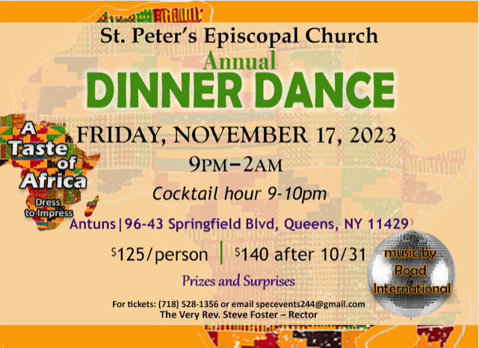

St. Peter’s Church Rosedale
Staff
Mr. Carl Hampden - Sexton
Mr. Eiichi Shimada - Organist, and Choir Director
(In transition)– Parish Administrator
The Very Rev. Steve Foster – Rector
The Rt. Rev. Lawrence Provenzano – Bishop of the Diocese of Long Island
The Most Rev. Michael Curry, Presiding Bishop of the Episcopal Church

Vestry
Mrs. Phyllis Harris Williams – Warden
Mrs. Yvonne Robinson – Warden
Mrs. Lamarcia Parkin Bascombe – Clerk of the Vestry
Mrs. Karen Mayne Lee – Assistant Treasurer
Mrs. Monica Carrington – Member
Mrs. Gail Adams – Member
Ms. Elaine Henry - Member
Ms. Shadiyah Evans – Member
Mrs. Marcelle Pennycooke – Member
Mrs. Phyllis Nicholas – Member
Mrs. Brenda Innis – Member
Mr. Richard Connell – Treasurer

Church Tel: (718) 528-1356
Rectory: (718) 528-2417
Fax: (718) 341-8635
E-mail Address:
office@stpetersrosedale.org

Larson, Craig Brian, Phyllis Ten Elshof, Illustration 940, When a Diamond Isn’t Forever, (Sam O’Neal, Saint Charles, Illinois) 1001 Illustrations That Connect, Compelling Stories, Stats, and News Items for Preaching, Teaching, and Writing. Michigan, Grand Rapids, Zondervan. 2008, pg506

